# "I Am Kind”

## Lesson Four

Lesson Overview

Moral - "I Am Kind”

Craft - Coloring Page

Song - “Kindness Counts”

Note to the Teacher

Before presenting this lesson, we encourage you to read through the lesson plan first so that you know the story well. This will help you present the story to the students in a way that they will understand.

Craft

Vocabulary

Materials pre-made coloring sheet

Crayons, Markers, Pastels

Pencil

banana teacher hand sick medicine

house gift happy door bed

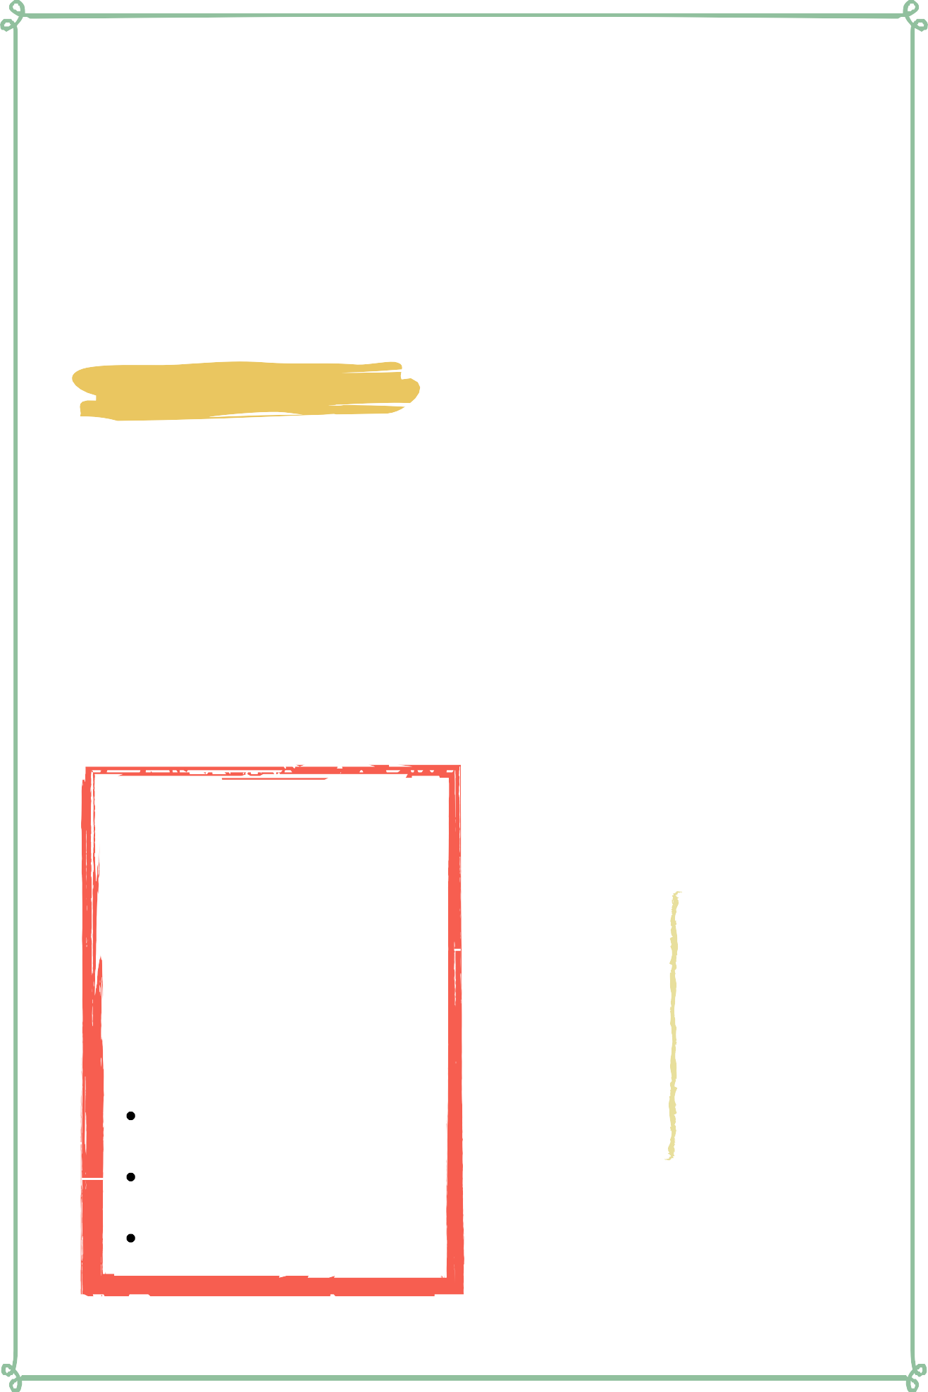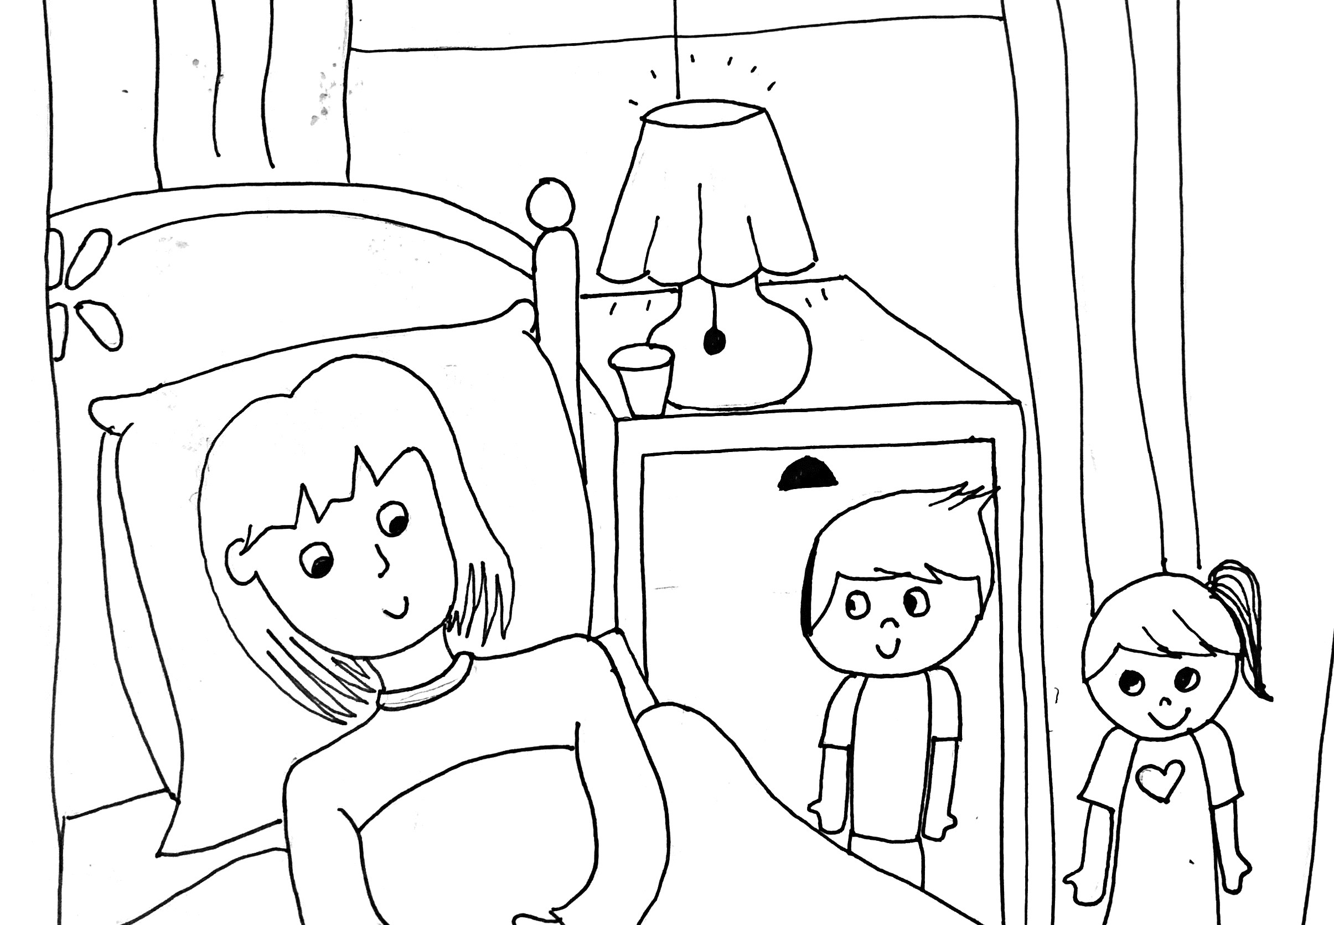

Lesson Four | Page 1

Lesson Outline

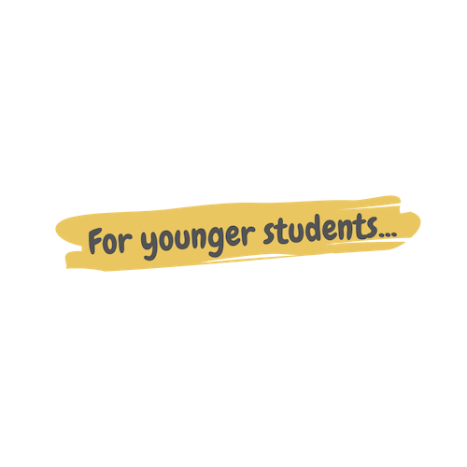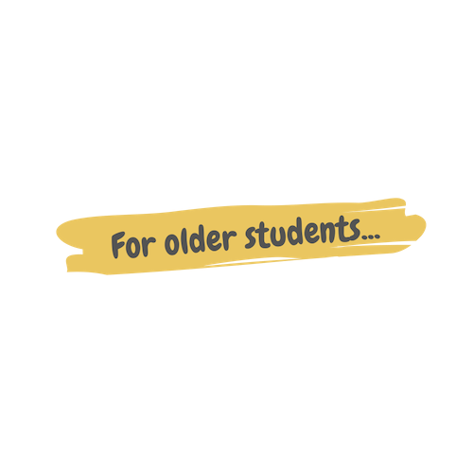

**Read the Story**

**Help the children retell the story in their own words.**

What happened first? What happened next?

What did God do on the last day?

**Discuss the story with the students.**

Why was Miss Irene, the teacher, not at school? What did Nabila and Nabil bring Miss Irene?

Why did Nabila want to help Miss Irene when she was sick?

**Discuss the story with the students.**

Why did Nabila want to help Miss Irene?

What did Nabila and Nabil do to be kind to Miss Irene? What are some ways you can be kind to your friends?

**Do the craft with the students.**

Lesson Four | Page 2

Story



One day, Nabil and Nabila went to school, but their teacher, Miss Irene was not there! They had a substitute named Miss Meva.

Nabila was curious about why her teacher wasn't in class, and so she raised her hand, "Excuse me, Miss Meva, where is Miss Irene today?"

"Miss Irene is at home today because she is sick."

The kids in the classroom gasped. They were very concerned about their teacher because they loved her a lot.

After school, Nabila ran up to her friend. "Nabil, I have an idea!" she exclaimed.

"What is your idea?" Nabil asked. He was curious to know why Nabila was so excited.

"Miss Irene is sick! We should visit her and bring medicine to make her feel better." "That's a good idea" Nabil said hesitantly, "but what if she doesn't want us to visit?" "Nabil, it's the kind thing to do. When someone is sick, you visit to cheer them up.

Miss Irene will be very thankful that we thought of her."

Nabil thought about it for a second and then smiled. "You're right Nabila, it is the kind thing to do. My mom brought home bananas from the market this morning. I can ask her if we can give them to Miss Irene."

"Good idea! I will ask my mom if we have any medicine to give."

The two friends went their separate ways and agreed to meet back up again once they had the gifts for Miss Irene. Their moms were glad that the kids wanted to do a kind thing for their teacher and gladly gave them the fruit and medicine.

Soon, Nabil and Nabila went on their way to Miss Irene's house. They knocked on the door and Mister Irene answered. He was tall and wore a blue shirt. He looked at the kids and wondered why they were there. "Hi. How can I help you?".

Nabil spoke up first, "Hi, sir. We heard that Miss Irene was sick, and so we brought her something."

Mister Irene smiled and led the kids to Miss Irene's room. She was laying in her bed with blankets on. When Miss Irene saw the kids, she said, "Nabil? Nabila? What are you two doing here?"

"We heard you were sick!" Nabila exclaimed, "So we brought you fruit and medicine."

"Yea, we hope you feel better soon!" Nabil said

"Wow, that is very kind of you. Thank you so much!" Miss Irene's heart was warmed because her students did something kind for her. The hearts of Nabil and Nabila were warmed because they knew that being kind was the best way to be.

Lesson Four | Page 3

Craft Instructions

**In this lesson we learned about kindness! You can use this craft with the students to help them remember the lesson that they learned today!**

Materials

Pre-made coloring sheet

Crayons, Markers, Pastel

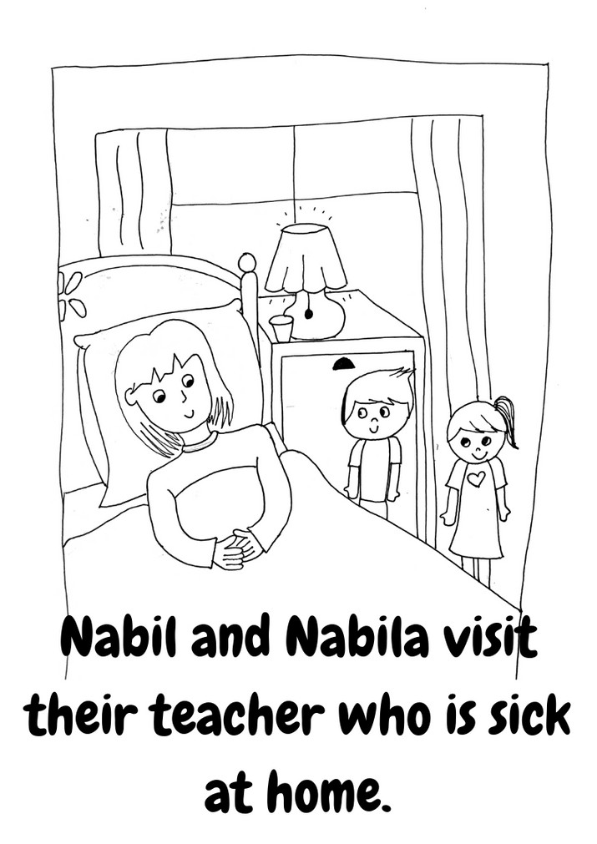

Instructions

Step 1 - Pass out one coloring sheet to each student along with coloring supplies.

Step 2 - Allow them time to color this page based off of today's story.

Lesson Four | Page 4

Vocabulary Practice

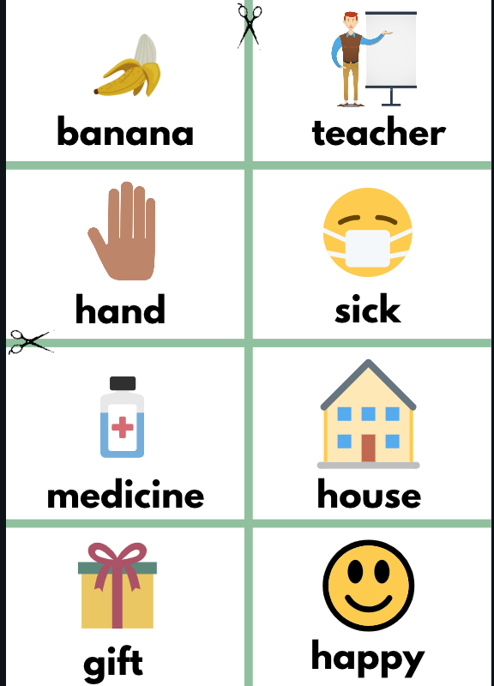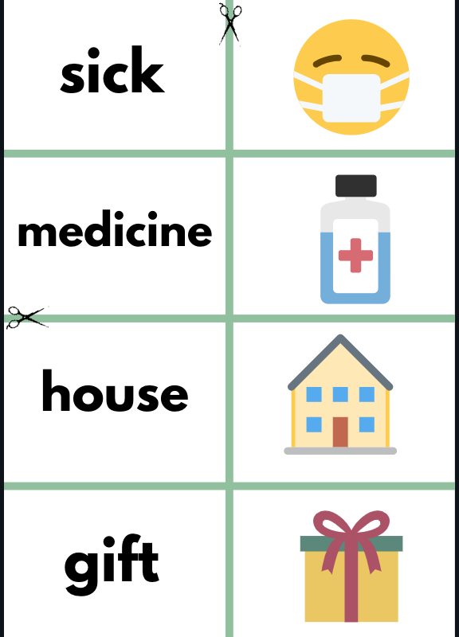

Flash Cards

Step 1- Cut out each card along the blue lines.

Step 2- Use the flash cards to teach the students the English word for each picture.

Step 3- Optional: Punch a hole in the top left corner of each card. Put them on a ring and have the students practice flipping through the cards while reading each word.

Matching Game

Step 1- Cut out each card along the blue lines.

Step 2- Teach the children the English words by connecting them with the corresponding picture. (If you need help matching them, look at the flash cards.) Step 3- Matching Game: Spread out the cards face-up on a flat surface. Make sure that they are mixed up. Have the children pick up a word or picture card and match it with the corresponding word or picture.

Lesson Four | Page 5

Song Lyrics

**Kindness Counts**

Kindness is a muscle, Work it out, gotta hustle We kids will show you the way, Gotta flex it everyday

Kindness is muscle, Work it out, Gotta hustle

We kids will show you the way, Gotta flex it everyday

Thump, Thump, Your heart will grow, every time your kindness shows Beat, Beat, Your heart gets strong when you sing a kindness song Grown ups, if you are mean, Don't think it goes unseen

We act the way you do, So be kind everyday too

Kindness is a muscle, Work it out, gotta hustle We kids will show you the way, Gotta flex it everyday

Kindness is muscle, Work it out, Gotta hustle

We kids will show you the way, Gotta flex it everyday

Kindness is a muscle, We already know and like a muscle, you can make it grow, By being kind, even when we're mad and helping others, when they're sad its easy, its easy,

its how we're made, we don't know hate, we don't throw shade If someone is different, It's the greatest thing

cause being different makes us sing

thump thump thump, your heart knows whats right beat beat beat, kindness gives us might

grown ups, follow our lead, sometimes all you need

its easy, watch our moves and dance to our kindness grooves

Kindness is a muscle, Work it out, gotta hustle We kids will show you the way, Gotta flex it everyday

Kindness is muscle, Work it out, Gotta hustle

We kids will show you the way, Gotta flex it everyday

I'll break it down, one more time for you,

Because I got more kindness rhymes to do there's a couple more things to keep in mind, and so many reasons for being kind, its all about exercise, we don't want awards

or a prize, its acting how we should because being kind feels good

Kindness is a muscle, Work it out, gotta hustle We kids will show you the way, Gotta flex it everyday

Kindness is muscle, Work it out, Gotta hustle

We kids will show you the way, Gotta flex it everyday Gotta flex it everyday

https://[www.youtube.com/watch?v=Fk5YXOB--Qo&list=PL_ZJ-](http://www.youtube.com/watch?v=Fk5YXOB--Qo&amp;list=PL_ZJ-) xy_g0TgWfBPPopKUV3GOJ2Gk9VBR&index=2

Lesson Four | Page 6



**banana teacher**

**hand sick**

**medicine house**

**gift happy**



**door bed**

**banana teacher**

**hand**

**sick**



**medicine**

**house**

**gift**



**happy door**

**bed**

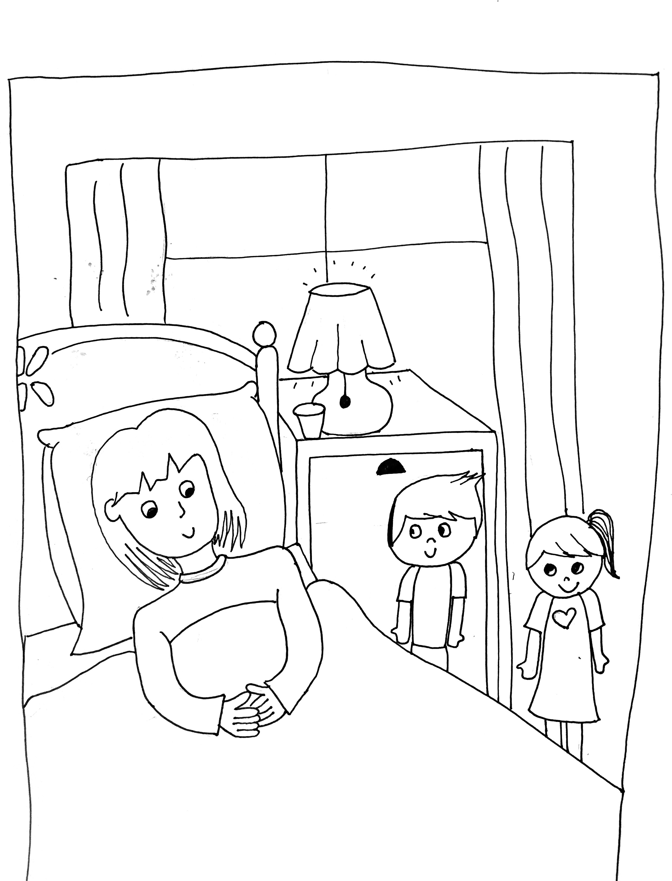Nabil and Nabila visit their teacher who is sick at home.