## The Creation Story

##### Lesson One

Lesson Overview

Scripture - Genesis 1:1-31, 2:1-

3

Craft - Days of Creation Circles

Main Point - God created the world and everything in it.

God called His creation Good.

Song - "God Created"

Note to the Teacher

Before presenting this lesson, we encourage you to read the scripture passages and understand the story for yourself. This lesson plan is meant to give you direction as you teach, but it is important to share the story from your heart and allow God to lead you as you go.

Craft

Vocabulary

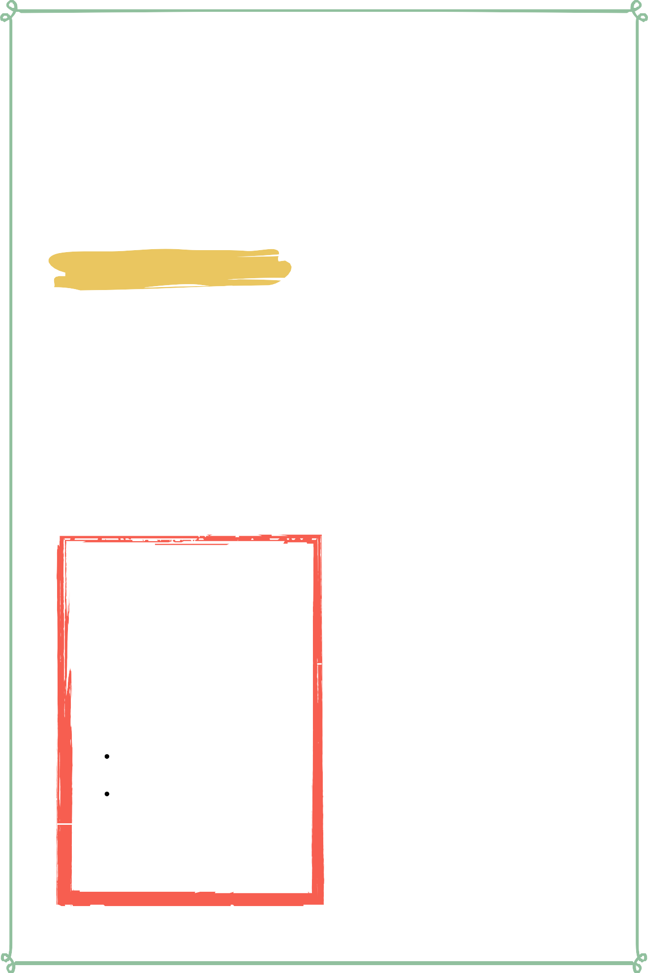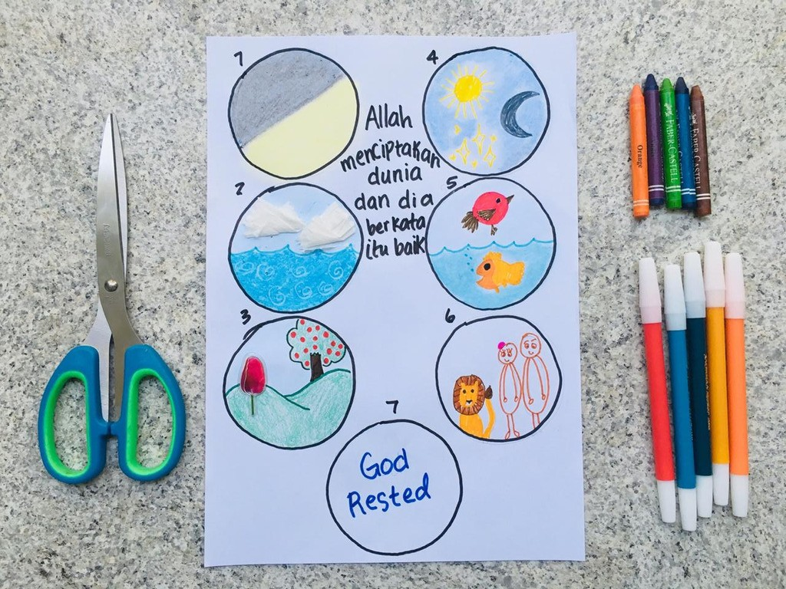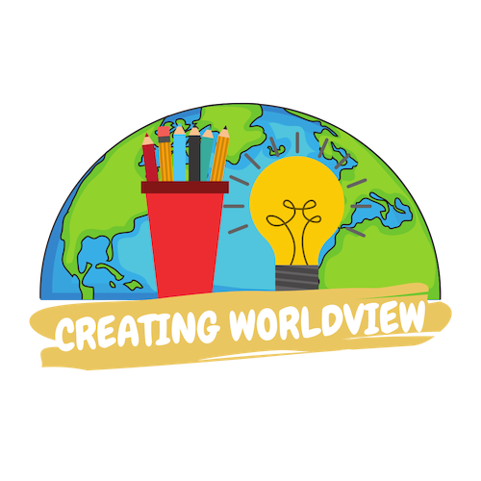

Materials pre-made coloring sheet

Crayons, Markers, Pastels

Make sure to prepare an example of this craft ahead of time to use to teach the lesson.

clouds night day fish land

plants sun moon stars animals

## Lesson Outline



**Read the Scripture** Genesis 1:1-31 & 2:1-3

###### Help the children retell the story in their own words.

What happened first? What happened next? What happened last?

**Discuss the story with the students.**

What are some ways you enjoy God's creation? What are some of your favorite things about God's creation?

How can we help take care of the things God created?

**Discuss the story with the students.**

What does this story say about God? What does this story say about us?

What do we need to obey from this passage?

**Do the craft with the students.**

Craft Instructions

God created the world and

everything in it and for today's lesson we will create a fun and easy way to remember what God did on each day of the creation story! You can complete this craft with the pre-made coloring sheet attached to the lesson and just a few supplies!

Materials

Pre-made coloring sheet Crayons, Markers, Pastel



Instructions

Step 1 - Hand out the pre- made coloring sheet.

Step 2 - Have the students color each circle. You can walk them through the circles one at a time from Day 1-Day 6.

Step 3 - Read together at the bottom of the page "And on the seventh day God rested."

Step 4 - Allow the children to bring their finished coloring sheet home with them to remember the story they learned.

## Vocabulary Practice

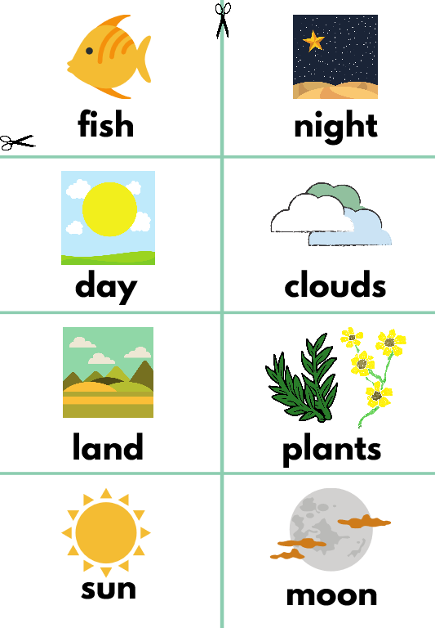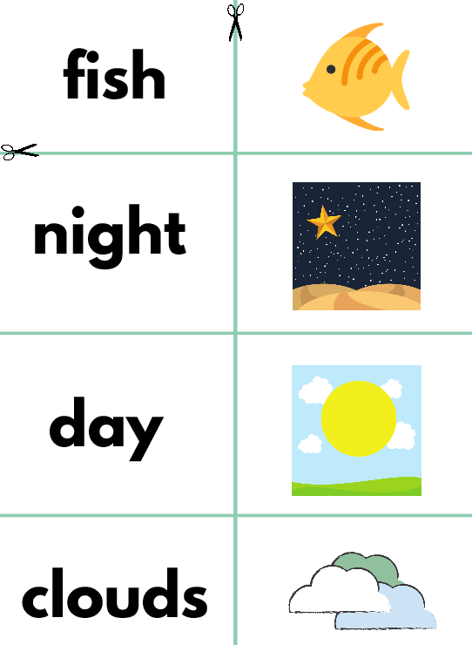

#### Flash Cards

Step 1 - Cut out each card along the green lines.

Step 2 - Use the flash cards to teach the students the English word for each picture.

Step 3 - Optional: Punch a hole in the top left corner of each card. Put them on a ring and have the students practice flipping through the cards while reading each word.

Matching Game

Step 1 - Cut out each card along the green lines.

Step 2 - Teach the children the English words by connecting them with the corresponding picture. (If you need help matching them, look at the flash cards.) Step 3 - Matching Game: Spread out the cards face-up on a flat surface. Make sure that they are mixed up. Have the children pick up a word or picture card and match it with the corresponding word or picture.

Song Lyrics



##### Creation Song

God created, God created night and day, night and day

that was on the first day, that was on the first day and God saw it was good, and God saw it was good God created, God created

sky and clouds, sky and clouds

that was on the second day, that was on the second day and God saw it was good, and God saw it was good God created, God created

land and plants, land and plants

that was on the third day, that was on the third day and God saw it was good, and God saw it was good God created, God created

sun, moon, and stars sun, moon and stars

that was on the fourth day, that was on the fourth day and God saw it was good, and God saw it was good God created, God created

birds and fish, birds and fish

that was on the fifth day, that was on the fifth day and God saw it was good, and God saw it was good God created, God created

creatures on land, people too, creatures on land, people too that was on the sixth day, that was on the sixth day

and god saw it was good then God rested, then God rested

from His work, from His work

that was on the seventh day, that was on the seventh day a holy day to worship God, a holy day to worship God

lets sing praises, let sing praises to our God, to our God

He created all things, He created all things God is good,

all the time

https://[www.youtube.com/watch?v=aoehyq6X650&list=PL_ZJ-xy_g0TgJKc_Zc_iGRFVMl7ODQI1n](http://www.youtube.com/watch?v=aoehyq6X650&amp;list=PL_ZJ-xy_g0TgJKc_Zc_iGRFVMl7ODQI1n)





**fish night**



**day clouds**

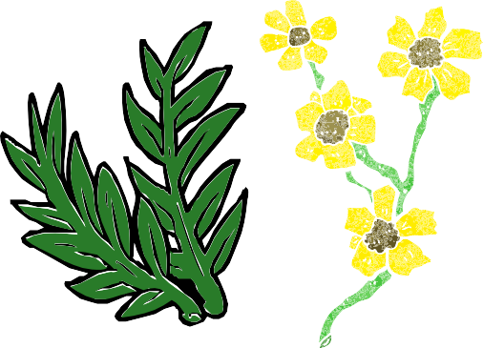

**land plants**

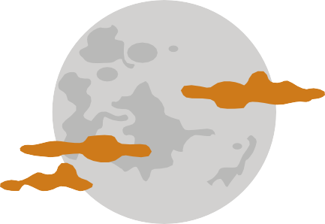

**sun moon**



**stars animals**

**fish**



**night**



**clouds**

**land**

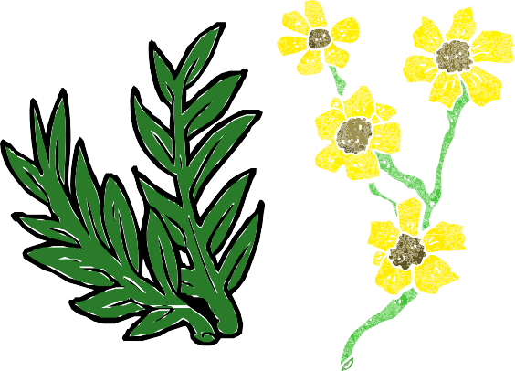**plants**



# moon stars

**animals**



### God Created the World and everything in it!

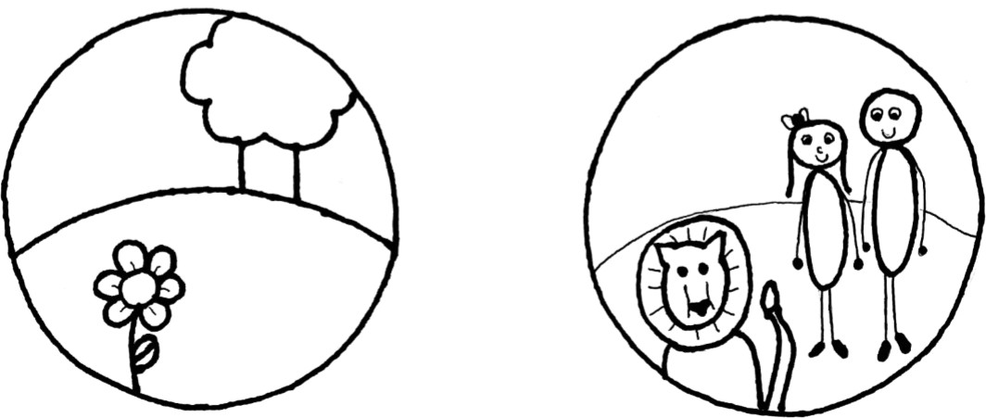And on the 7th day, God Rested.