## "I Am Special"

### Lesson One

Lesson Overview

Moral: "I Am Special"

Craft: "I Am Special" Coloring sheet

Note to the Teacher

Before presenting this lesson, we encourage you to read through the lesson plan first so that you know the story well. This will help you present the story to the students in a way that they will understand.

Craft

Vocabulary

|  |  |  |
| --- | --- | --- |
|  |  |  |

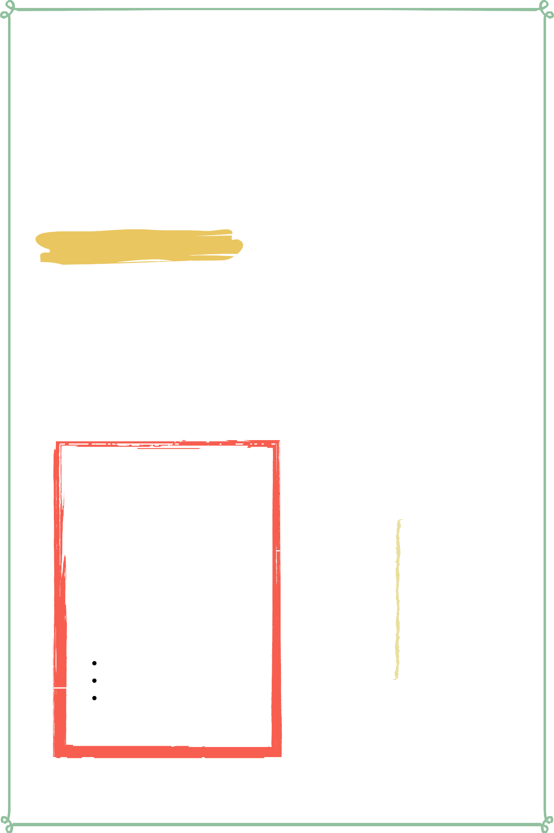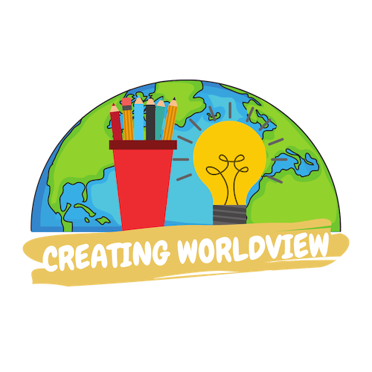

Materials

pre-made coloring sheet Crayons, Markers, Pastels Pencil

clouds night day fish land

plants sun moon stars animals

## Lesson Outline

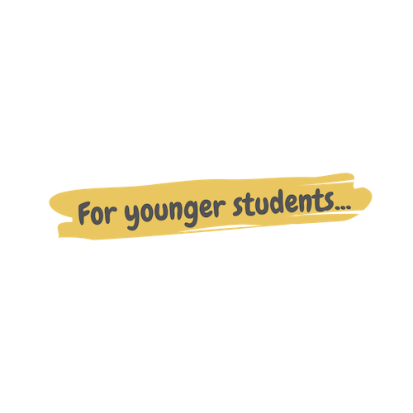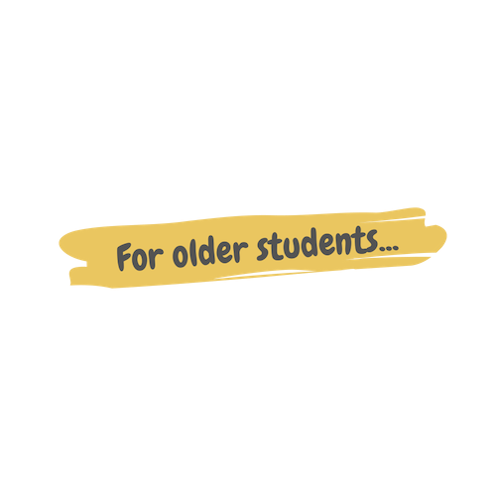

**Read the Story**

#### Help the children retell the story in their own words.

What happened first? What happened next?

What did God do on the last day?

**Discuss the story with the students.**

Why was Nabil sad?

What did Nabila say to help him feel better? Why are you special?

**Discuss the story with the students.**

Why are you special?

Is it okay to be different than your friends? How can we make other people feel special?

**Do the craft with the students.**

Story



I want to introduce you to two children who live on an island, in a village, just like you! Nabeel is a 10 year old boy who lives in a blue house with three sisters. Nabila is a little girl who lives in a yellow house and has two brothers and a new baby sister.

One day, after school, Nabila saw Nabil sitting under a banana tree with a sad face. Nabila asked, “What’s wrong Nabil?”

Nabil replied, “I don’t want to talk about it.”

Then Nabila said, "It's okay Nabil. You can tell me!"

So, he explained, "Well, I was playing soccer with my friends and they started making fun of me because I couldn't kick the ball well!"

Nabila replied, "I'm sorry that happened Nabil. Even though you cannot kick the ball well, you are still special! There are many special things about you. One thing that is special about you is how you always make people laugh!"

"Really? You think I am special?"

Nabila replied, "You sure are! And I am special too. We are all special in different ways. The sun is different from the rain, but they are both important because one gives us light and keeps us warm and the other gives us water to make the plants grow. Even though we are different, we are each special."

Then, will a smile on his face, Nabil jumped up and said, "You are right! I am special! Thank you Nabila!"

## Craft Instructions

**In this lesson we learned about how we are all special! You can use this craft with the students to help them remember the lesson that they learned today!**

Materials

Pre-made coloring sheet

Crayons, Markers, Pastels

Pencil

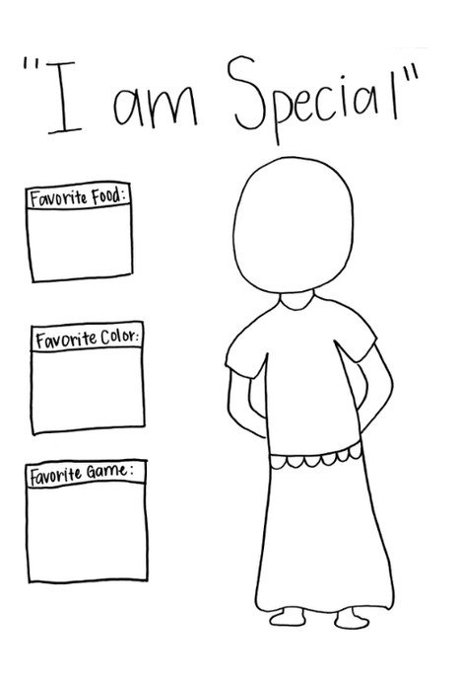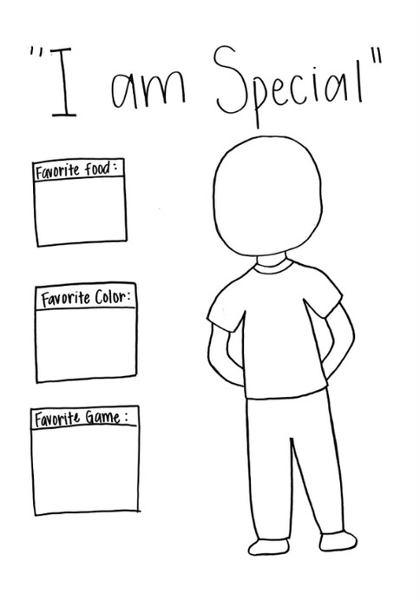

Instructions

Step 1 - Hand out the coloring sheets. There are two sheets - one for the boys and one for the girls.

Step 2 - Have the children draw themselves in the outline of the person. They can draw a face, hair, and color their clothing how they want to.

Step 3 - Have the children fill in the boxes with their answers. They can either write their answers or draw a picture of their answers.

Step 4 - You can have the children bring their coloring sheet home or hang it on your classroom walls so that the other children can see their classmates and read about their favorite things.

Vocabulary Practice

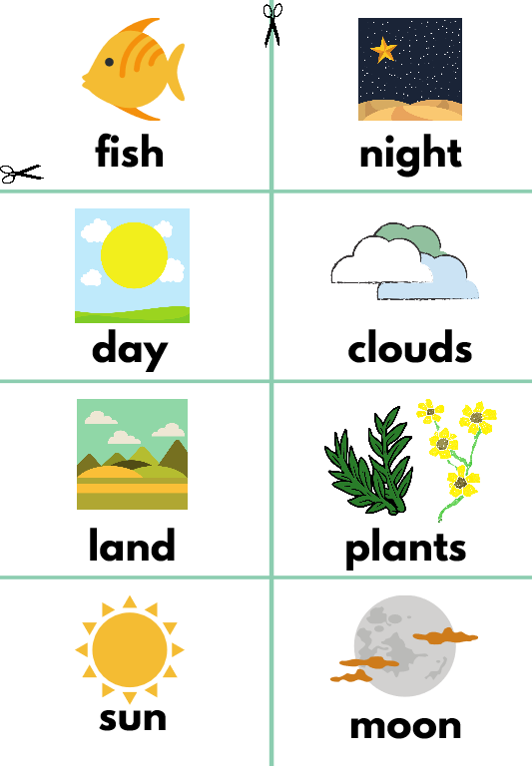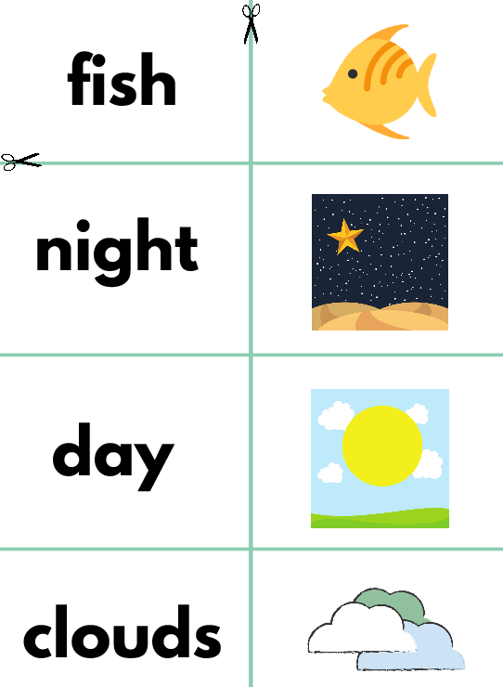

Flash Cards

Step 1 - Cut out each card along the green lines.

Step 2 - Use the flash cards to teach the students the English word for each picture.

Step 3 - Optional: Punch a hole in the top left corner of each card. Put them on a ring and have the students practice flipping through the cards while reading each word.

Matching Game

Step 1 - Cut out each card along the green lines. Step 2 - Teach the children the English words by connecting them with the corresponding picture. (If you need help matching them, look at the flash cards.)

Step 3 - Matching Game: Spread out the cards face-up on a flat surface. Make sure that they are mixed up. Have the children pick up a word or picture card and match it with the corresponding word or picture.

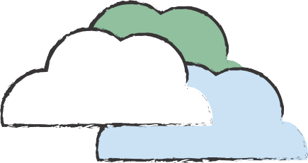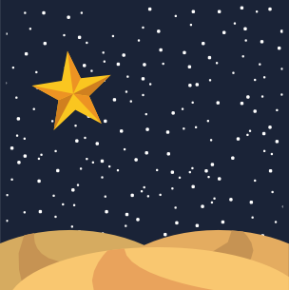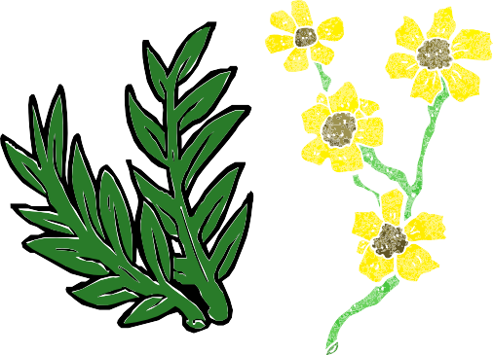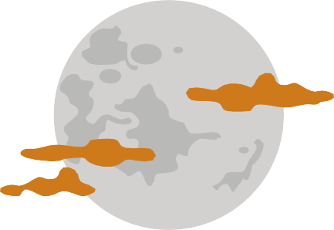

**fish night**

**day clouds**

**land plants**

**sun moon**

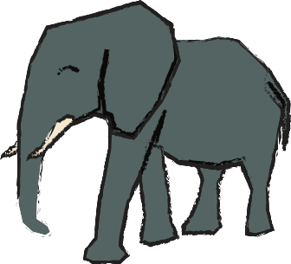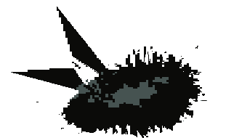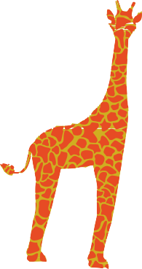

**stars animals**

**fish**

**night**

**clouds**

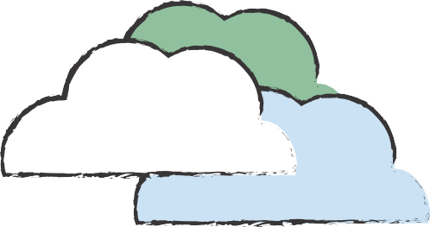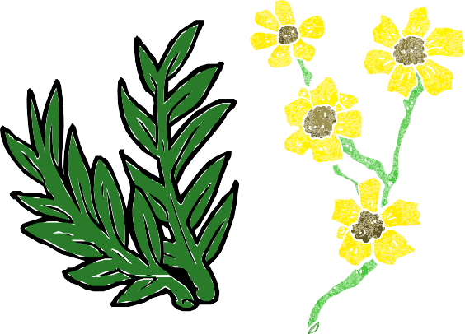

**land**

**plants**

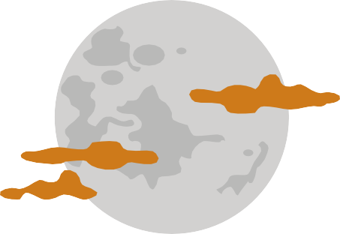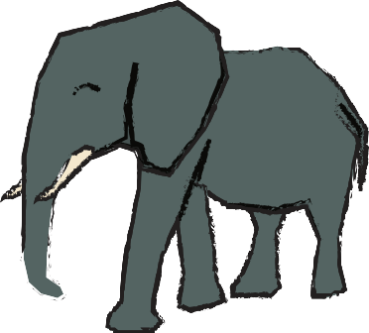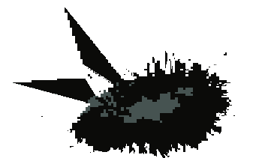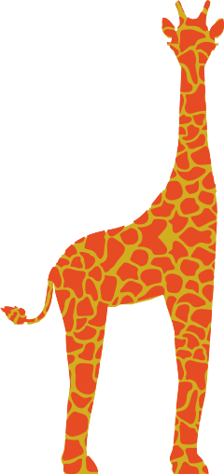

# moon

**stars**

**animals**

