## God Forgives

### Lesson Ten

Lesson Overview

Scripture - Leviticus 4:1-5

Main Point - In the New Testament Jesus died for our sins to forgive us, but in the Old Testament, a sin offering is how the people were forgiven by God.

Craft - God Forgives Sin Coloring Sheet

Song - God Forgave

Note to the Teacher

Before presenting this lesson, we encourage you to read the scripture passages and understand the story for yourself. This lesson plan is meant to give you direction as you teach, but it is important to share the story from your heart and allow God to lead you as you go.

Craft

Vocabulary

good bad above below

outside inside in front behind

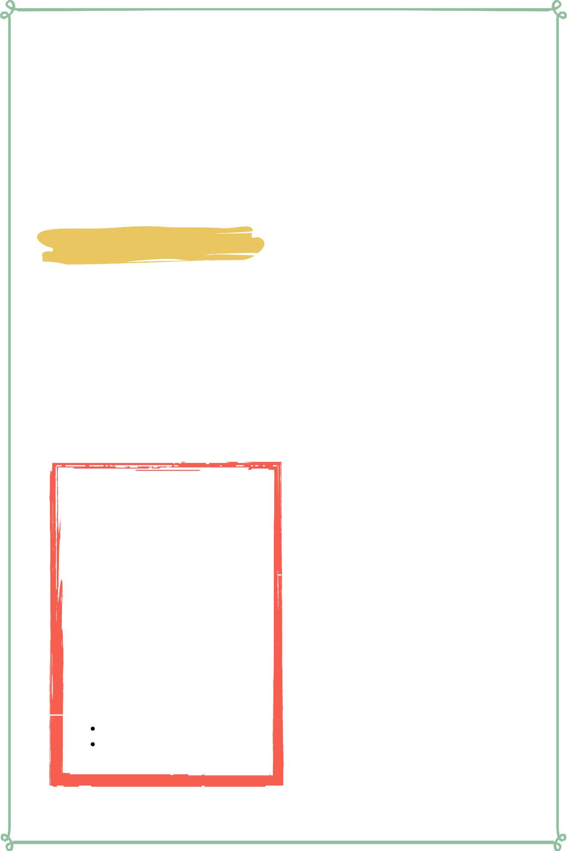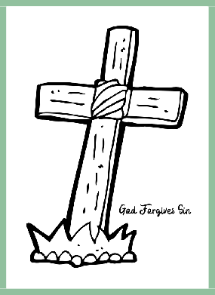

Materials

pre-made coloring sheet crayons, markers, pastels

## Lesson Outline



**Read the Scripture** Leviticus 4:1-35

#### Help the children retell the story in their own words.

What happened first? What happened next? What happened last?

**Discuss the story with the students.**

Why did God's people have to make sacrifices? Do we have to make sacrifices now?

Who made the ultimate sacrifice?

**Discuss the story with the students.**

What does this story say about God? What does this story say about us?

What do we need to obey from this passage?

**Do the craft with the students.**

Craft Instructions

###### Today we learned that the in the Old Testament, God's people had to make sacrifices in order to receive forgiveness from their sins. We also learned that because of Jesus' sacrifice on the cross, we can all receive forgiveness!

Materials

pre-made coloring sheet

crayons, markers, pastels

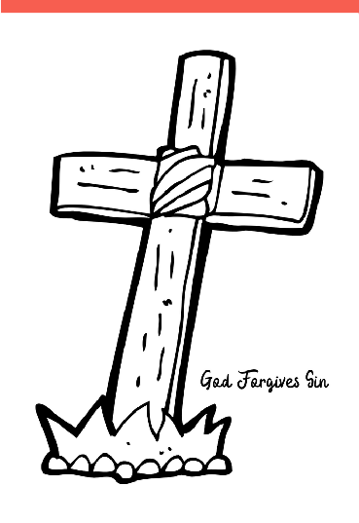

Instructions

Step 1 - Pass out one coloring sheet to each student along with markers, crayons, or pastels.

Step 2 - Instruct them to color the page and remember that God forgives sins because of Jesus.

Step 3 - Allow the students to take their creations home with them.

Vocabulary Practice

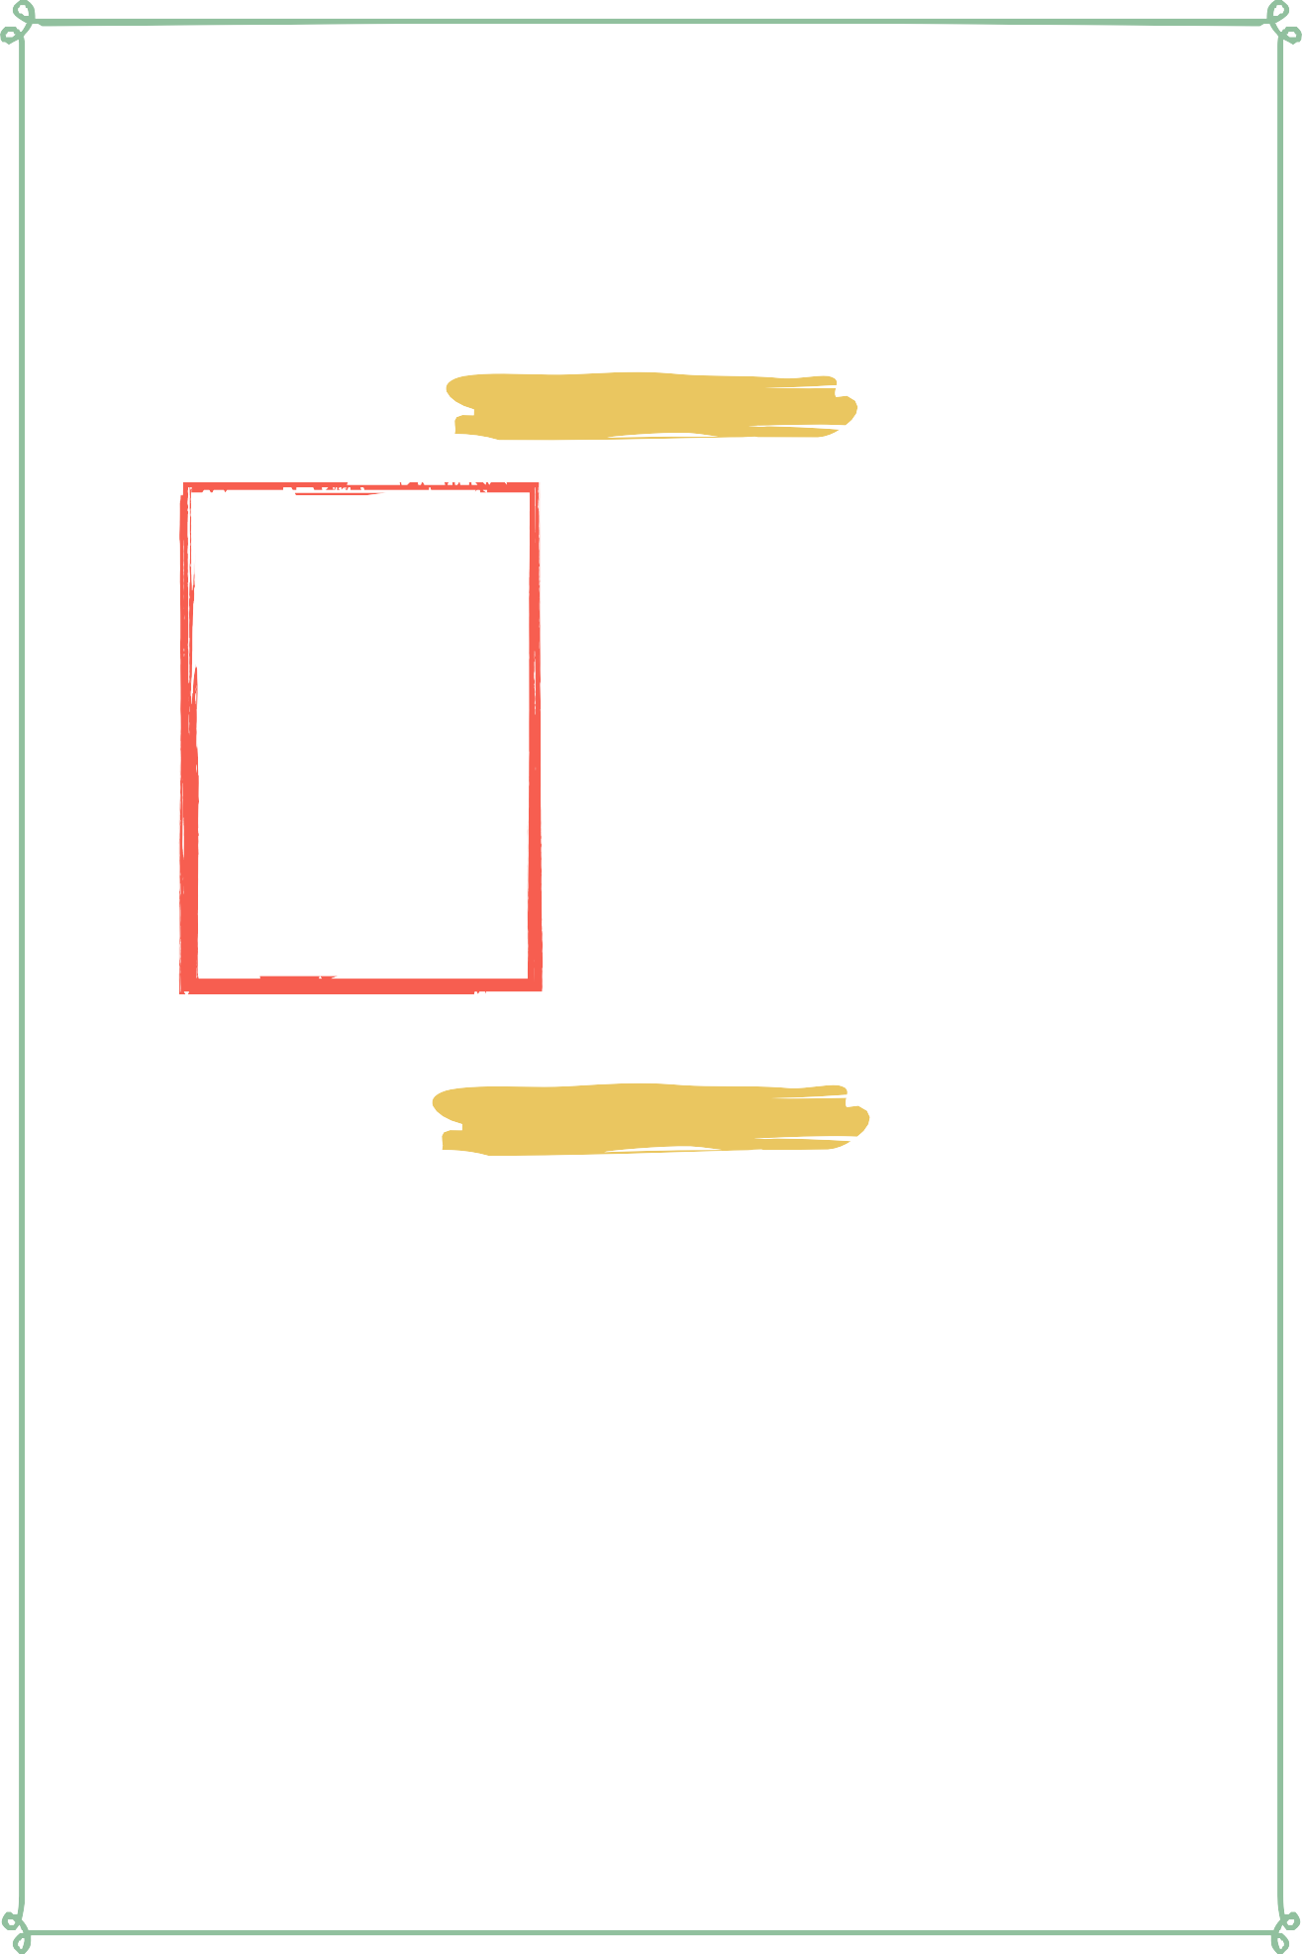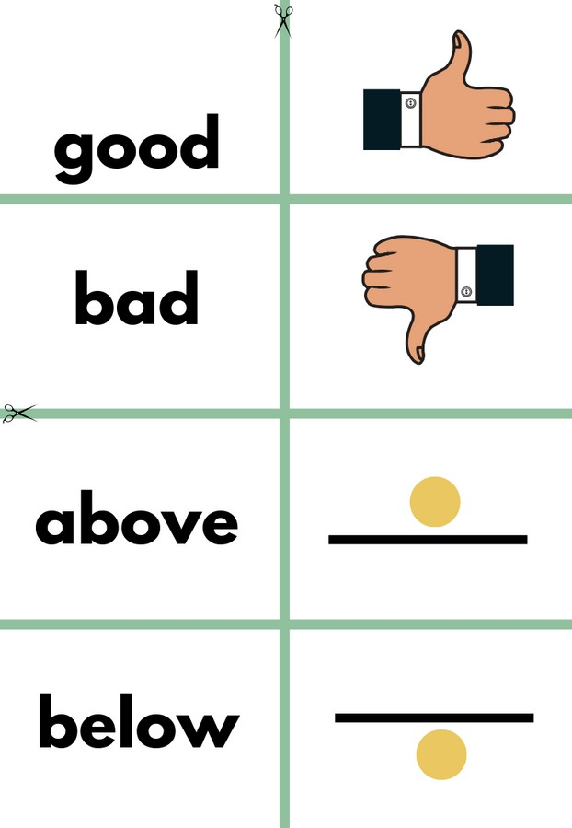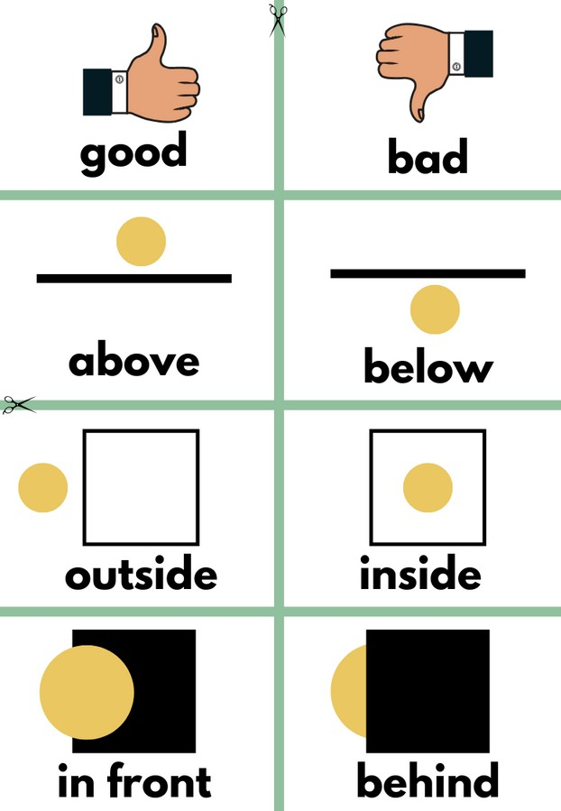

Flash Cards

Step 1- Cut out each card along the green lines.

Step 2- Use the flash cards to teach the students the English word for each picture.

Step 3- Optional: Punch a hole in the top left corner of each card. Put them on a ring and have the students practice flipping through the cards while reading each word.

Matching Game

Step 1- Cut out each card along the green lines.

Step 2- Teach the children the English words by connecting them with the corresponding picture. If you need help matching them, look at the flash cards. Step 3- Matching Game: Spread out the cards face-up on a flat surface. Make sure that they are mixed up. Have the children pick up a word or picture card and match it with the corresponding word or picture.

**Look at the following page for more ideas to use the flashcards.**

Vocabulary Games

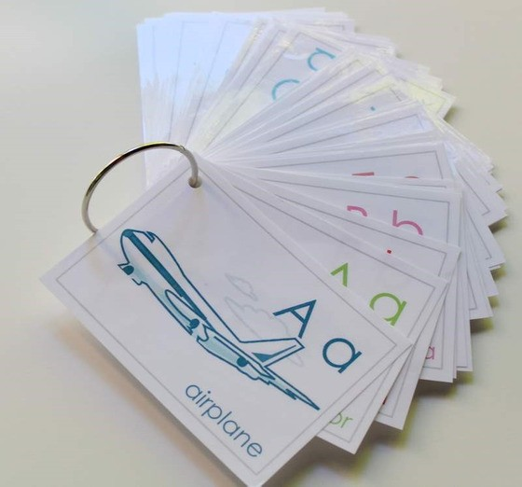

**Flashcard Game Ideas:**

The flashcards are the cards with the picture and word on the same side of the card. These flashcards are meant to help the student learn the English word for each picture. These cards can be used by putting them on a metal ring and having the student flip through the cards as they practice saying the word that goes with each picture.

**Flashcard Ring Example**

**Matching Game Ideas:**

For these four games, you can use the matching cards. The matching cards have a picture card and a word card that go together.

For this first game, start by laying the picture cards face down. (Do not use the word cards.) Have the students, one-by-one, pick up a card and flip it over and say the English word for that picture card.

For this game, lay the picture cards face-up on a flat surface. (Do not use the word cards.) Next, ask the students, one-by-one, where each picture card is. Do this by saying the English word for the picture on the card. Example: Where is the dog? Where is the door?

For this game, give each student a picture card. Then, call out one of the English words. Example: "Door". If a student has that picture card, have them hold it up, say the word, and show their friends.

For this game, lay out all of the cards (word cards and picture cards) face-up on a flat surface. One-by-one, allow the students to pick up an English word card and match it with the picture card. Try the other way by having the students pick up the picture card and match it with the English word card.

For a harder version of this game, lay all of the cards (word cards and picture cards) face-down. Have the children pick up a card and then pick up a second card. If they match, they can keep them. If they don't match they must put them back face-down and let the next student have a turn.

## Song Lyrics

### God Forgave

##### God didn't have to do this, He didn't have to give so much, But He gave it all, When He gave His son to save us, Came to forgive our every sin, And he gave His life, So we could live, No matter how this world will test me, I know how my Jesus loves me, He is all I'll ever need, Surely I will fail and fall down, But God won't even see my sin, Cause Jesus washed it all away, God forgave.

God didn't have to do this, He didn't have to give so much, But He gave it all, when He gave His Son, Then Jesus came to save us, Came to forgive our every sin, And He gave His life.



https://[www.youtube.com/watch?](http://www.youtube.com/watch) v=XZw6qQby24A

Lesson Ten | Page 6

**good**

**bad**



**above below**

**outside inside**

**in front behind**



**good bad**

**above**

**outside**



**inside**

# in front

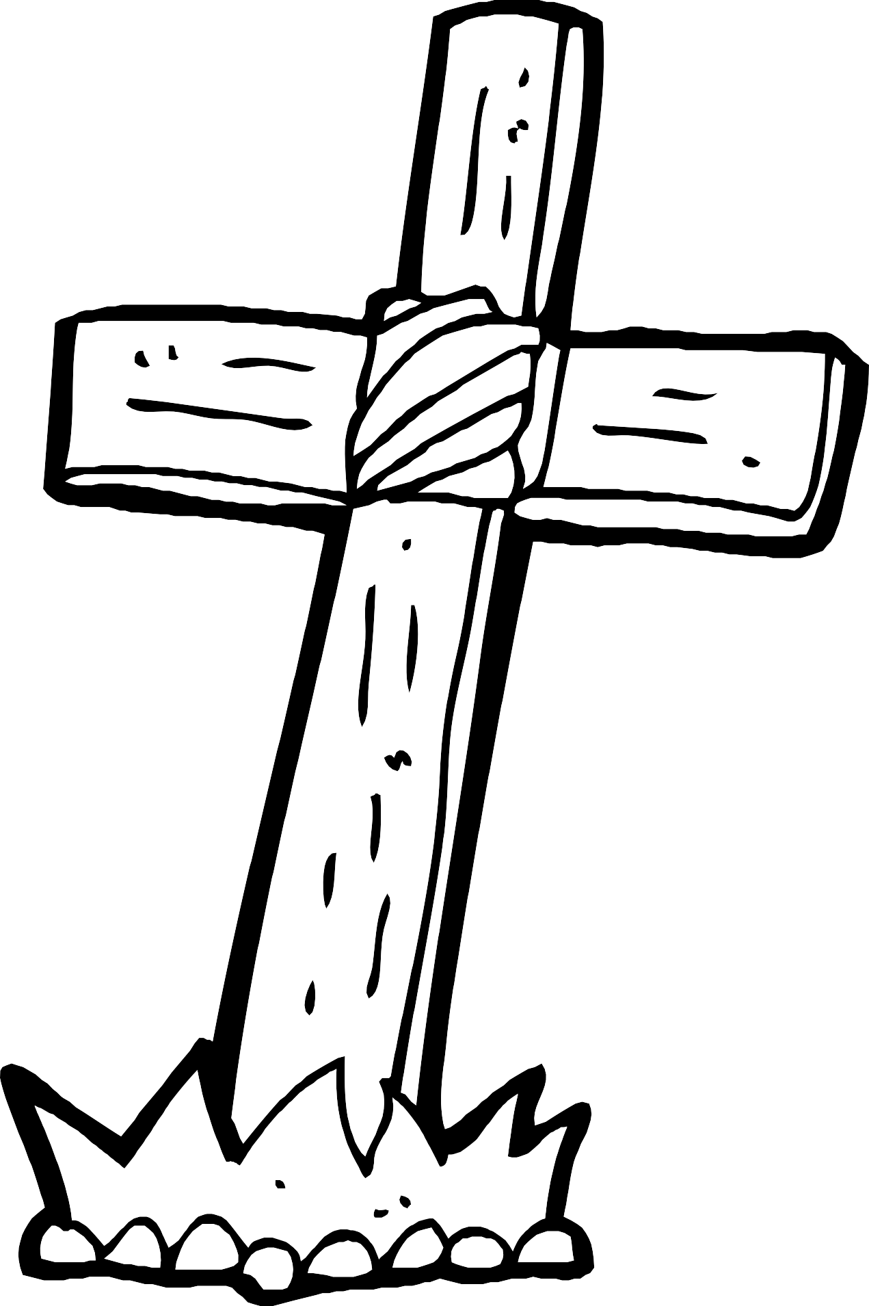

God Forgives Sin