# "I Am Loyal"

## Lesson Thirteen

Lesson Overview

Moral - Loyalty

Craft - Cookie Maze Song - "Loyalty" by The Watchkins

Note to the Teacher

Before presenting this lesson, we encourage you to read through the lesson plan first so that you know the story well. This will help you present the story to the students in a way that they will understand.

Craft

Vocabulary

Materials

pre-made coloring sheet crayons, markers, pastels

loyal friend talk climb table

eat cookie talk laugh treat

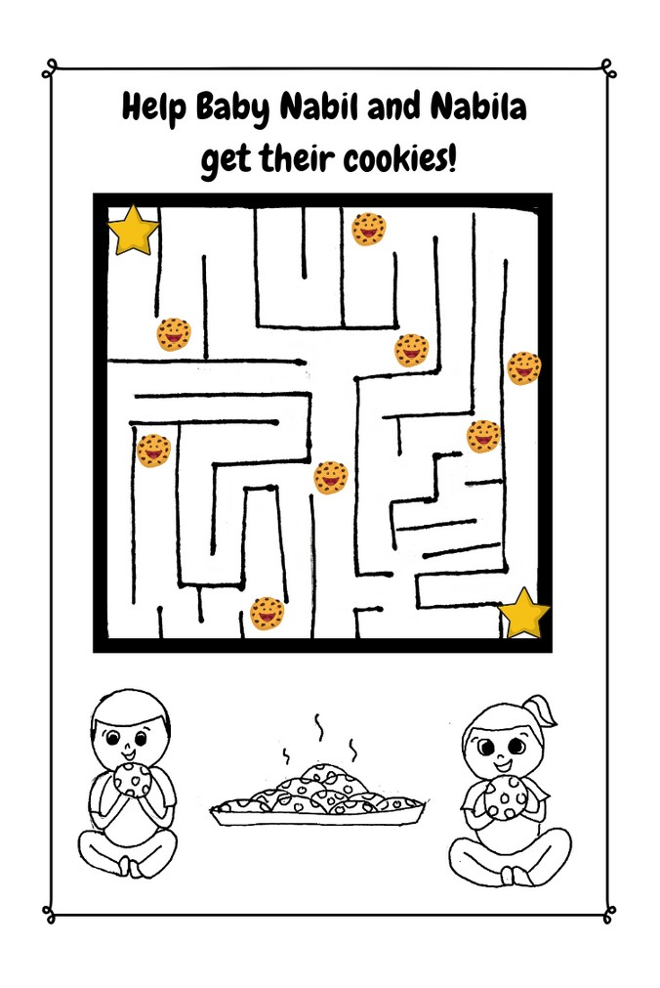

Lesson Thirteen | Page 1

Lesson Outline

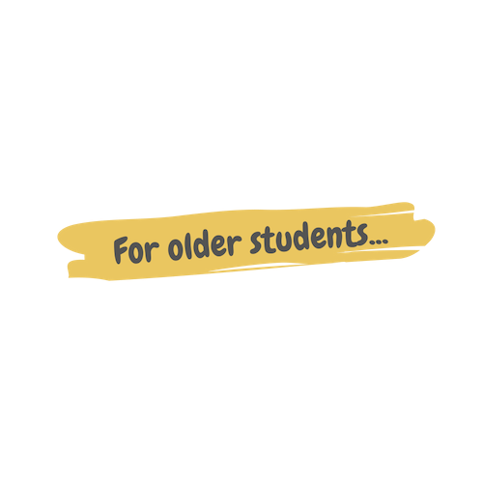

**Read the Story**

**Help the children retell the story in their own words.**

What happened first? What happened next?

What happened on the last day?

**Discuss the story with the students.**

What was on top of the kitchen table?

How many cookies did Nabil and Nabila eat?

Who is someone you are loyal to? Your mom and dad? A friend?

**Discuss the story with the students.**

Nabil and Nabila became friends because of an experience they had when they were little, but why do you think they've stayed friends for so long? What qualities make a friend a good friend?

**Do the craft with the students.**

Lesson Thirteen | Page 2

Story



On that long-ago rainy day Nabil and Nabila were a lot younger than they are now. Nabila and her mom went over to Nabil's house. As their moms were talking, the two little kids got into some mischief.

"Psst." Nabil said to Nabila. "My mom made cookies." Then he looked towards the table where there was a big plate of fresh cookies. Nabila's eyes widened as she gazed at the delicious treats. "I can't reach them. Maybe you can help?"

"Yea!" Nabila shrieked with excitement.

The two little ones waddled towards the table. Nabil pulled out a chair and lifted Nabila up onto it.

"Okay, now get them."

Nabila gulped nervously and then climbed onto the table. Nabil kept watch to make sure no moms were coming. She grabbed the cookies and moved them to the edge of the table so Nabil could reach them and then she climbed down. Feeling accomplished, they ate every single cookie on the plate. They were so full that they fell asleep right there on the kitchen floor!

"Nabila, honey, it's time to go!" Nabila's mom called. Then she walked into the kitchen and saw the two tiny kids fast asleep next to the empty plate of cookies.

"Oh no!" Nabil's mom exclaimed! "Those cookies were for our neighbor!" From that day forward, Nabil and Nabila became the best of friends.

They've been on many fun adventures, got into trouble sometimes, but

also learned a lot about being good kids. Loyalty is when you support and love someone even though sometimes it might be easier not to. Nabil and Nabila are loyal to one another even when things are hard.

Lesson Thirteen | Page 3

Craft Instructions

**Today we heard a story about how Nabil and Nabila became friends! A silly story started their friendship but what has kept their friendship alive was the loyalty they shared. Now you can help them get their cookies!**

Materials

pre-made coloring sheet

crayons, markers, pastels

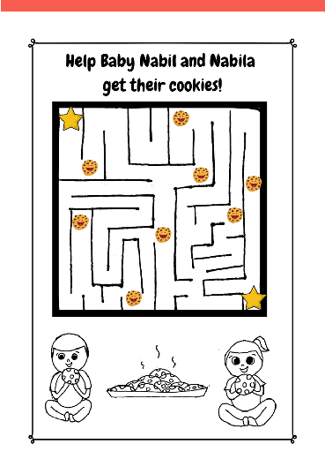

Instructions

Step 1 - Pass out one maze coloring sheet to each student along with markers, crayons, or pastels.

Step 2 - Instruct them to work through the maze connecting one star to the other and picking up as many cookies as they can on the way.

Step 3 - Allow them to take their creations home.

Lesson Thirteen | Page 4

Vocabulary Practice

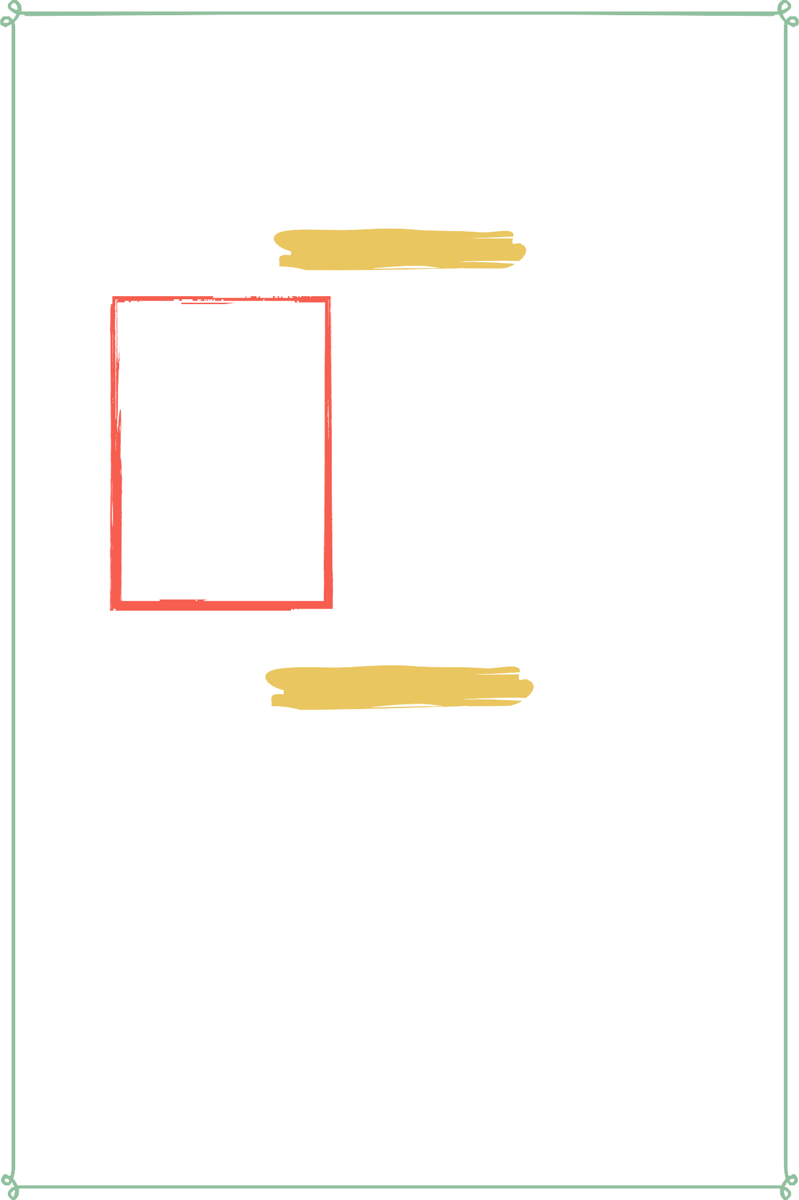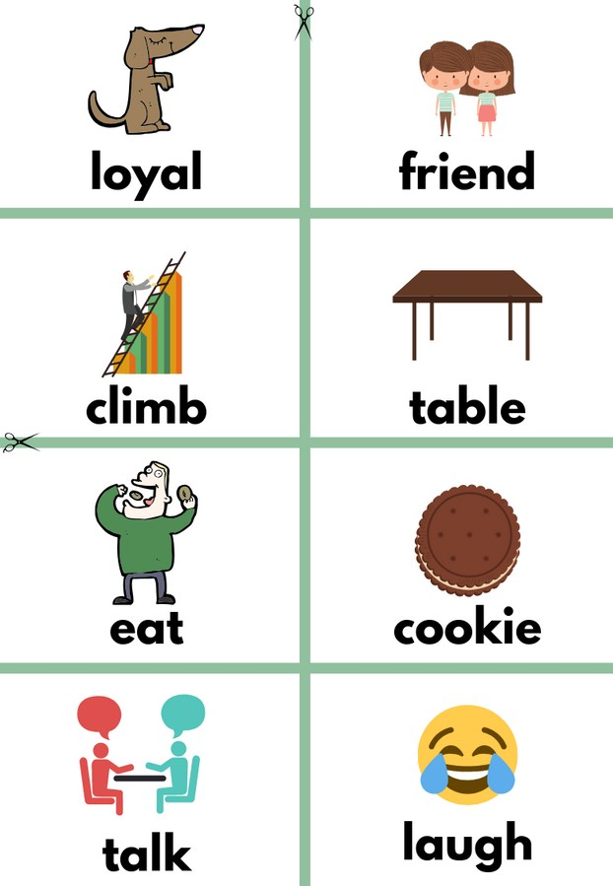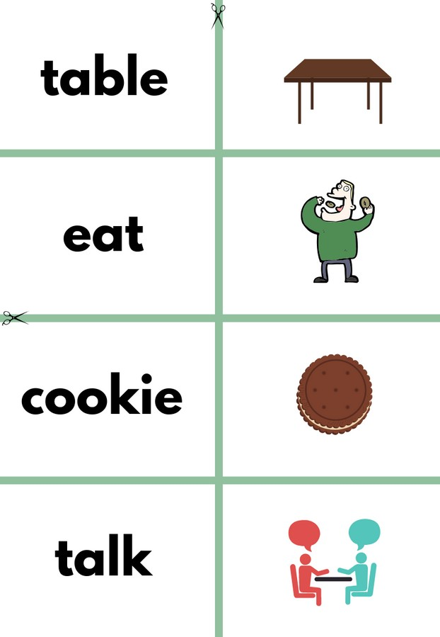

Flash Cards

Step 1- Cut out each card along the green lines.

Step 2- Use the flash cards to teach the students the English word for each picture.

Step 3- Optional: Punch a hole in the top left corner of each card. Put them on a ring and have the students practice flipping through the cards while reading each word.

Matching Game

Step 1- Cut out each card along the green lines.

Step 2- Teach the children the English words by connecting them with the corresponding picture. If you need help matching them, look at the flash cards. Step 3- Matching Game: Spread out the cards face-up on a flat surface. Make sure that they are mixed up. Have the children pick up a word or picture card and match it with the corresponding word or picture.

**Look at the following page for more ideas to use the flashcards.**

Lesson Thirteen | Page 5

Vocabulary Games

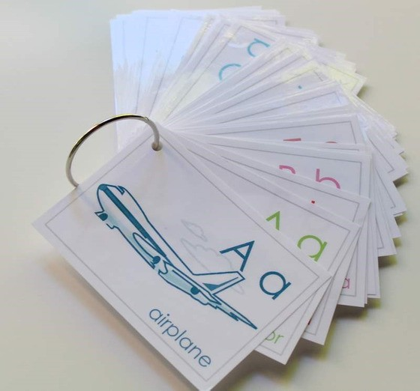

**Flashcard Game Ideas:**

The flashcards are the cards with the picture and word on the same side of the card. These flashcards are meant to help the student learn the English word for each picture. These cards can be used by putting them on a metal ring and having the student flip through the cards as they practice saying the word that goes with each picture.

**Flashcard Ring Example**

**Matching Game Ideas:**

For these four games, you can use the matching cards. The matching cards have a picture card and a word card that go together.

For this first game, start by laying the picture cards face down. (Do not use the word cards.) Have the students, one-by-one, pick up a card and flip it over and say the English word for that picture card.

For this game, lay the picture cards face-up on a flat surface. (Do not use the word cards.) Next, ask the students, one-by-one, where each picture card is. Do this by saying the English word for the picture on the card. Example: Where is the dog? Where is the door?

For this game, give each student a picture card. Then, call out one of the English words. Example: "Door". If a student has that picture card, have them hold it up, say the word, and show their friends.

For this game, lay out all of the cards (word cards and picture cards) face-up on a flat surface. One-by-one, allow the students to pick up an English word card and match it with the picture card. Try the other way by having the students pick up the picture card and match it with the English word card.

For a harder version of this game, lay all of the cards (word cards and picture cards) face-down. Have the children pick up a card and then pick up a second card. If they match, they can keep them. If they don't match they must put them back face-down and let the next student have a turn.

Lesson Thirteen | Page 6

Song Lyrics

**Loyalty**

We are birds of a feather, we are always together

We’re partners wherever we ride

We are friends and amigos; I go where he goes

We travel the trail side by side

She’s my sunshine and laughter, this moment after

We’ll always be faithful and true Cause I grew up believing, it’s part of my

breeding

It’s every dog’s duty to do

Loyalty, loyalty

It’s being a friend true to the end Sticking by each other through thick and thin

That’s loyalty

We’re a couple of sidekicks together an odd mix

Best friends under the sun Though it sounds kinda nutty having him

for a buddy

Makes a cat’s life second to none

No two could be closer, what’s more you should know sir

No matter how the trail bends, I’ll be right there beside him

I’ll never misguide him

My partner, my buddy, my friend

Loyalty, loyalty

It’s being a friend true to the end Sticking by each other through thick and thin

That’s loyalty

I will always protect her, never neglect her I promise to love without fail

We’re the closest of friends, my love extends

From the tip of my nose to my tail

I’m her buddy and playmate our friendship is first rate

Together we’re two of a kind Wherever her trail goes, I’ll find her with

my nose

With my tail wagging behind

Loyalty, loyalty

It’s being a friend true to the end Sticking by each other through thick and thin

That’s loyalty



https://[www.youtube.com/watch?](http://www.youtube.com/watch) v=LbRX073HCCM&t=16s

Lesson Thirteen | Page 7

**loyal**

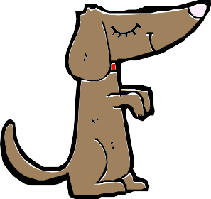

**climb**

**eat**

**talk**

**friend**

**table**

**cookie**

**laugh**

**sleep**

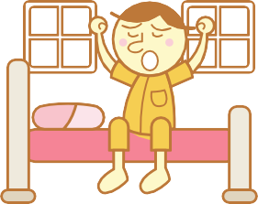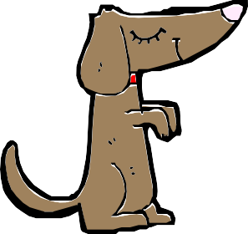

**loyal**

**friend climb**

**wake**

**table eat cookie**



**talk**

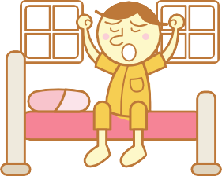

**laugh sleep wake**

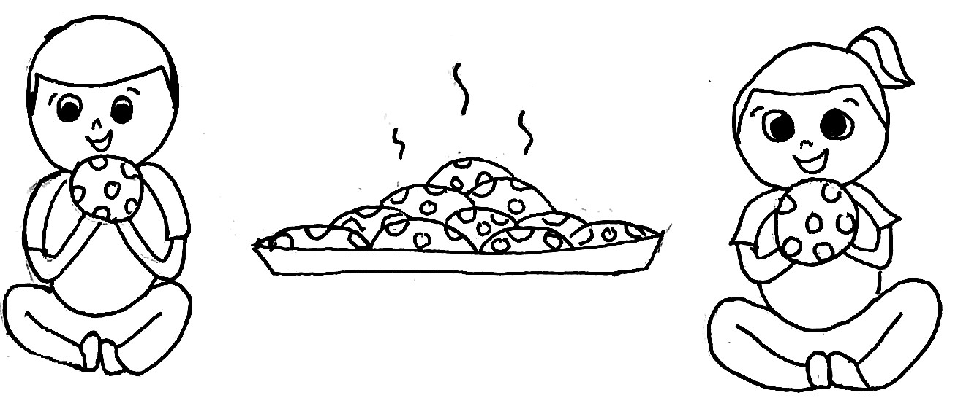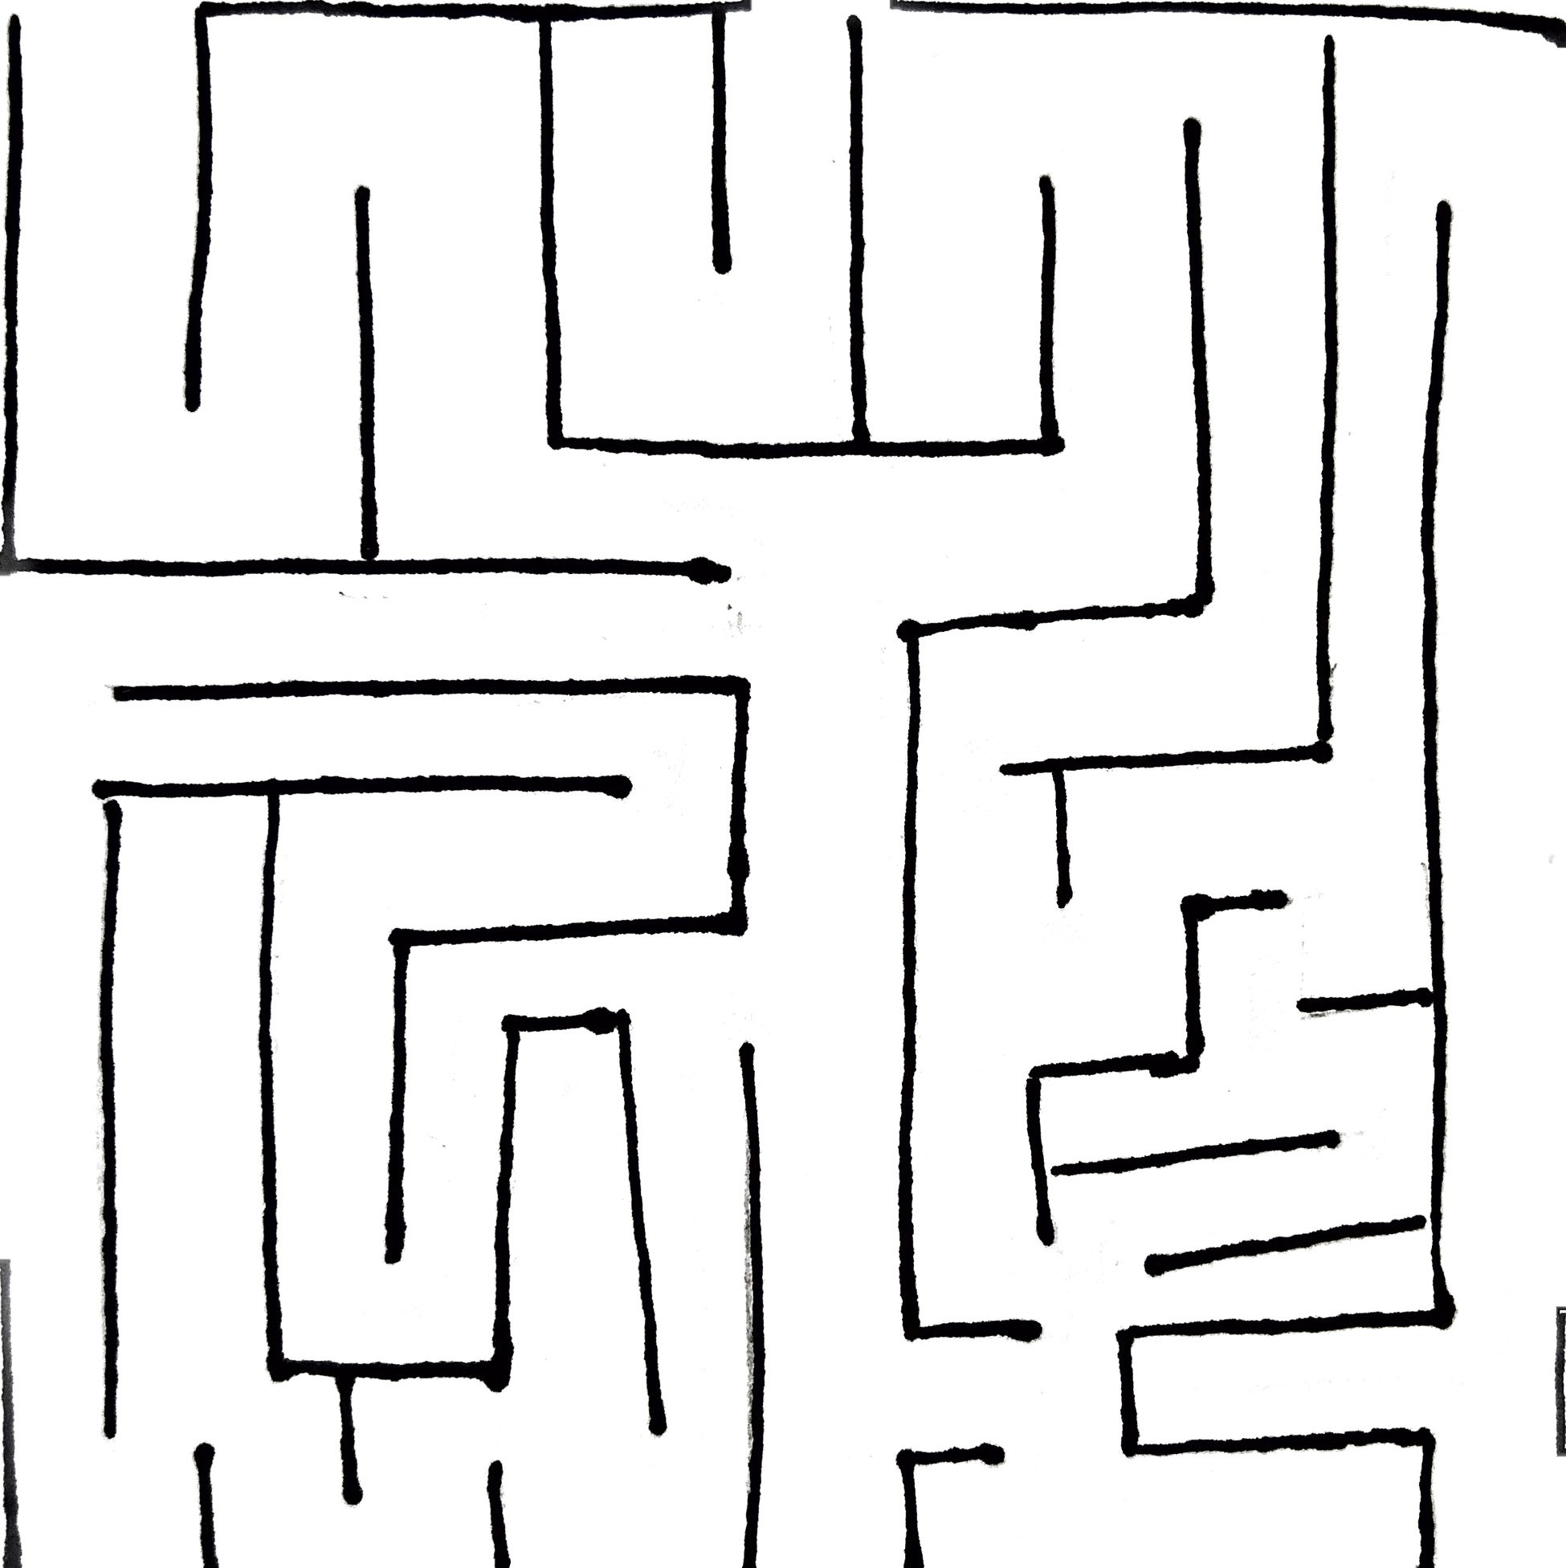

Help Baby Nabil and Nabila get their cookies!