## The Fall of Man

#### Lesson Three

Lesson Overview

Scripture - Genesis 3:1-13

Craft - Fall of Man Coloring Sheet Main Point - God created the world without sin but Adam and Eve brought sin into the world. Because we are God’s creation, He doesn’t want us to sin. God can help us not to sin if we ask Him.

Song - "Adam and Eve" by Diana Dow

Note to the Teacher

Before presenting this lesson, we encourage you to read the scripture passages and understand the story for yourself. This lesson plan is meant to give you direction as you teach, but it is important to share the story from your heart and allow God to lead you as you go.

Craft

Vocabulary

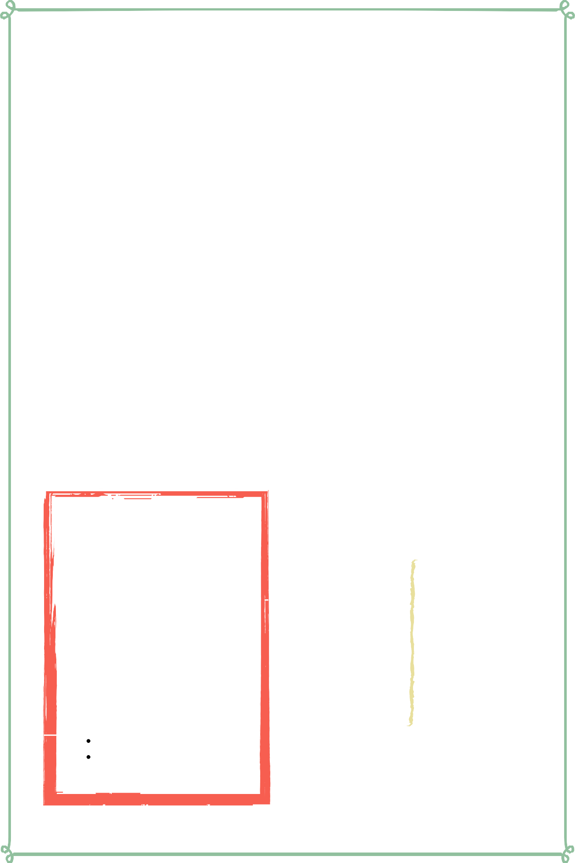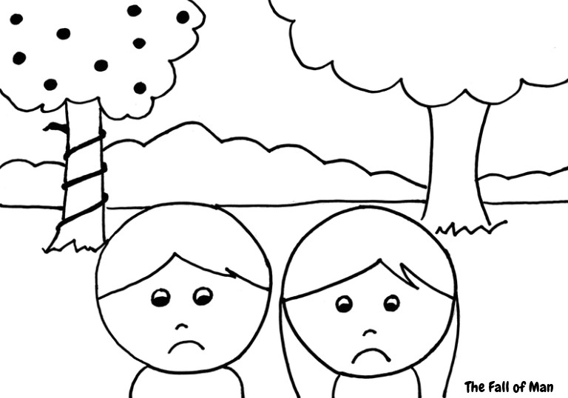

Materials

pre-made coloring sheet crayons, markers, pastels

snake sin fruit

vegetable eyes

garden eat leaf hide walk

## Lesson Outline



**Read the Scripture** Genesis 3:1-13

##### Help the children retell the story in their own words.

What happened first? What happened next? What happened last?

**Discuss the story with the students.**

Who tempted Eve to eat from the tree in the Garden that God said not to eat from?

What did Adam and Eve do after they sinned? What did God do when Adam and Eve sinned?

Sin created a big problem. Do you know how God intended to fix it?

**Discuss the story with the students.**

What does this story say about God? What does this story say about us?

What do we need to obey from this passage?

**Do the craft with the students.**

Craft Instructions

**Today's craft reminds us of how Adam and Eve dishonored God when they ate from the tree that God told them not to eat from. You can complete this craft with the pre-made coloring sheet and simple coloring materials!**

Materials

pre-made coloring sheet

crayons, markers, pastels

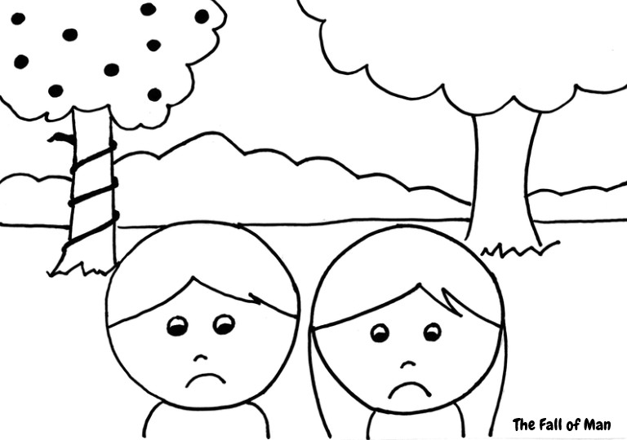

### Instructions

**Step 1 -** Hand out the pre-made coloring sheet.

**Step 2 -** Have the students color the coloring sheet.

**Step 3 -** Remind the students - “God created the world without sin but Adam and Eve brought sin into the world. Because we are God’s creation, He doesn’t want us to sin. God can help us not to sin if we ask Him.”

**Step 4 -** Let the students bring their coloring sheet home to remind them of the story.

Vocabulary Practice

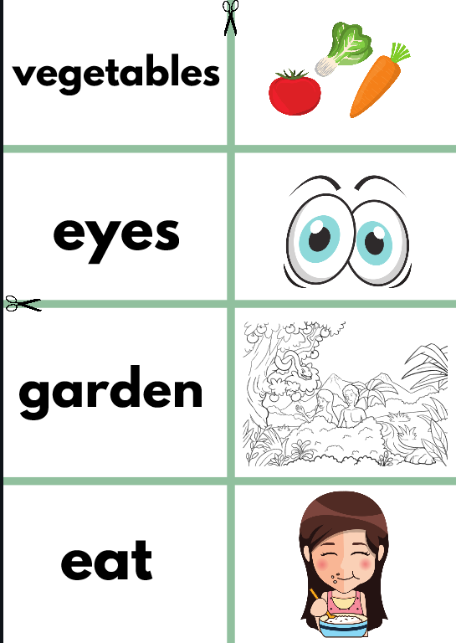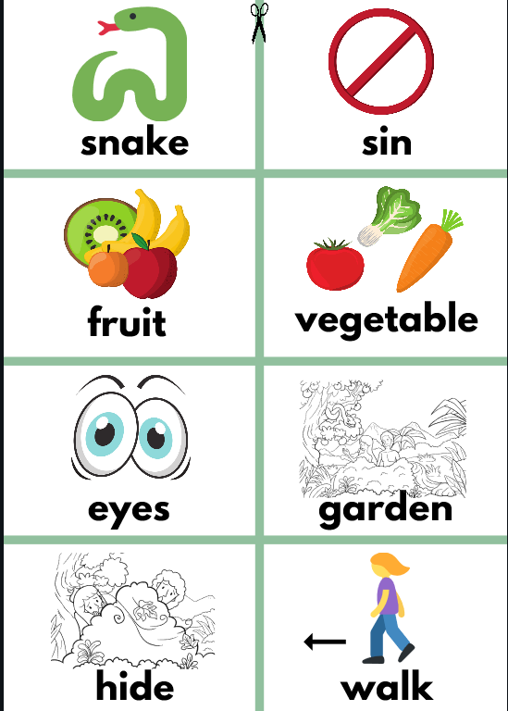

Flash Cards

Step 1- Cut out each card along the green lines.

Step 2- Use the flash cards to teach the students the English word for each picture.

Step 3- Optional: Punch a hole in the top left corner of each card. Put them on a ring and have the students practice flipping through the cards while reading each word.

Matching Game

Step 1- Cut out each card along the green lines.

Step 2- Teach the children the English words by connecting them with the corresponding picture. (If you need help matching them, look at the flash cards.)

Step 3- Matching Game: Spread out the cards face-up on a flat surface. Make sure that they are mixed up. Have the children pick up a word or picture card and match it with the corresponding word or picture.

Song Lyrics

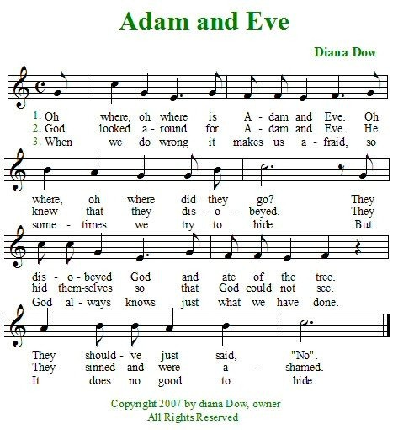

**snake sin**





**fruit vegetable**

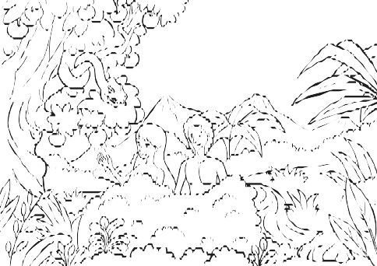

**eyes garden**

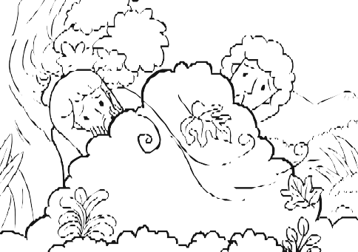

**hide walk**



**eat leaf**



**snake sin**

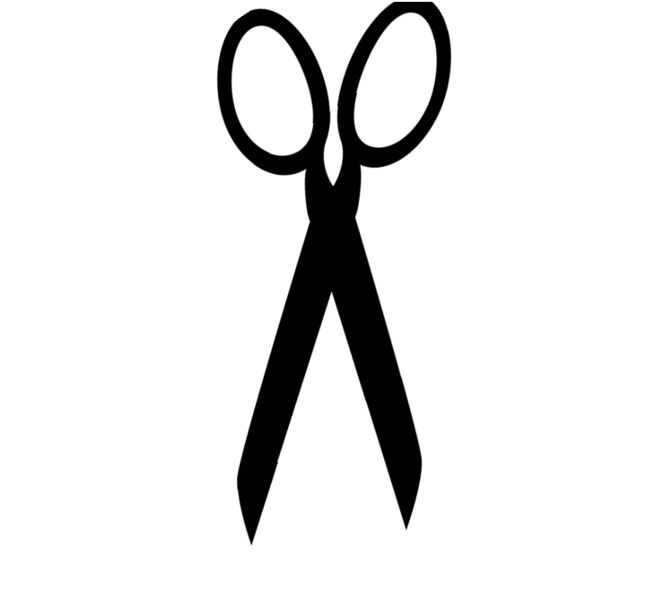

**vegetables**

# eyes

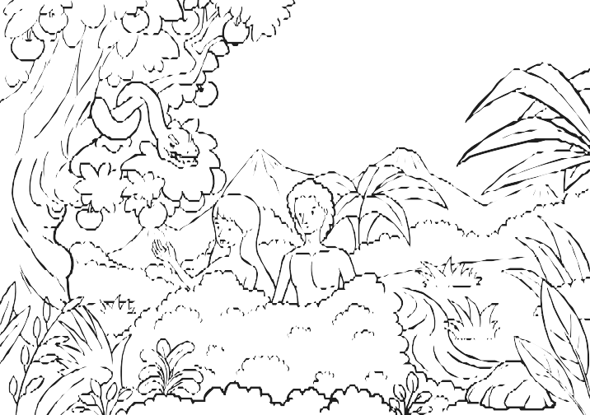**garden**

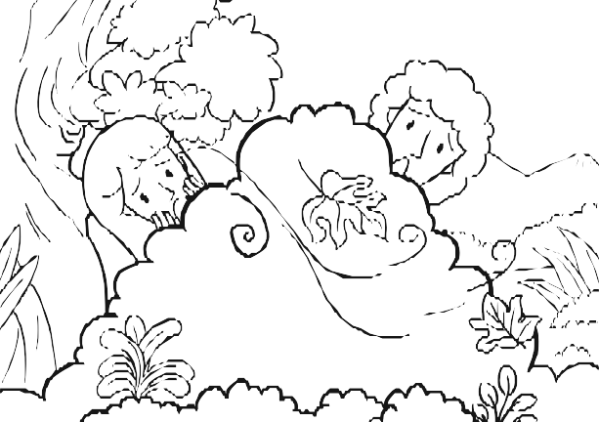

# leaf

**walk hide**

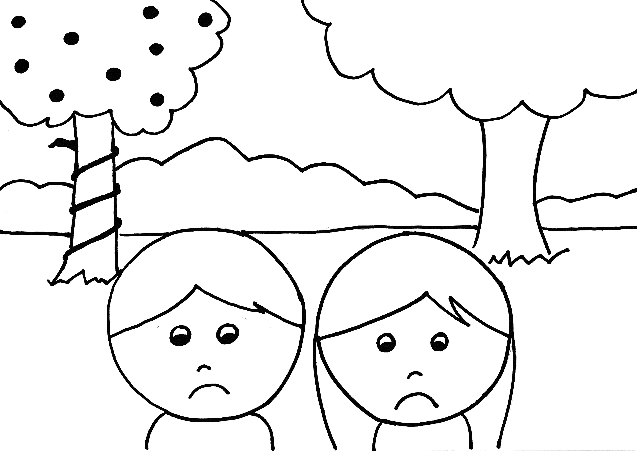

The Fall of Man