# God Provides a Sacrifice

## Lesson Seven

Lesson Overview

Scripture - Genesis 22:1-19 Main Point - Abraham obeyed God's command and God provided a sacrifice for Abraham.

Craft - Lamb Craft

Song - Jehovah Jireh

Note to the Teacher

Before presenting this lesson, we encourage you to read the scripture passages and understand the story for yourself. This lesson plan is meant to give you direction as you teach, but it is important to share the story from your heart and allow God to lead you as you go.

Craft

Vocabulary

Materials

pre-made coloring sheet crayons, markers, pastels white crepe paper

glue

mountain donkey fire

wood knife

lamb angel bush sand beach

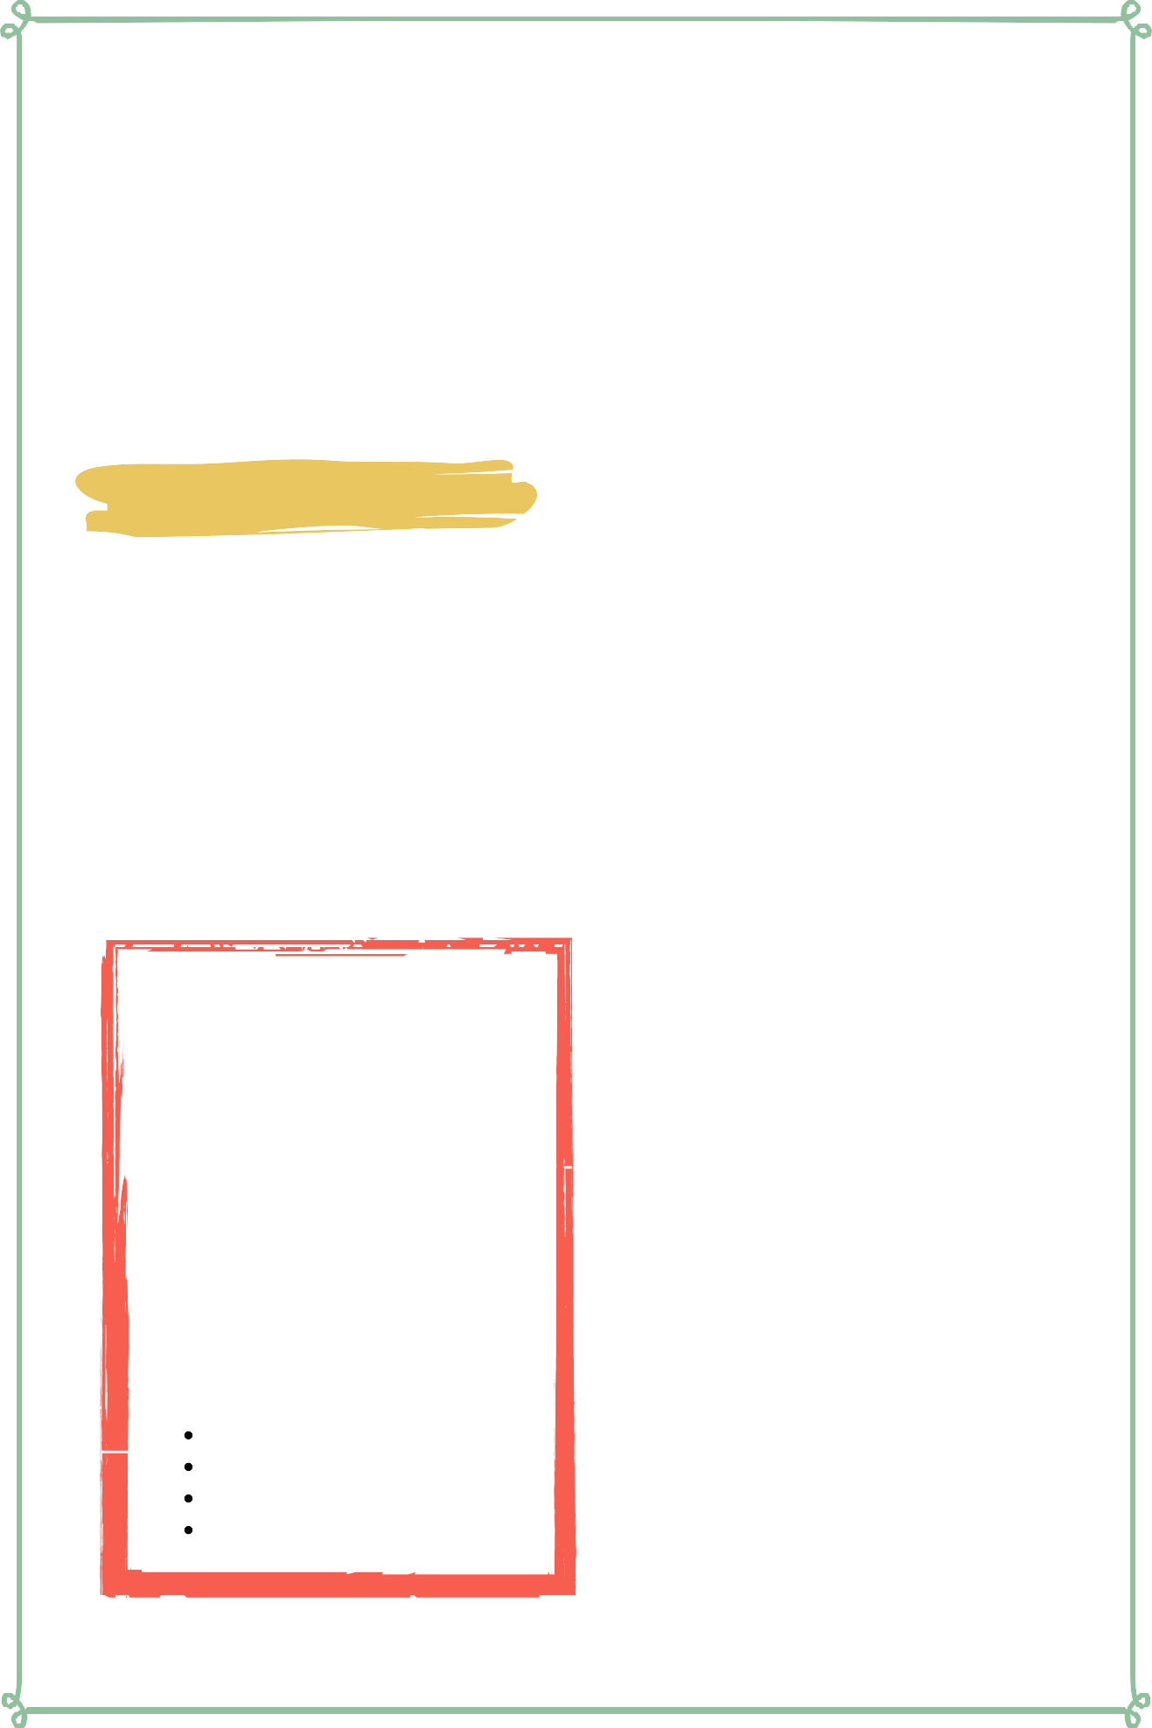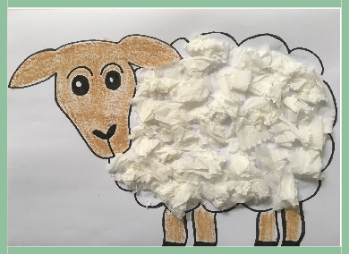

Lesson Seven | Page 1

Lesson Outline

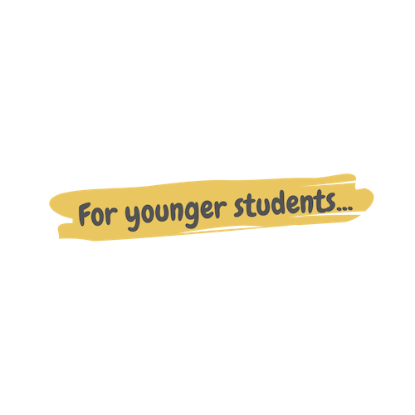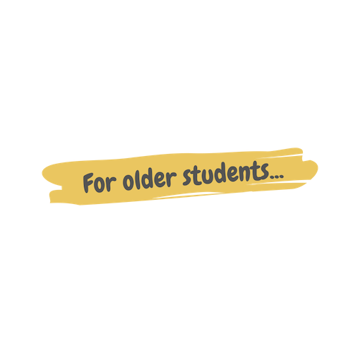

**Read the Scripture** Genesis 22:1-19

**Help the children retell the story in their own words.**

What happened first? What happened next? What happened last?

**Discuss the story with the students.**

Who was Abraham's son?

Where did Abraham take his son?

What animal did God provide for Abraham?

**Discuss the story with the students.**

What does this story say about God? What does this story say about us?

What do we need to obey from this passage?

**Do the craft with the students.**

Lesson Seven | Page 2

Craft Instructions

**Abraham obeyed God's command and God provided a sacrifice for Abraham. Today's craft reminds us of the sacrifice that God gave to Abraham.**

**You can complete this craft with the pre-made coloring sheet attached to the lesson and just a few supplies!**

Materials

pre-made coloring sheet

crayons, markers, pastels

white crepe paper glue

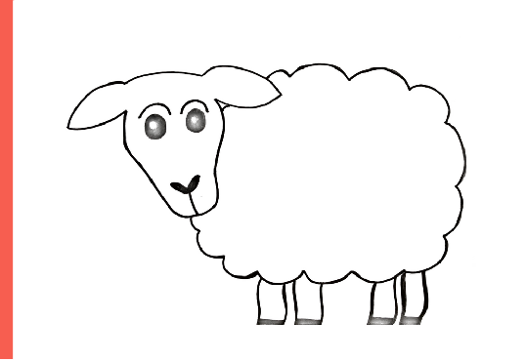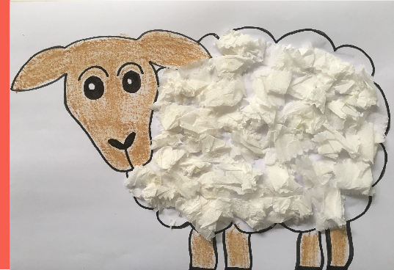

Instructions

Step 1 - Hand out pre-made coloring sheet and supplies.

Step 2 - Have the students color the lamb's head and legs first.

Step 3 - Have the students crumple the crepe paper and glue it to the lamb to make the lamb's wool.

Step 4 - Remind the students that God provided a sacrifice for Abraham and this reminds us of when God gave the ultimate sacrifice of His son Jesus.

Step 5 - Allow the students to take home their craft to remember the story.

Lesson Seven | Page 3

Vocabulary Practice

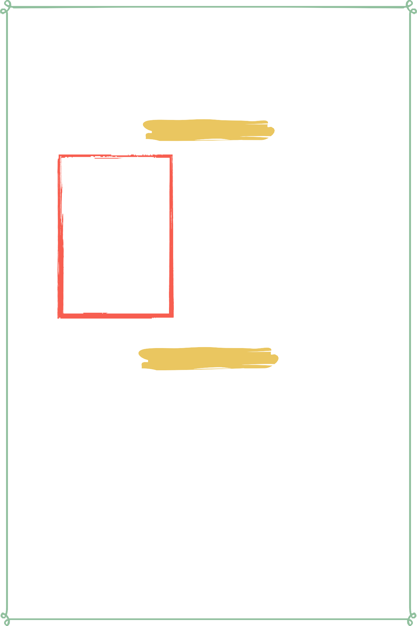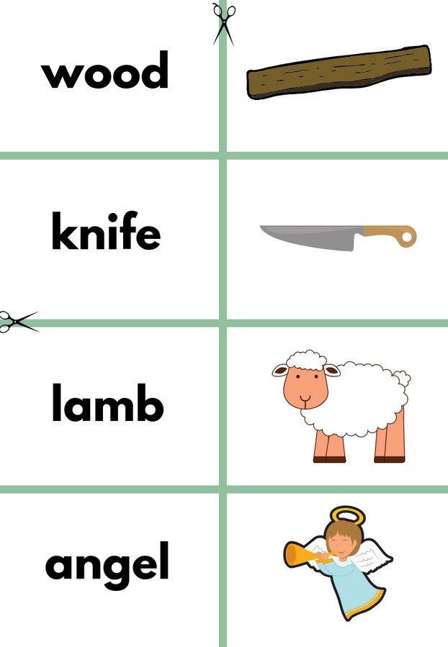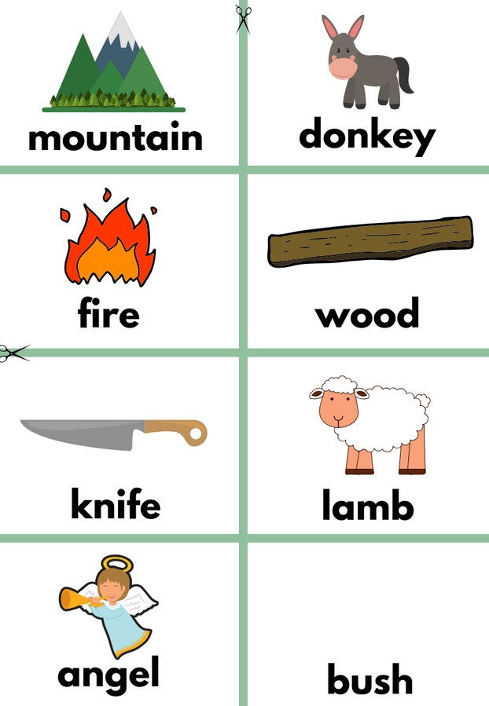

Flash Cards

Step 1- Cut out each card along the green lines.

Step 2- Use the flash cards to teach the students the English word for each picture.

Step 3- Optional: Punch a hole in the top left corner of each card. Put them on a ring and have the students practice flipping through the cards while reading each word.

Matching Game

Step 1- Cut out each card along the green lines.

Step 2- Teach the children the English words by connecting them with the corresponding picture. If you need help matching them, look at the flash cards. Step 3- Matching Game: Spread out the cards face-up on a flat surface. Make sure that they are mixed up. Have the children pick up a word or picture card and match it with the corresponding word or picture.

**Look at the following page for more ideas to use the flashcards.**

Lesson Seven | Page 4

Vocabulary Games

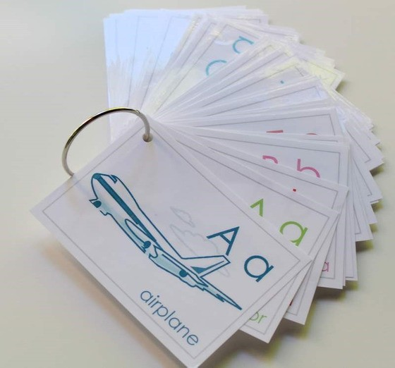

**Flashcard Game Ideas:**

The flashcards are the cards with the picture and word on the same side of the card. These flashcards are meant to help the student learn the English word for each picture. These cards can be used by putting them on a metal ring and having the student flip through the cards as they practice saying the word that goes with each picture.

**Flashcard Ring Example**

**Matching Game Ideas:**

For these four games, you can use the matching cards. The matching cards have a picture card and a word card that go together.

For this first game, start by laying the picture cards face down. (Do not use the word cards.) Have the students, one-by-one, pick up a card and flip it over and say the English word for that picture card.

For this game, lay the picture cards face-up on a flat surface. (Do not use the word cards.) Next, ask the students, one-by-one, where each picture card is. Do this by saying the English word for the picture on the card. Example: Where is the dog? Where is the door?

For this game, give each student a picture card. Then, call out one of the English words. Example: "Door". If a student has that picture card, have them hold it up, say the word, and show their friends.

For this game, lay out all of the cards (word cards and picture cards) face-up on a flat surface. One-by-one, allow the students to pick up an English word card and match it with the picture card. Try the other way by having the students pick up the picture card and match it with the English word card.

For a harder version of this game, lay all of the cards (word cards and picture cards) face-down. Have the children pick up a card and then pick up a second card. If they match, they can keep them. If they don't match they must put them back face-down and let the next student have a turn.

Lesson Seven | Page 5

Song Lyrics

**Jehova Jireh**

Jehovah Jireh My provider

His grace is sufficient For me, for me, for me

Jehovah Jireh My provider

His grace is sufficient For me

My God shall supply all my needs According to His riches in glory He will give His angels

Charge over me

Jehovah Jireh cares for me, for me, for me

Jehovah Jireh cares for me

Jehovah Jireh My provider

His grace is sufficient For me, for me, for me

Jehovah Jireh My provider

His grace is sufficient For me

My God shall supply all my needs According to His riches in glory He will give His angels

Charge over me Jehovah Jireh cares for me, for

me, for me

Jehovah Jireh cares for me My God shall supply all my needs

According to His riches in glory He will give His angels

Charge over me

Jehovah Jireh cares for me, for me, for me

Jehovah Jireh cares for me, for me, for me

Jehovah Jireh cares for me

My God shall supply all my needs According to His riches in glory He will give His angels

Charge over me

Jehovah Jireh cares for me, for me, for me

Jehovah Jireh cares for me, for me, for me

Jehovah Jireh cares for me

https://[www.youtube.com/watch?](http://www.youtube.com/watch) v=rPt2z6XJ3cA&list=PL_ZJ- xy_g0TgJKc_Zc_iGRFVMl7ODQI1n&inde x=7&t=3s



Lesson Seven | Page 6

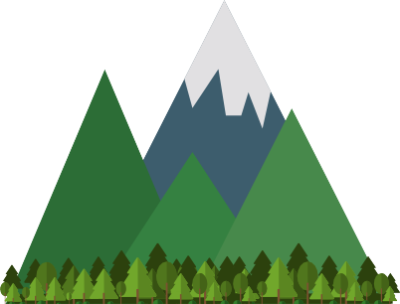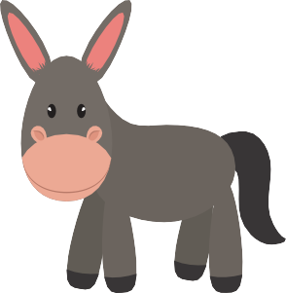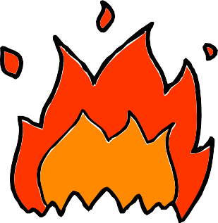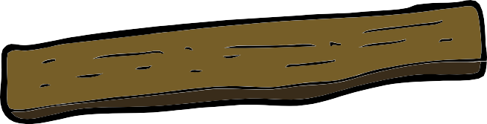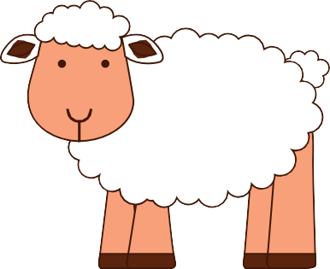

**mountain donkey**

**fire wood**

**knife lamb**

**angel bush**

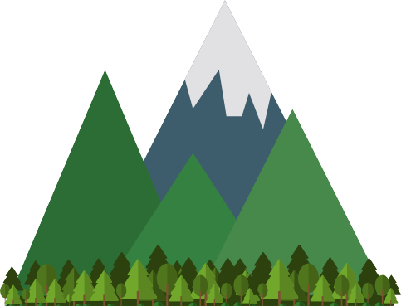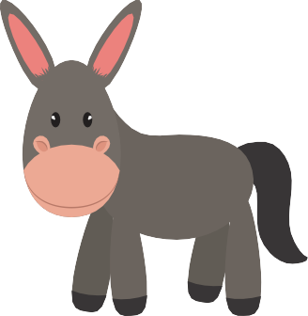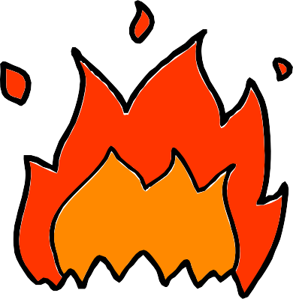

**sand beach**

**mountain**

**donkey**

**fire**

**wood**

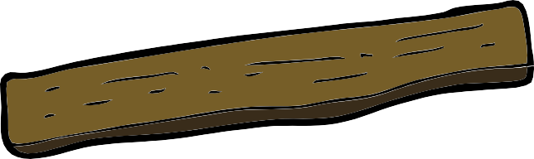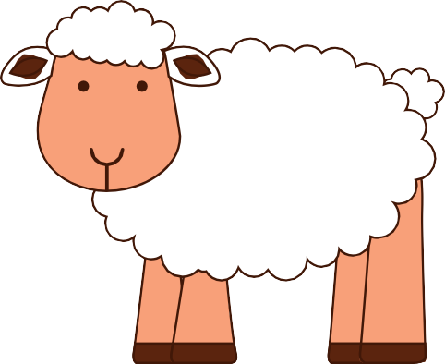

**knife**

**lamb**

**angel**



**bush**

**sand**

**beach**

