## The Birth of Christ

#### Lesson Eleven

Lesson Overview

Scripture - Luke 1:26-38 & 2:1-20 Main Point - God sent Jesus to earth as a baby to save the world. Many people rejoiced and praised God for baby Jesus, who brought hope to the world!

Craft - The Birth of Christ Song - "Away in a Manger" by Cedarmont Kids

Note to the Teacher

Before presenting this lesson, we encourage you to read the scripture passages and understand the story for yourself. This lesson plan is meant to give you direction as you teach, but it is important to share the story from your heart and allow God to lead you as you go.

Craft

Vocabulary

Materials

pre-made coloring sheet crayons, markers, pastels

baby angel town house rejoice

shepherd manger star

king Bethlehem

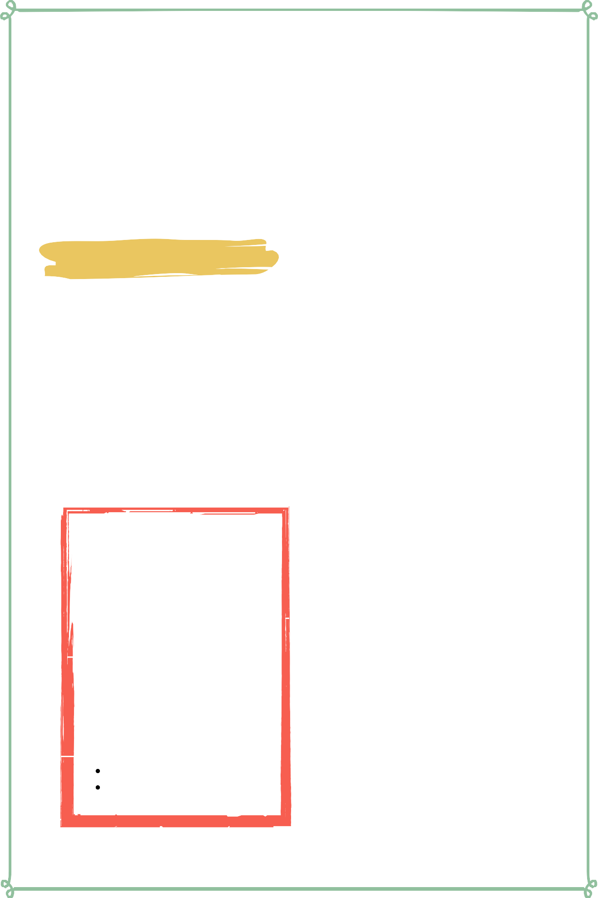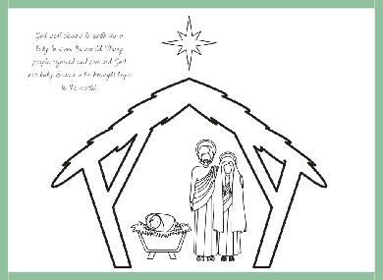

Lesson Eleven | Page 1

Lesson Outline

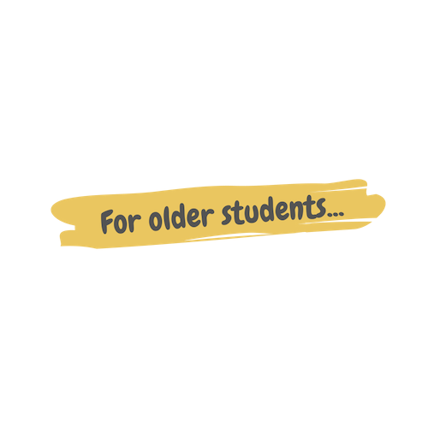

**Read the Scripture** Luke 1:26-38 & 2:1-20

**Help the children retell the story in their own words.**

What happened first? What happened next? What happened last?

**Discuss the story with the students.**

Who did God send to earth as a baby?

Who did the angel Gabriel tell about baby Jesus?

What did the shepherds do when they heard about baby Jesus?

**Discuss the story with the students.**

What does this story say about God? What does this story say about us?

What do we need to obey from this passage?

**Do the craft with the students.**

Lesson Eleven | Page 2

Craft Instructions

**Today we learned about how God sent Jesus to earth as a baby to save the world. You can complete this craft with the pre-made coloring sheet attached to the lesson and just a few supplies!**

Materials

pre-made coloring sheet

crayons, markers, pastels

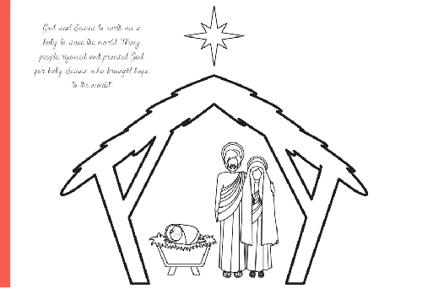

Instructions

Step 1 - Hand out the pre-made coloring sheet along with coloring supplies.

Step 2 - Remind the students about the Birth of Jesus and why it is important.

Step 3 - Allow the students to color their coloring sheet.

Step 4 - Allow the students to take their coloring sheet home to remind them of the story they learned today.

Lesson Eleven | Page 3

Vocabulary Practice

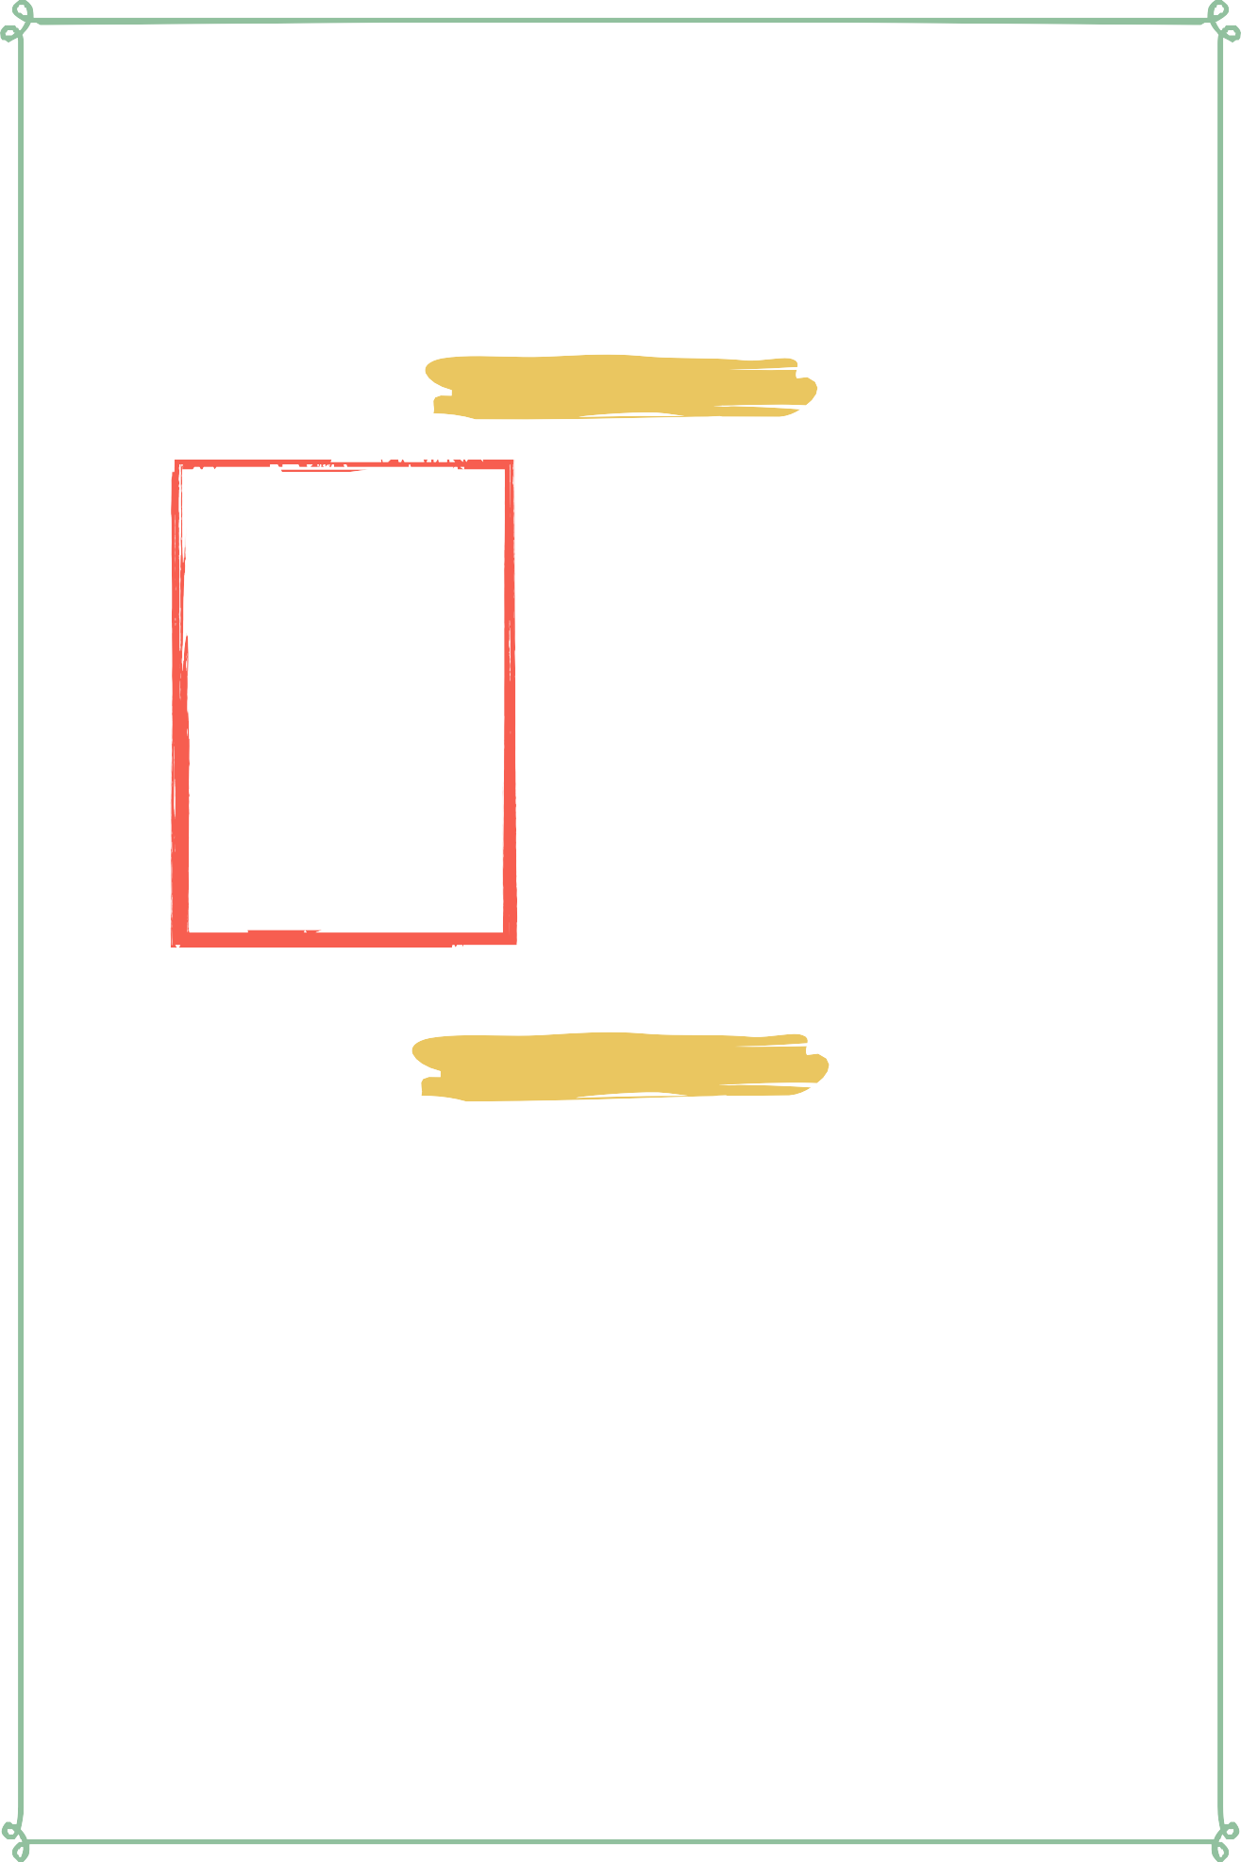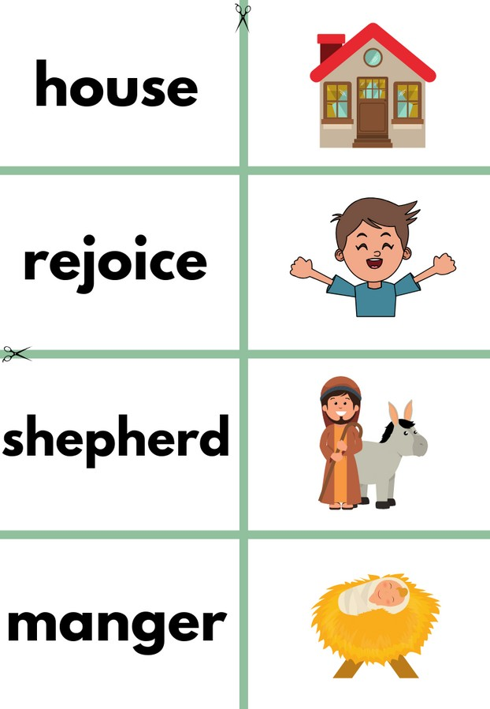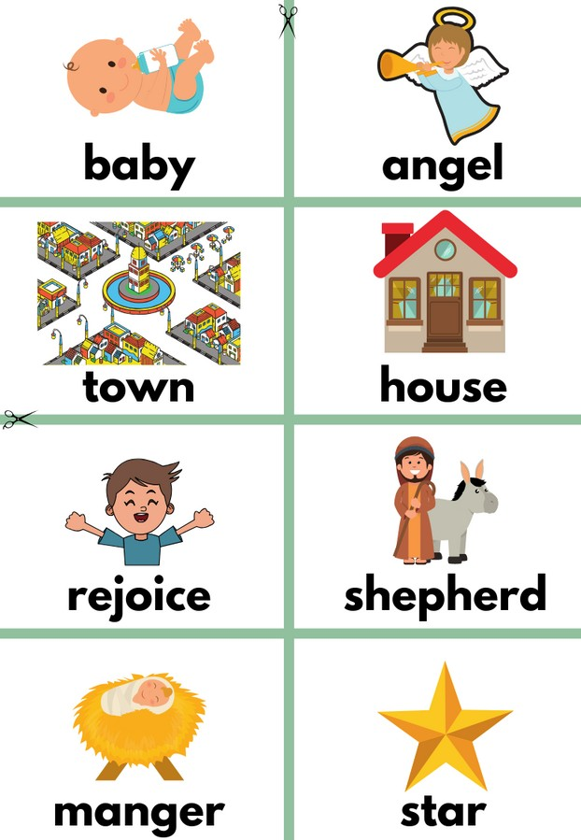

Flash Cards

Step 1- Cut out each card along the green lines.

Step 2- Use the flash cards to teach the students the English word for each picture.

Step 3- Optional: Punch a hole in the top left corner of each card. Put them on a ring and have the students practice flipping through the cards while reading each word.

Matching Game

Step 1- Cut out each card along the green lines.

Step 2- Teach the children the English words by connecting them with the corresponding picture. If you need help matching them, look at the flash cards. Step 3- Matching Game: Spread out the cards face-up on a flat surface. Make sure that they are mixed up. Have the children pick up a word or picture card and match it with the corresponding word or picture.

**Look at the following page for more ideas to use the flashcards.**

Lesson Eleven | Page 4

Vocabulary Games

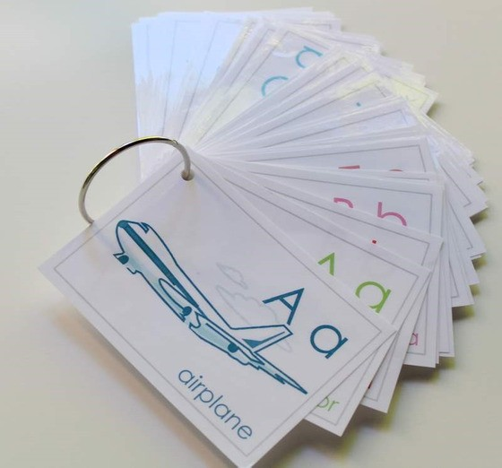

**Flashcard Game Ideas:**

The flashcards are the cards with the picture and word on the same side of the card. These flashcards are meant to help the student learn the English word for each picture. These cards can be used by putting them on a metal ring and having the student flip through the cards as they practice saying the word that goes with each picture.

**Flashcard Ring Example**

**Matching Game Ideas:**

For these four games, you can use the matching cards. The matching cards have a picture card and a word card that go together.

For this first game, start by laying the picture cards face down. (Do not use the word cards.) Have the students, one-by-one, pick up a card and flip it over and say the English word for that picture card.

For this game, lay the picture cards face-up on a flat surface. (Do not use the word cards.) Next, ask the students, one-by-one, where each picture card is. Do this by saying the English word for the picture on the card. Example: Where is the dog? Where is the door?

For this game, give each student a picture card. Then, call out one of the English words. Example: "Door". If a student has that picture card, have them hold it up, say the word, and show their friends.

For this game, lay out all of the cards (word cards and picture cards) face-up on a flat surface. One-by-one, allow the students to pick up an English word card and match it with the picture card. Try the other way by having the students pick up the picture card and match it with the English word card.

For a harder version of this game, lay all of the cards (word cards and picture cards) face-down. Have the children pick up a card and then pick up a second card. If they match, they can keep them. If they don't match they must put them back face-down and let the next student have a turn.

Lesson Eleven | Page 5

Song Lyrics

**Away in a Manger**

Away in a manger, no crib for a bed

The little Lord Jesus laid down His sweet head The stars in the sky looked down where He lay The little Lord Jesus asleep on the hay

The cattle are lowing, the poor baby wakes The little Lord Jesus no crying He makes

I love Thee Lord Jesus, look down from the sky And stay by my cradle 'til morning is night Be near me Lord Jesus, I ask Thee to stay

By me forever and love me, I pray Bless all the dear children in thy tender care And take us to heaven to live with Thee there

Away in a manger, no crib for His bed The little Lord Jesus laid down His sweet head

The stars in the heaven looked down where He lay The little Lord Jesus asleep on the hay

The little Lord Jesus asleep on the hay

https://[www.youtube.com/watch?](http://www.youtube.com/watch) v=M2ULTkNmIEY



Lesson Eleven | Page 6

**baby**

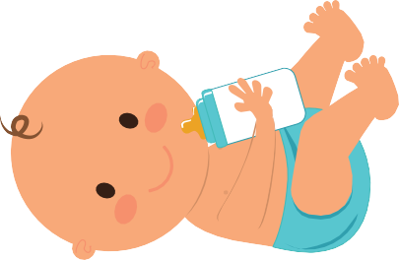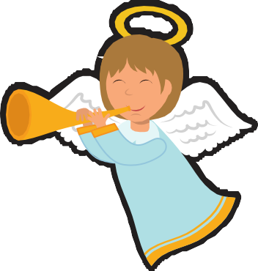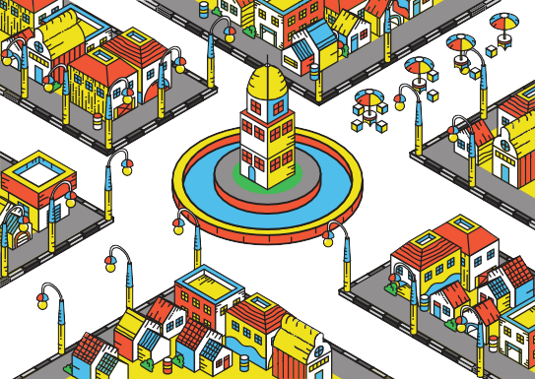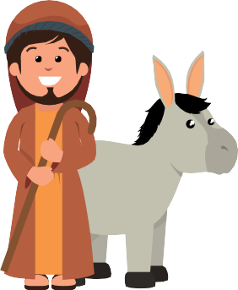

**town**

**rejoice**

**manger**

**angel**

**house**

**shepherd**

**star**

**king**

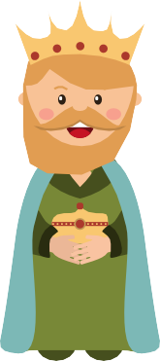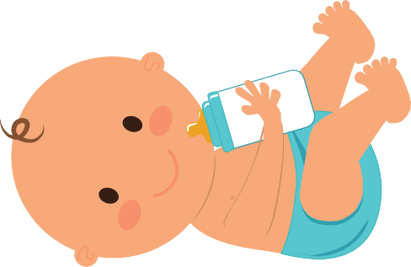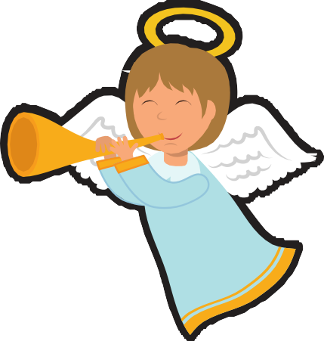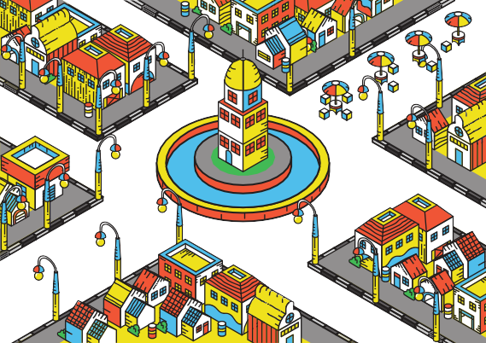

**baby**

**angel town**

**Bethlehem**

**house rejoice shepherd**

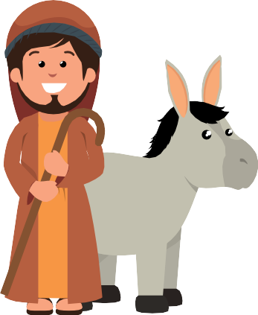

# manger

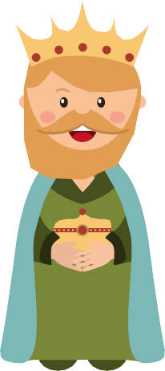

**star king**

**Bethlehem**

### God sent Jesus to earth as a

baby to save the world. Many people rejoiced and praised God for baby Jesus, who brought hope to the world!

