# God's Promise to Abram

## Lesson Six

Lesson Overview

Scripture - Genesis 12:1-8; 15:1-6 Main Point - God called Abram to leave his home to go to a land God would show Him. God promised to make Abram into a great nation.

Craft - Abram Coloring Sheet

Song - "Father Abraham"

Craft

Note to the Teacher

Before presenting this lesson, we encourage you to read the scripture passages and understand the story for yourself. This lesson plan is meant to give you direction as you teach, but it is important to share the story from your heart and allow God to lead you as you go.

Vocabulary

Materials

pre-made coloring sheet crayons, markers, pastels

family father mother baby

brother sister grandpa grandma

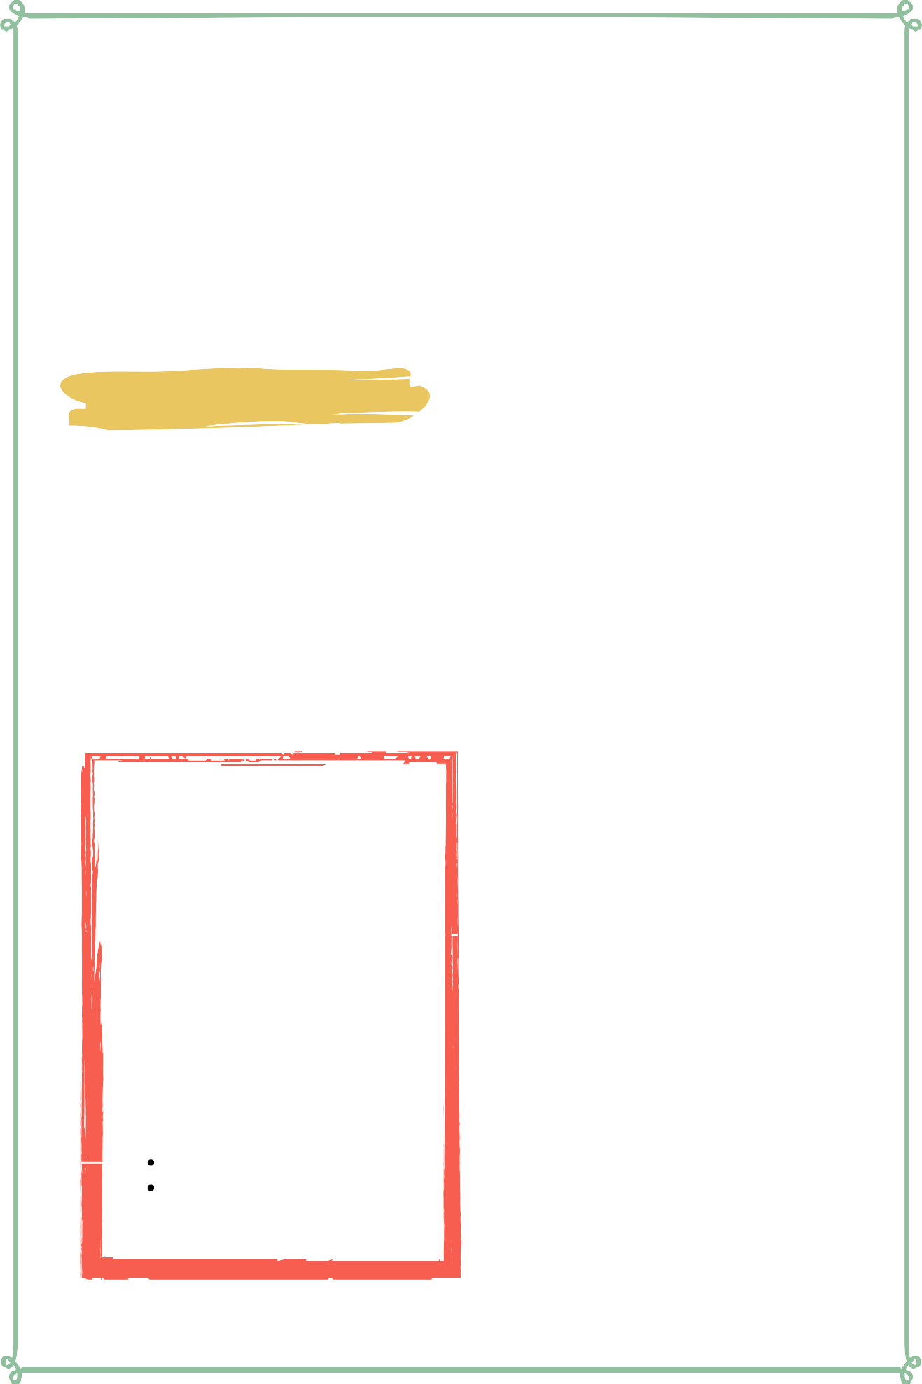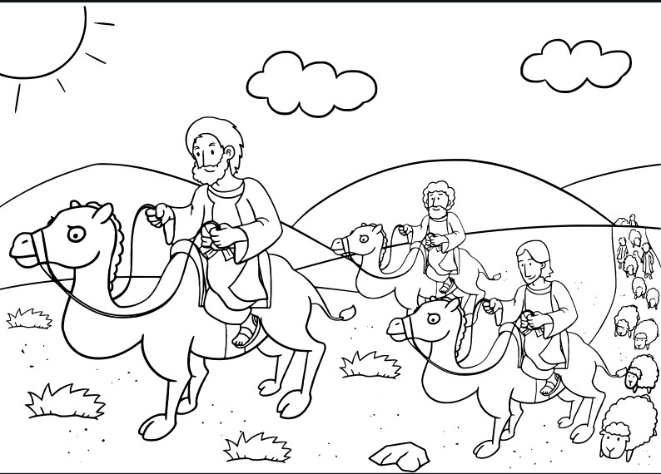

Lesson Six | Page 1

Lesson Outline



**Read the Scripture** Genesis 12:1-8; 15:1-6

**Help the children retell the story in their own words.**

What happened first? What happened next? What happened last?

**Discuss the story with the students.**

Who did Abram take with him on his journey? Did God tell Abram where to go?

What was God's promise to Abram?

**Discuss the story with the students.**

What does this story say about God? What does this story say about us?

What do we need to obey from this passage?

**Do the craft with the students.**

Lesson Six | Page 2

Craft Instructions

**In this lesson we learned about God's promise to Abram! You can use this craft with the students to help them remember the lesson that they learned today!**

Materials

pre-made coloring sheet

crayons, markers, pastels

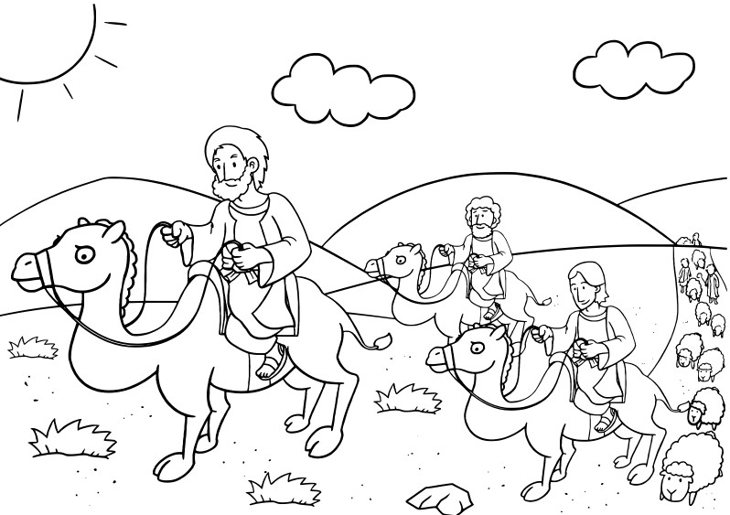

Instructions

Step 1 - Hand out the pre-made coloring sheet

Step 2 - Remind the children of how God called Abram to go to a new land and how God promised to make Abram into a great nation.

Step 3 - Allow the children to bring their coloring sheet home to remind them of the story they learned today.

Lesson Six | Page 3

Vocabulary Practice

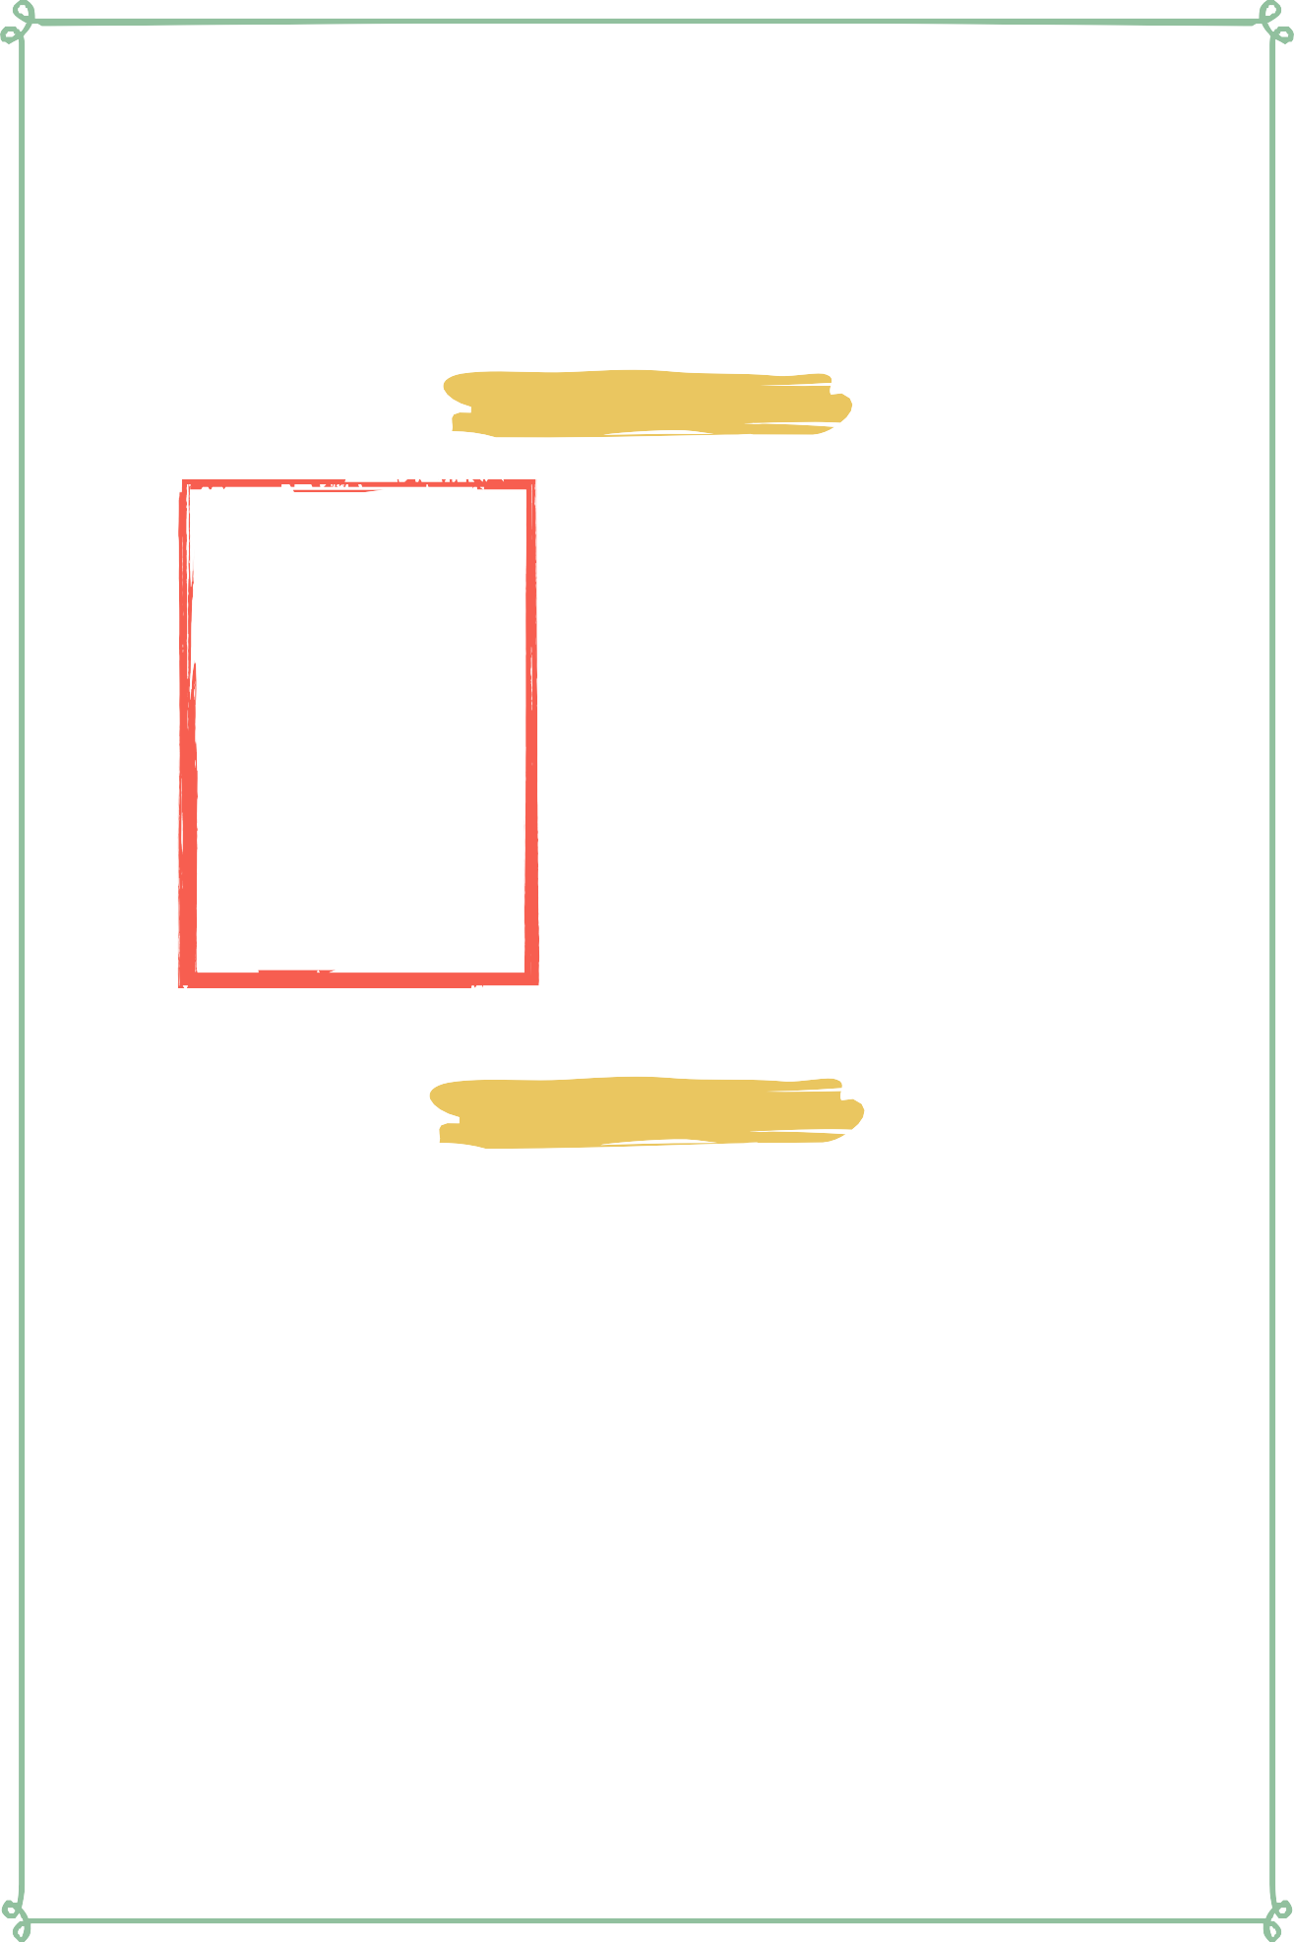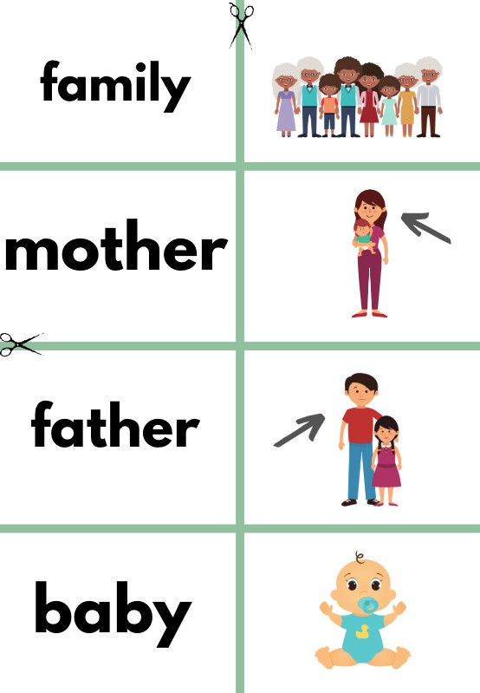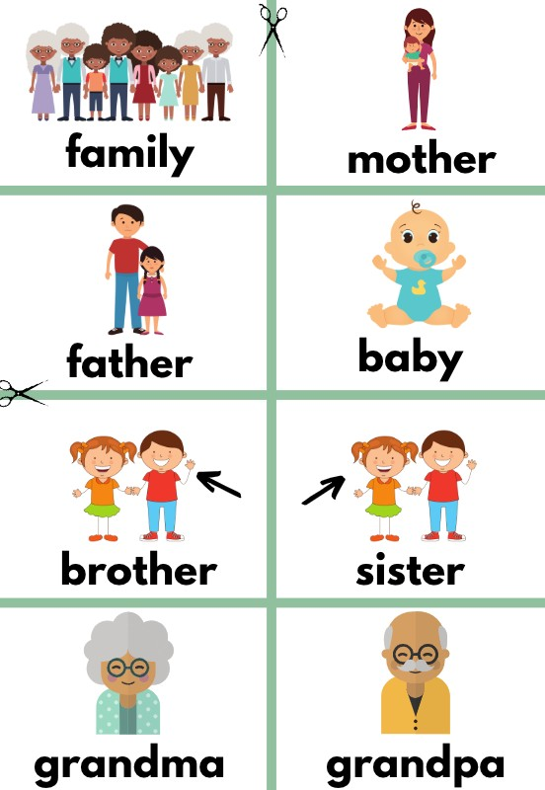

Flash Cards

Step 1- Cut out each card along the green lines.

Step 2- Use the flash cards to teach the students the English word for each picture.

Step 3- Optional: Punch a hole in the top left corner of each card. Put them on a ring and have the students practice flipping through the cards while reading each word.

Matching Game

Step 1- Cut out each card along the green lines.

Step 2- Teach the children the English words by connecting them with the corresponding picture. If you need help matching them, look at the flash cards. Step 3- Matching Game: Spread out the cards face-up on a flat surface. Make sure that they are mixed up. Have the children pick up a word or picture card and match it with the corresponding word or picture.

**Look at the following page for more ideas to use the flashcards.**

Lesson Six | Page

Song Lyrics

**Father Abraham**

Father Abraham had many sons Many sons had Father Abraham I am one of them and so are you So let's all praise the Lord.

Right arm!

Father Abraham had many sons Many sons had Father Abraham I am one of them and so are you So let's all praise the Lord.

Right arm, left arm!

Father Abraham had many sons Many sons had Father Abraham I am one of them and so are you So let's all praise the Lord.

Right arm, left arm, right foot! Father Abraham had many sons Many sons had Father Abraham I am one of them and so are you So let's all praise the Lord.

Right arm, left arm, right foot, left foot!

Father Abraham had many sons Many sons had Father Abraham I am one of them and so are you So let's all praise the Lord.

Right arm, left arm, right foot, left foot, nod your head!

Father Abraham had many sons Many sons had Father Abraham I am one of them and so are you So let's all praise the Lord.

Right arm, left arm, right foot, left foot, Nod your head, turn around

Father Abraham had many sons Many sons had Father Abraham I am one of them and so are you So let's all praise the Lord.

Right arm, left arm, right foot, left foot,

Nod your head, Turn around, Jump up and Down Clap your hands, Stomp your feet,

Say Amen Say Amen Say Amen Jump up and down, Clap your hands

and stomp your feet say amen now sit down



https://[www.youtube.com/watch?](http://www.youtube.com/watch) v=ASXowiv3FAc

Lesson Six | Page

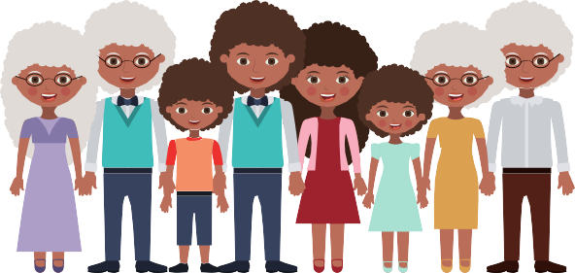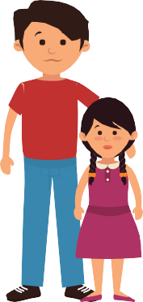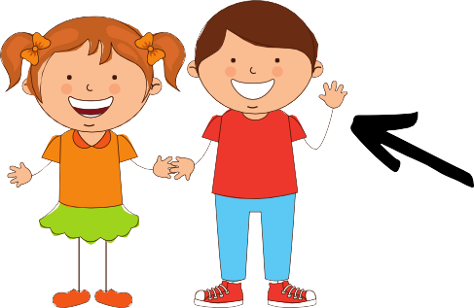

**family mother**

**father baby**

**brother sister**

**grandma grandpa**

**family mother**

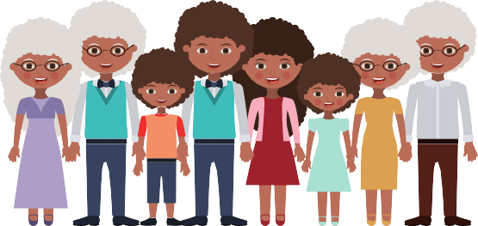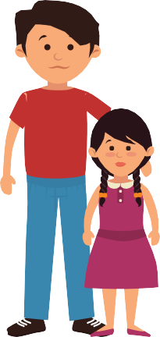

**father**

**baby**

**brother sister**

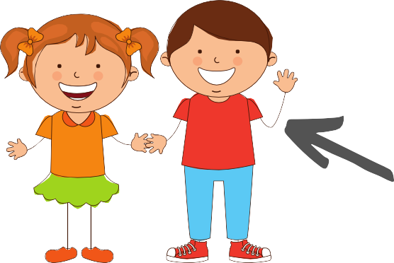

**grandma**

**grandpa**

