# "I Am Self-Controlled"

## Lesson Eight

Lesson Overview

Moral - Self-Control

Craft - A Drawing for a Friend

Song - All About Self-Control

Note to the Teacher

Before presenting this lesson, we encourage you to read through the lesson plan first so that you know the story well. This will help you present the story to the students in a way that they will understand.

Craft

Vocabulary

Materials

pre-made coloring sheet crayons, markers, pastels scissors

marker red blue green yellow

purple orange pink black white

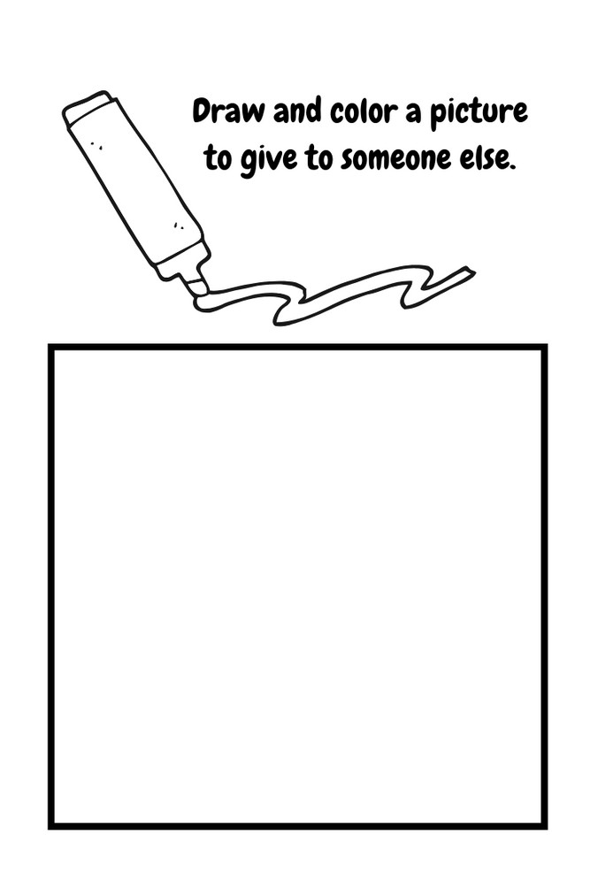

Lesson Eight | Page 1

Lesson Outline

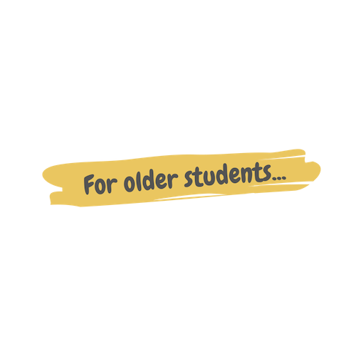

**Read the Story**

**Help the children retell the story in their own words.**

What happened first? What happened next?

What did God do on the last day?

**Discuss the story with the students.**

Were Nabila's markers new or old? Who was Nabila coloring a picture for? Who took Nabila's marker?

**Discuss the story with the students.**

Who gave Nabila her new markers?

How did Nabila feel about Ana taking her new markers? What did she do?

How can you practice self-control when you are angry?

**Do the craft with the students.**

Lesson Eight | Page 2

Story



One day Nabila was coloring with her new markers. They were beautiful and in many colors, such as red, blue, green, yellow, purple and orange. The markers were a gift from her aunt and Nabila was very happy with them. Nabila was sitting quietly coloring a beautiful picture for her aunt as a thank you gift.

When all a sudden, a younger girl name Ana came up to Nabila, reached out her hand and took hold of the blue marker. She lifted the cap and drew a big blue scribble in the middle of Nabila’s picture! Nabila froze and looked at the little girl with shock.

How could she do that?! Nabila thought. She was so angry. She wanted to yell at the girl and snatch the marker from her hand, but she knew she would probably get in trouble for that. The younger girl was very little and did not know better. Nabila realized this, and so she slowly took a deep breath in and then out. Nabila was still very angry, but she calmly said "Ana, please stop. This picture is a gift for my aunt."

Ana looked up at Nabila and became upset because Nabila was asking her to stop. She grabbed the picture and crumbled it!

Nabila's gift was destroyed. She would have to start over. This made her feel so angry that she wanted to cry and get revenge on the little girl. She wanted to push her and take her marker back. But still, she knew that it wasn't a good idea.

So, with tears in her eyes, she walked up to Miss Meva, and showed her the ruined picture.

"Oh no, Nabila, what happened?" her teacher asked.

Nabila explained everything that had happened and how she felt so angry.

"I'm sorry that happened, Nabila. I am proud of you for the self-control you showed by not taking revenge." She sweetly smiled at Nabila and reassured her that she had chosen to do the right thing.

Nabila sat back down in her seat and started a new picture for her aunt. She drew a big mountain, a yellow house, and all of her family members. When Nabila finished her drawing, she looked at it and decided that it was even better than the first one! Even though things didn’t happen the way Nabila expected, they were still good.

Lesson Eight | Page 3

Craft Instructions

**In today's story, Nabila was drawing a beautiful picture for her Aunt to say thank you.**

**Today you get to draw a picture for someone else too. You can give your drawing to anyone you want. Who are you going to choose?**

Materials

pre-made coloring sheet

crayons, markers, pastels

scissors

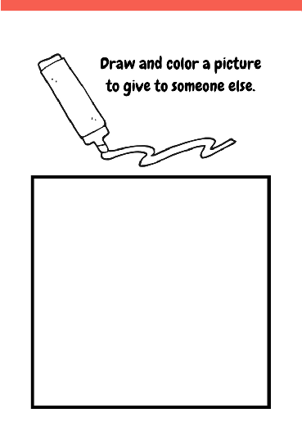

Instructions

Step 1 - Pass out one coloring sheet to each student along with crayons, markers, or pastels.

Step 2 - Each student will draw and color a picture inside the box.

Step 3 - Have the students cut their pictures out following the bold black lines.

Step 4 - Remind them to give their drawings to someone else.

Lesson Eight | Page 4

Vocabulary Practice

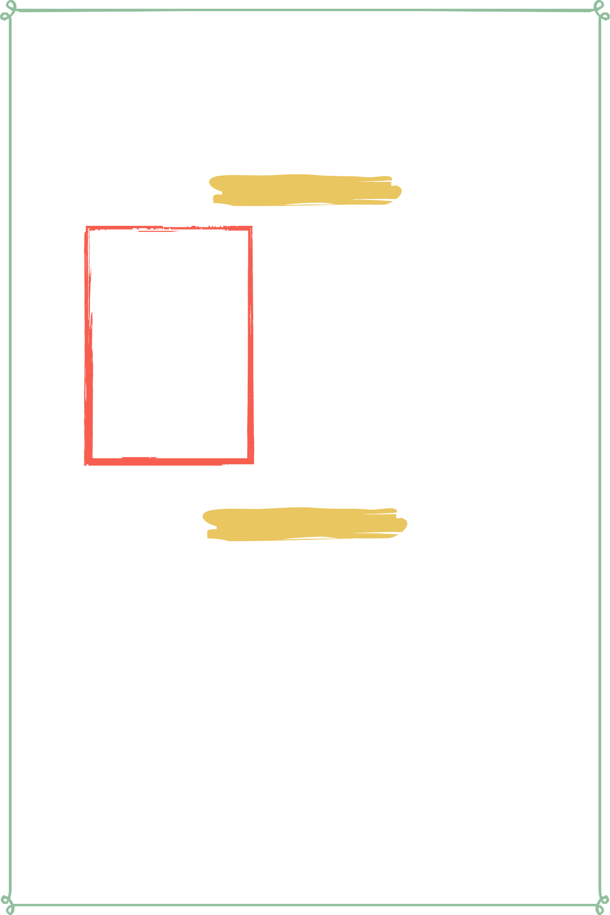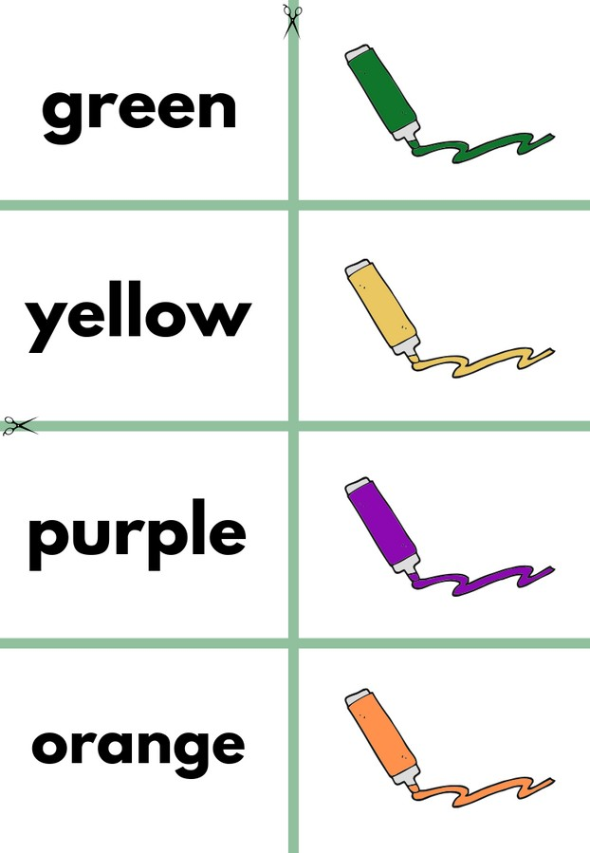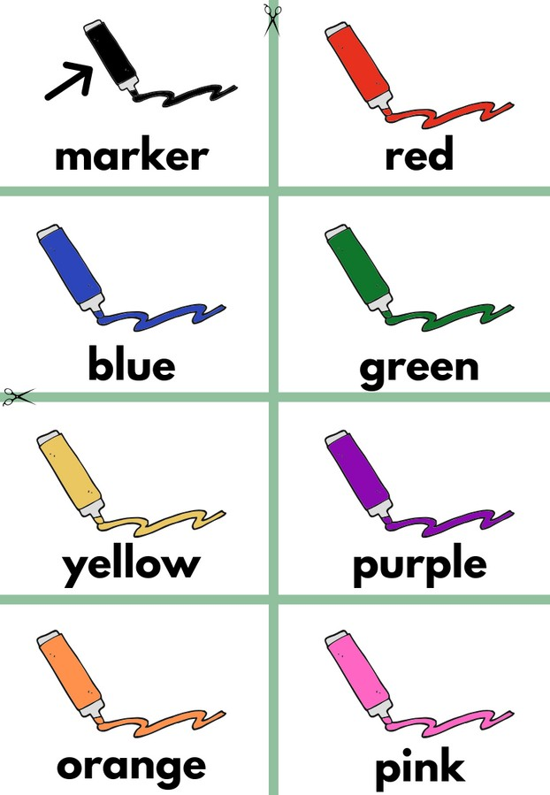

Flash Cards

Step 1- Cut out each card along the green lines.

Step 2- Use the flash cards to teach the students the English word for each picture.

Step 3- Optional: Punch a hole in the top left corner of each card. Put them on a ring and have the students practice flipping through the cards while reading each word.

Matching Game

Step 1- Cut out each card along the green lines.

Step 2- Teach the children the English words by connecting them with the corresponding picture. If you need help matching them, look at the flash cards. Step 3- Matching Game: Spread out the cards face-up on a flat surface. Make sure that they are mixed up. Have the children pick up a word or picture card and match it with the corresponding word or picture.

**Look at the following page for more ideas to use the flashcards.**

Lesson Eight | Page 5

Vocabulary Games

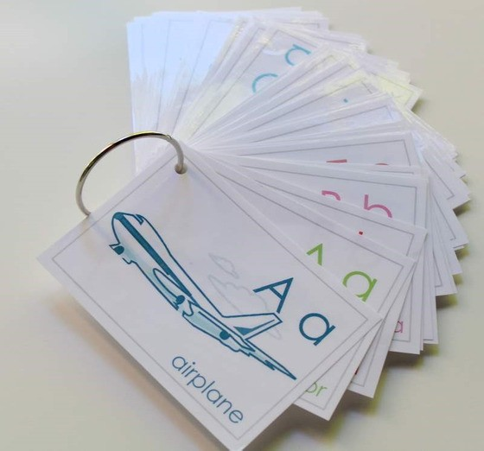

**Flashcard Game Ideas:**

The flashcards are the cards with the picture and word on the same side of the card. These flashcards are meant to help the student learn the English word for each picture. These cards can be used by putting them on a metal ring and having the student flip through the cards as they practice saying the word that goes with each picture.

**Flashcard Ring Example**

**Matching Game Ideas:**

For these four games, you can use the matching cards. The matching cards have a picture card and a word card that go together.

For this first game, start by laying the picture cards face down. (Do not use the word cards.) Have the students, one-by-one, pick up a card and flip it over and say the English word for that picture card.

For this game, lay the picture cards face-up on a flat surface. (Do not use the word cards.) Next, ask the students, one-by-one, where each picture card is. Do this by saying the English word for the picture on the card. Example: Where is the dog? Where is the door?

For this game, give each student a picture card. Then, call out one of the English words. Example: "Door". If a student has that picture card, have them hold it up, say the word, and show their friends.

For this game, lay out all of the cards (word cards and picture cards) face-up on a flat surface. One-by-one, allow the students to pick up an English word card and match it with the picture card. Try the other way by having the students pick up the picture card and match it with the English word card.

For a harder version of this game, lay all of the cards (word cards and picture cards) face-down. Have the children pick up a card and then pick up a second card. If they match, they can keep them. If they don't match they must put them back face-down and let the next student have a turn.

Lesson Eight | Page 6

Song Lyrics

**All About Self-Control**

Even when something goes wrong, take a deep breath. Stay calm. And when you're havin' fun, Bring it down, just stay calm.

Even when things don't go your way, you have to use self- control. We all get mad, every now and then. But you have to know how to be calm again! Here's a little trick that you can do... take a deep breath and that'll calm you. We all get sad, every now and then, But you have to know how to be calm again. Here's a little trick that you can do, think happy thoughts and that'll calm you. Even when something goes wrong, take a deep breath. Stay calm. Even when you're havin' fun, Bring it down. Just stay calm. Even when you get excited, you have to use self-control. of course its okay to have a lot of fun, But you have to know how to bring it down and be calm. When something goes well, you cannot yell! When you're on the winning team, you don't have to scream! Let me break it down for ya! When something is great, you can celebrate! But watch your volume, are you loud? Are you bumpin' into the crowd?

Control your body and control your words. Gettin' all wild is really absurd. Even when somethin' goes wrong, Take a deep breath, stay calm. Even when you're havin' fun, Bring it down, just stay calm. Even when you're just jokin' around, you have to use self-control. I know that you're jokin', you're only playin'. But control your body and what you're sayin. "We were just bein' silly man", Is not an excuse for when you ran! "We were just bein' silly man", is not an excuse to name-call a friend! You are accountable for what you say! So choose your words wisely every day! Even when something goes wrong, take a deep breath. Stay calm. Even when you're havin' fun! Bring it down, just stay calm.

https://[www.youtube.com/watch?](http://www.youtube.com/watch) v=BK25r16Bv3A



Lesson Eight | Page 7

**marker**

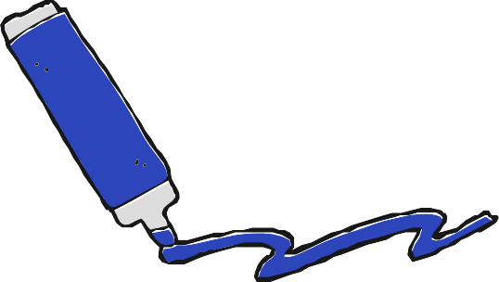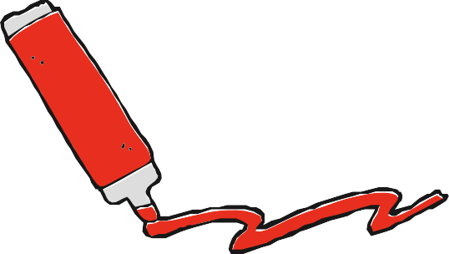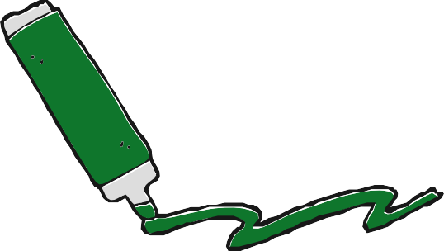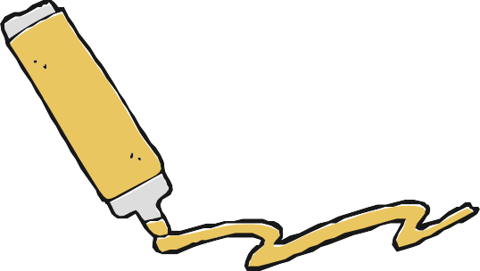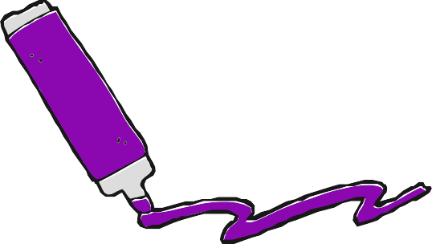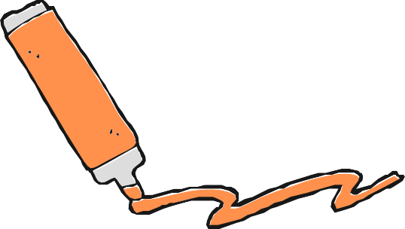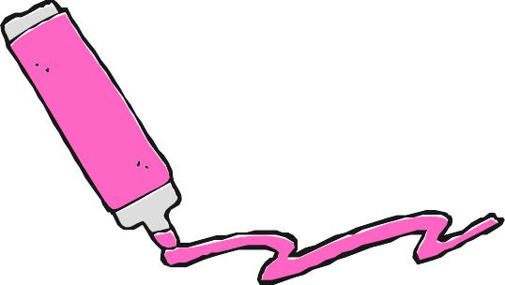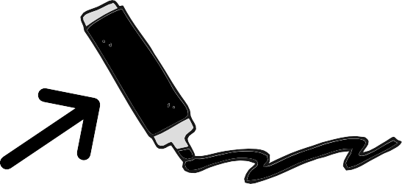

**blue**

**yellow**

**orange**

**red**

**green**

**purple**

**pink**

**black**

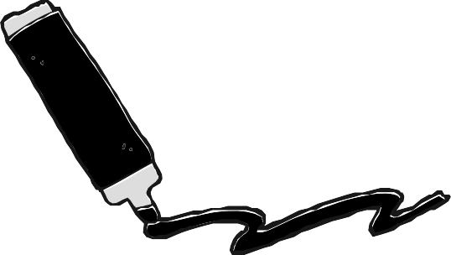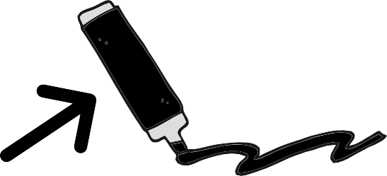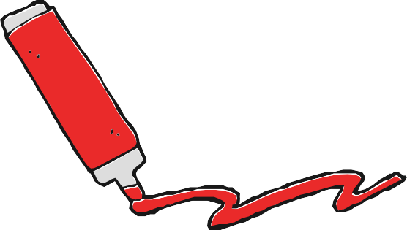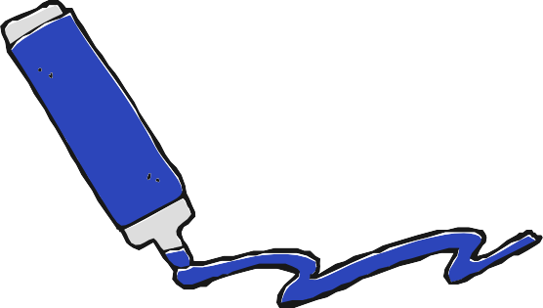

**marker**

**red blue**

**white**

**green yellow purple**

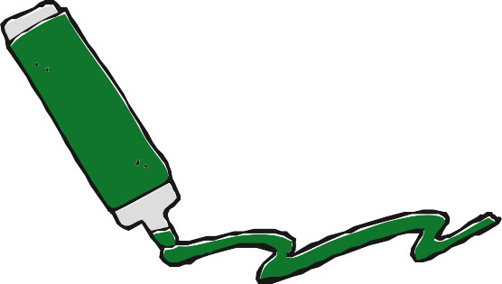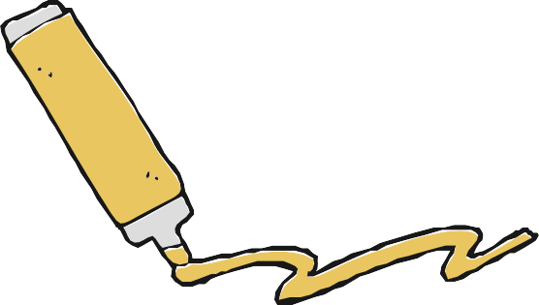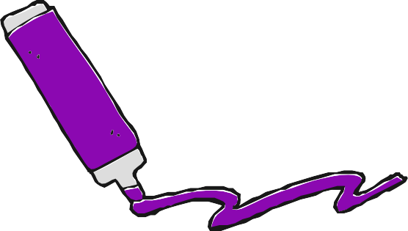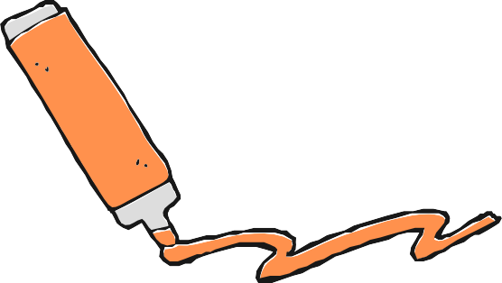

**orange**

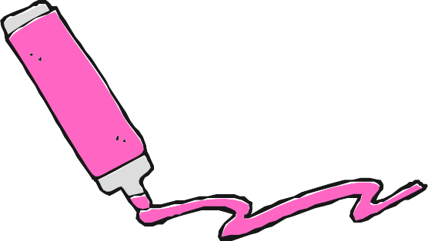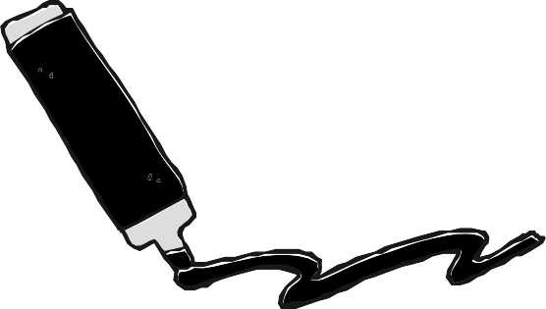

**pink black white**

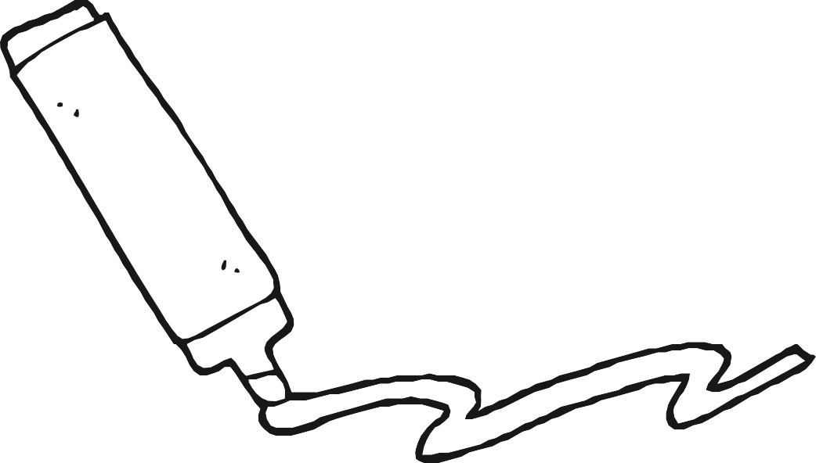Draw and color a picture to give to someone else.