# "I Am Forgiving"

### Lesson Seventeen

Lesson Overview

Moral - Forgiveness

Craft - Forgiveness Hands Song - "Nobody's Perfect (Forgive and Forget)"

Note to the Teacher

Before presenting this lesson, we encourage you to read through the lesson plan first so that you know the story well. This will help you present the story to the students in a way that they will understand.

Craft

Vocabulary

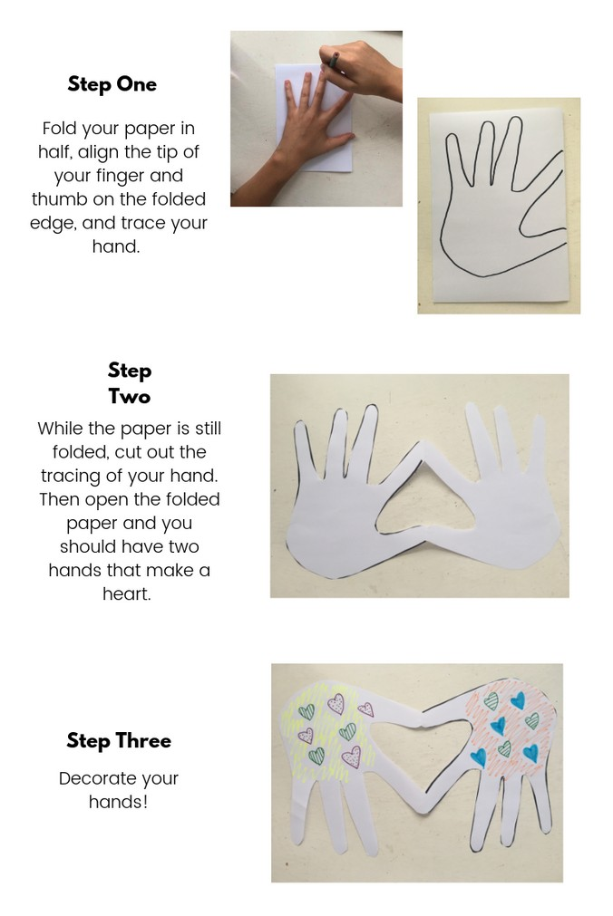

Materials

white paper scissors

crayons, markers, pastels

flower flour son sun eight

ate mail male knight night

# Lesson Outline

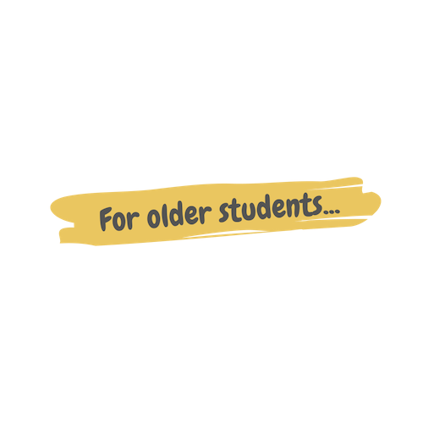

**Read the Story**

##### Help the children retell the story in their own words.

What happened first? What happened next? What happened last?

**Discuss the story with the students.**

Where were Nabil and Nabila in this story? Why was Nabil mad at Nabila?

What did Nabil and Nabila do to fix the problem?

**Discuss the story with the students.**

Why were Nabila and Nabila mad at one another? What did they do to fix the problem?

What should you do when you have a problem with your friend?

**Do the craft with the students.**

Story



One day on the island, Nabil and Nabila had gotten into a fight. Nabil was on one side of the playground and Nabila on the other. They hadn't spoken a word to each other all day, and neither of them were planning to.

Nabil stood by the swings when his friend Rio suggested everyone play a game of tag. "Let's invite Nabila to play!" he exclaimed.

"No!" Nabil protested. "I don't want her to play with us." "Why not?"

"Well, because I'm mad at her right now. She told my mom that I did something that I didn't even do and my mom grounded me! I can't go play badminton tonight because of her!"

All the way across the playground, Nabila and her friend Adi were having a similar conversation.

"Do you know why he's mad?" Adi asked Nabila.

"No, I didn't even do anything!" Nabila crossed her arms across her chest and grunted. “He's mad for no reason so now I'm mad at him."

"You should ask him why he’s angry." Adi spoke confident that that was the solution. "Then you guys can resolve the problem, and we can all play together again."

"No!" Nabila insisted.

Adi looked at her sternly. They both knew the right thing to do.

Nabila sighed, "Okay." She grabbed her backpack and marched across the playground towards her friend Nabil. Adi followed closely behind.

Nabil saw her coming and tried to get away but Rio stopped him. Finally Nabila stood before him.

# Story



"Nabil, I demand to know why you're mad at me! I didn't even do anything!"

"That's so not true Nabila. You lied!"

Nabila gasped. She was shocked at his suggestion. "I did not!" "You lied to my mom, and now I'm grounded because of you!"

"That's not true!" Nabila recalled what had happened the day before and told Nabil her side of the story, making sure to not leave any details out. She was determined to explain the whole, truthful story.

Nabil began to understand why his mom had grounded him, and he realized that it wasn't Nabila's fault at all. His heart felt a little sad because he had hurt his friend's feelings. "Nabila, I'm sorry. I didn't realize what had happened. Will you please forgive me?"

Nabila sighed. Nabil had hurt her feelings, but she knew that forgiveness was the right thing to do. "Okay, yes Nabil, I forgive you."

"Thanks Nabila." They both smiled.

"Sweet!" Rio exclaimed. "Can we play tag now?"

The four friends had a good time playing together until they all had to go back to class.

# Craft Instructions

**Today we learned about forgiveness! You can complete this craft with just a few supplies!**

Materials

white paper crayons, markers, pastels

scissors

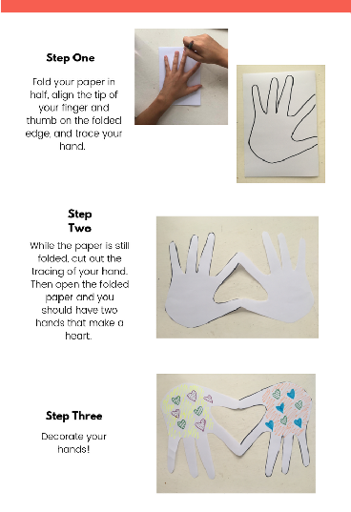

Instructions

Step 1 - Hand out the craft supplies to the students.

Step 2 - Remind the students of today's lesson about forgiveness.

Step 3 - Follow the instructions on the craft page.

Step 4 - Allow the students to bring their craft home to remind them of today's lesson.

# Vocabulary Practice

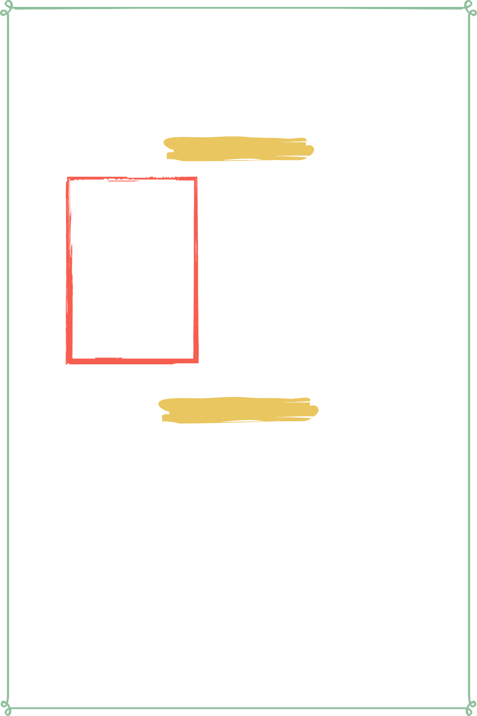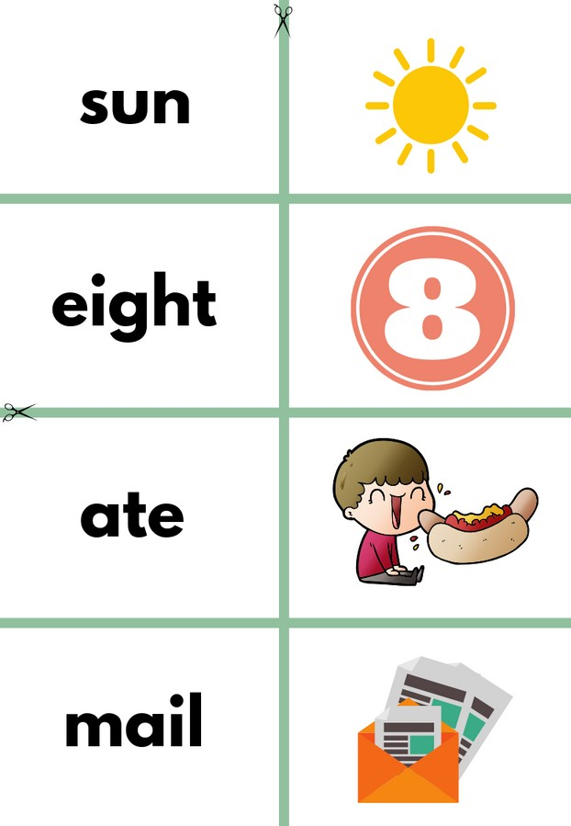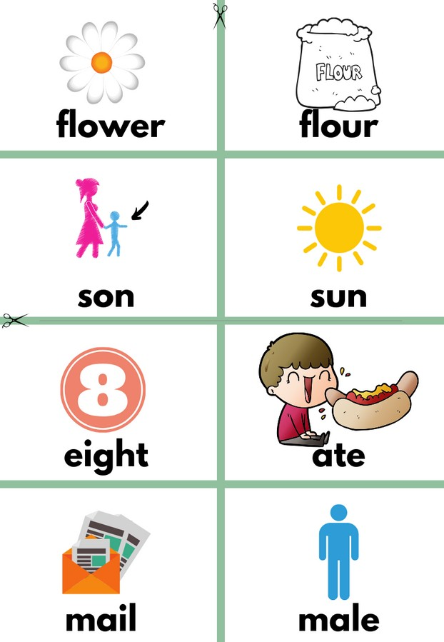

## Flash Cards

Step 1- Cut out each card along the green lines.

Step 2- Use the flash cards to teach the students the English word for each picture.

Step 3- Optional: Punch a hole in the top left corner of each card. Put them on a ring and have the students practice flipping through the cards while reading each word.

Matching Game

Step 1- Cut out each card along the green lines.

Step 2- Teach the children the English words by connecting them with the corresponding picture. If you need help matching them, look at the flash cards. Step 3- Matching Game: Spread out the cards face-up on a flat surface. Make sure that they are mixed up. Have the children pick up a word or picture card and match it with the corresponding word or picture.

**Look at the following page for more ideas to use the flashcards.**

Vocabulary Games

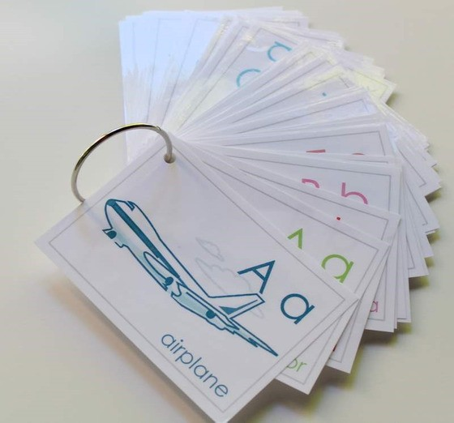

**Flashcard Game Ideas:**

The flashcards are the cards with the picture and word on the same side of the card. These flashcards are meant to help the student learn the English word for each picture. These cards can be used by putting them on a metal ring and having the student flip through the cards as they practice saying the word that goes with each picture.

**Flashcard Ring Example**

**Matching Game Ideas:**

For these four games, you can use the matching cards. The matching cards have a picture card and a word card that go together.

For this first game, start by laying the picture cards face down. (Do not use the word cards.) Have the students, one-by-one, pick up a card and flip it over and say the English word for that picture card.

For this game, lay the picture cards face-up on a flat surface. (Do not use the word cards.) Next, ask the students, one-by-one, where each picture card is. Do this by saying the English word for the picture on the card. Example: Where is the dog? Where is the door?

For this game, give each student a picture card. Then, call out one of the English words. Example: "Door". If a student has that picture card, have them hold it up, say the word, and show their friends.

For this game, lay out all of the cards (word cards and picture cards) face-up on a flat surface. One-by-one, allow the students to pick up an English word card and match it with the picture card. Try the other way by having the students pick up the picture card and match it with the English word card.

For a harder version of this game, lay all of the cards (word cards and picture cards) face-down. Have the children pick up a card and then pick up a second card. If they match, they can keep them. If they don't match they must put them back face-down and let the next student have a turn.

# Song Lyrics

### Nobody's Perfect (Forgive and Forget)

###### Nobody's perfect We all make mistakes

Its good to forgive and forget No one likes to get left in the rain

But good friends are never forgotten Feelings hurt, you fear the worst

And I know that made you feel rotten

Nobody's perfect We all make mistakes Try not to get too upset

Next thing you know, you're letting it go It's good to forgive and forget

It's good to forgive and forget



https://[www.youtube.com/watch?v=PuLo7dsflaI](http://www.youtube.com/watch?v=PuLo7dsflaI)

Lesson Seventeen | Page 8

**flower**

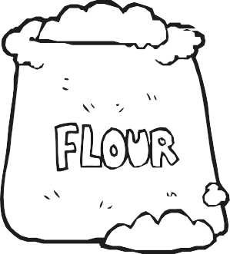

**son**

**eight**

**mail**

**flour**

**sun**

**ate**

**male**

**knight**

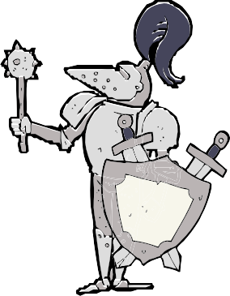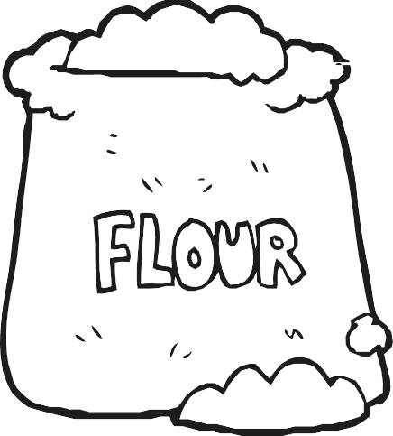

**flower**

**flour**

**night**

**sun eight ate**

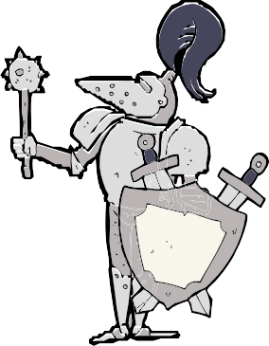

**male knight night**

#### Step One

Fold your paper in half, align the tip of your finger and thumb on the folded edge, and trace your hand.

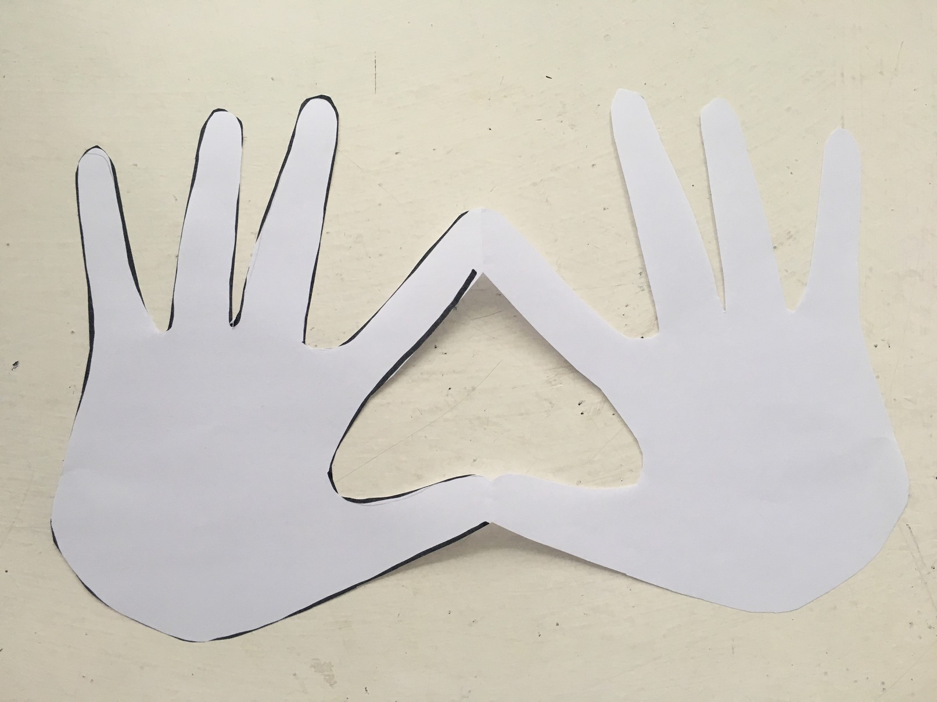**Step Two**

While the paper is still folded, cut out the tracing of your hand.

Then open the folded paper and you should have two hands that make a heart.

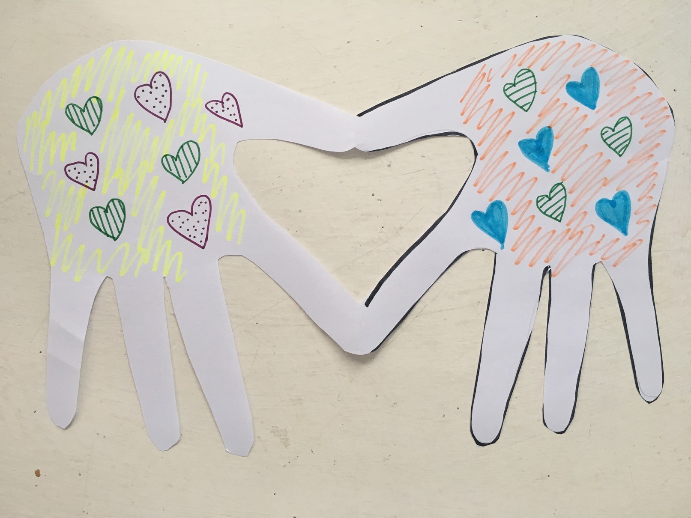**Step Three**

Decorate your hands!