### The Fall-The Flood

###### Lesson Five

Lesson Overview

Scripture - Genesis 6:11-22; 7:6-10, 17-

23; 8:1-4, 15-17, 20-22; 9:12-17

Main Point - The world grew and God saw that all humans were sinful, except one family who loved God. God decided to flood the world, but made a covenant with one family to carry on God's plan in the world.

Craft - Rainbow covenant craft

Song - The Arky, Arky song

Craft

Note to the Teacher

Before presenting this lesson, we encourage you to read the scripture passages and understand the story for yourself. This lesson plan is meant to give you direction as you teach, but it is important to share the story from your heart and allow God to lead you as you go.

#### Vocabulary

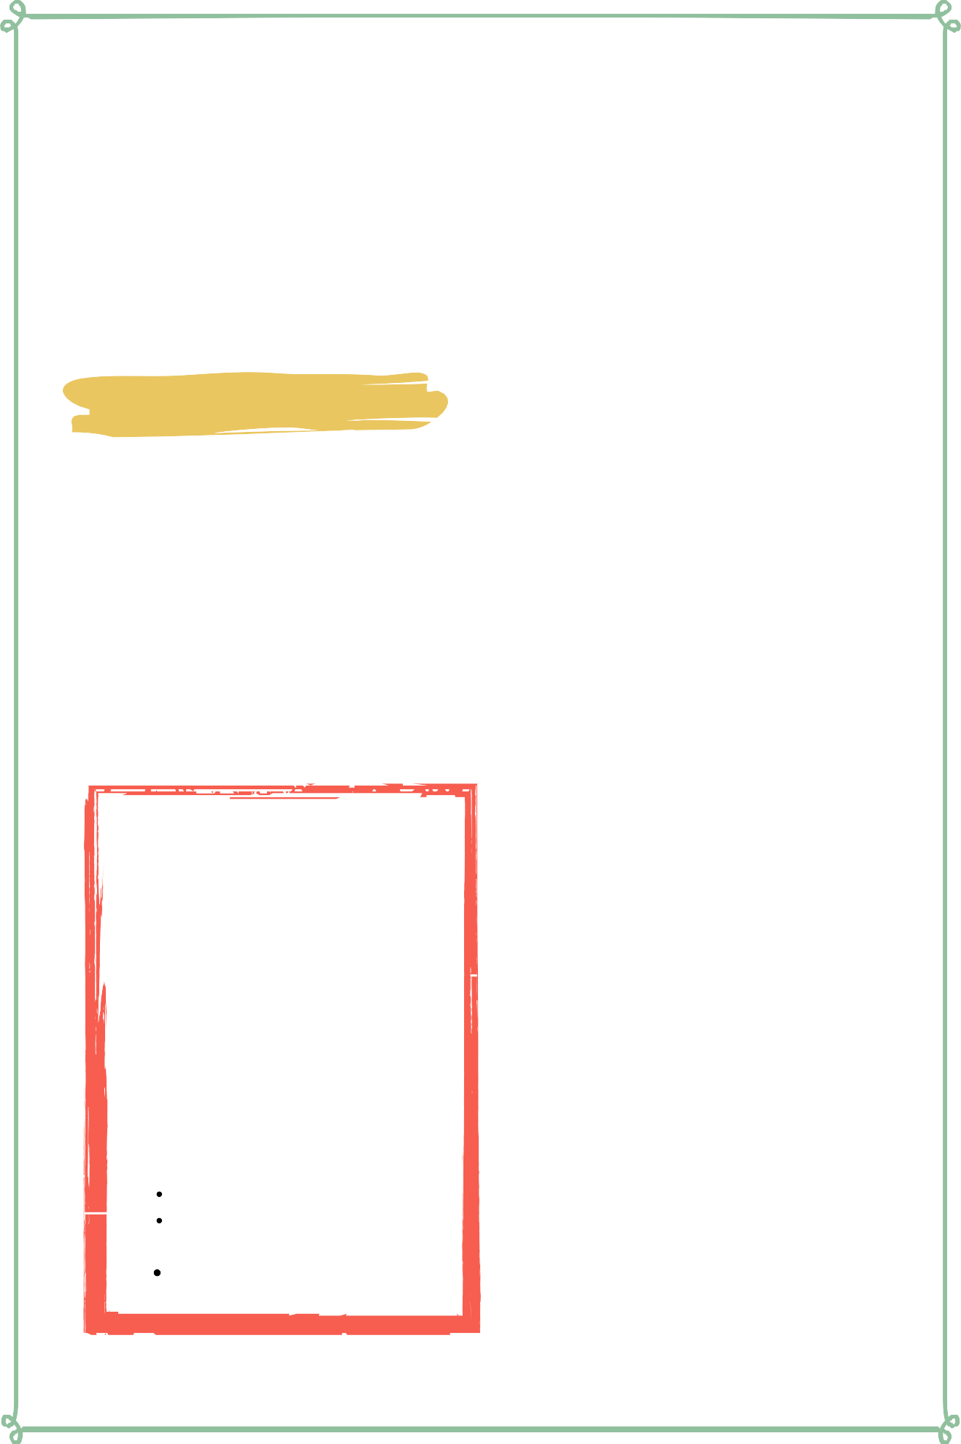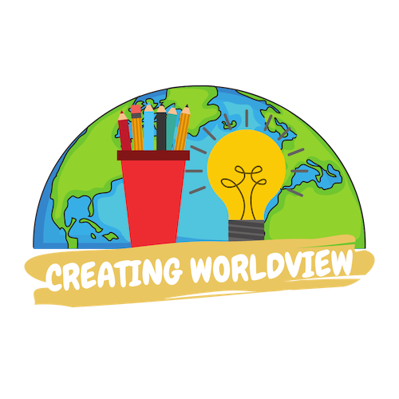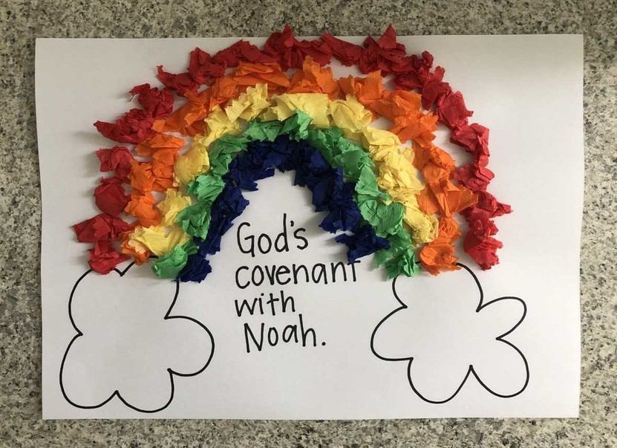

Materials

pre-made coloring sheet crepe paper (red, orange, yellow, green, and blue) glue

family dog cat

elephant bear

lion fish

chicken cow boat

### Lesson Outline

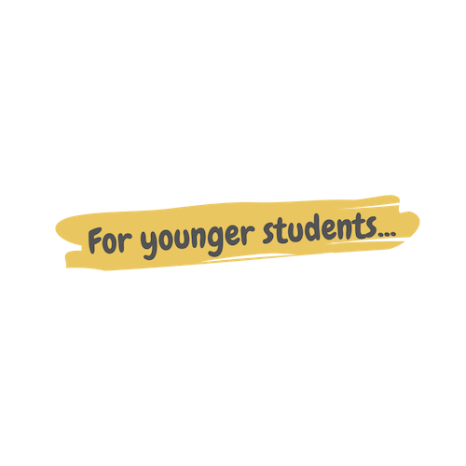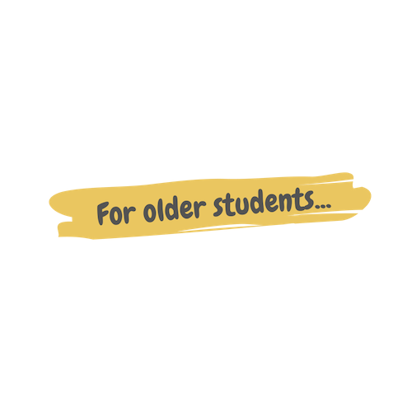

**Read the Scripture** Genesis 6-9

Help the children retell the story in their own words.

What happened first? What happened next? What happened last?

**Discuss the story with the students.**

What did Noah build? Who got on the ark?

What did God put in the sky to remind Noah and his family of the covenant?

**Discuss the story with the students.**

What does this story say about God? What does this story say about us?

What do we need to obey from this passage?

**Do the craft with the students.**

Craft Instructions

**In this lesson we learned about the flood and God's covenant with Noah! You can use this craft with the students to help them remember the lesson that they learned today!**

Materials

Pre-made coloring sheet

Crepe Paper (red, orange, yellow, green and blue) Glue

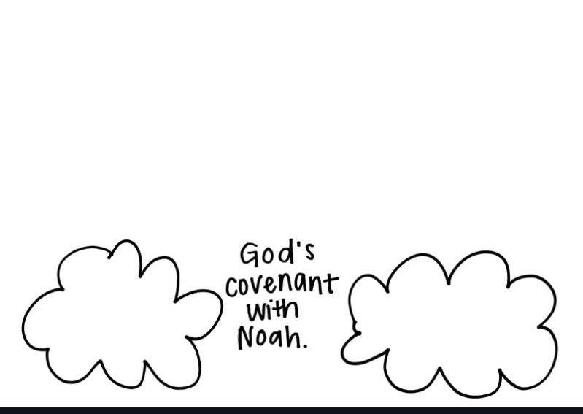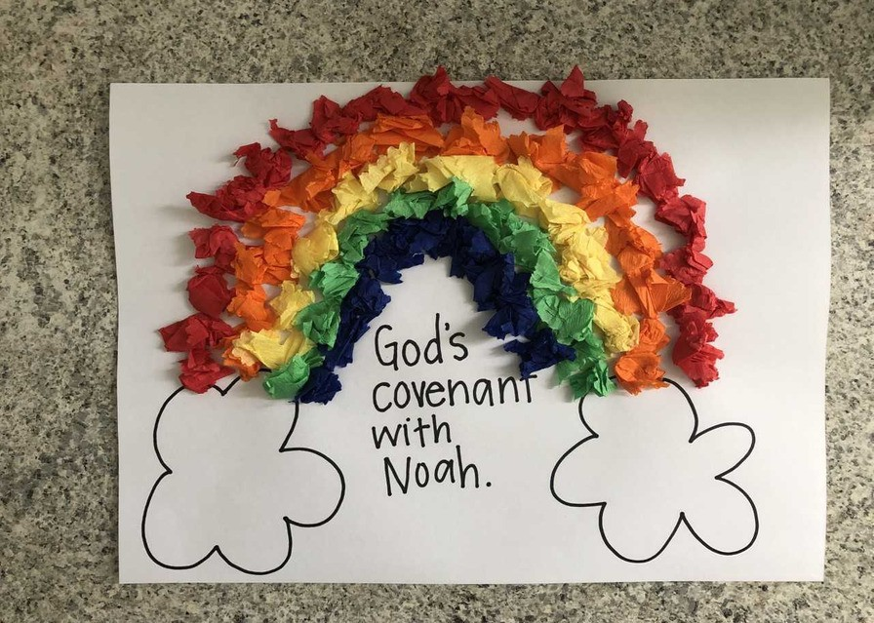

Instructions

Note: Before doing this craft with the students, cut the crepe paper into small squares.

Step 1 - Hand out the pre-made coloring sheet.

Step 2 - Explain to the students how to glue the crepe paper onto the pre-made coloring sheet in the shape of a rainbow.

Step 3 - Allow the children to glue the crepe paper onto their own coloring sheet. Talk about how the rainbow is a reminder of the covenant that God made with Noah.

Step 4 - Allow the children to bring their coloring sheet home or hang it on your classroom walls.

### Vocabulary Practice

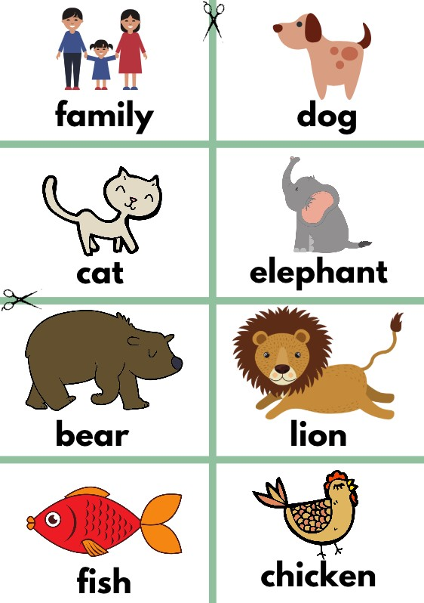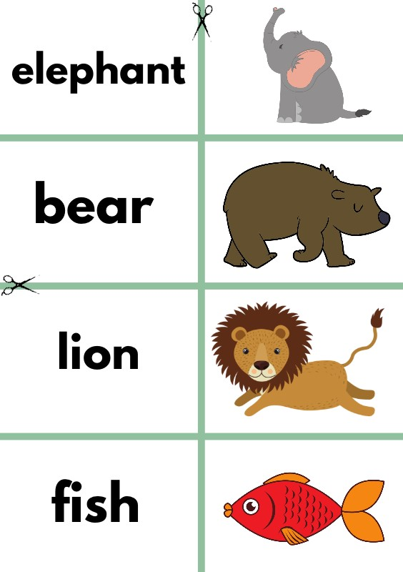

##### Flash Cards

Step 1- Cut out each card along the green lines.

Step 2- Use the flash cards to teach the students the English word for each picture.

Step 3- Optional: Punch a hole in the top left corner of each card. Put them on a ring and have the students practice flipping through the cards while reading each word.

Matching Game

Step 1- Cut out each card along the green lines.

Step 2- Teach the children the English words by connecting them with the corresponding picture. If you need help matching them, look at the flash cards. Step 3- Matching Game: Spread out the cards face-up on a flat surface. Make sure that they are mixed up. Have the children pick up a word or picture card and match it with the corresponding word or picture.

**Look at the following page for more ideas to use the flashcards.**

Song Lyrics

**The Arky, Arky Song**

The Lord said to Noah, theres gonna be a floody floody, Lord said to Noah theres gonna be a floody, floody

Get those children out of the muddy muddy, Children of the Lord

The Lord told Noah to build him an arky, arky The Lord told Noah to build him an arky, arky

Build it out of gopher barky, barky, Children of the Lord He called for the animals they came in by twosies, twosies,

called for the animals they came in by twosies, twosies Elephants and kangaroosie, roosies, Children of the Lord

It rained and poured for forty long daysies, daysies It rained and poured for forty long daysies, daysies

Almost drove those animals crazy, crazy, Children of the Lord Then Noah he sent out he sent out a dovie dovie Noah he sent out he sent out a dovie dovie

Dovie said theres clear skies abovie, bovie, Children of the Lord

The sun came out, and dried up the landy, landy The sun came out, and dried up the landy, landy

Everything was fine and dandy, dandy, children of the Lord The animals they came of they came off by three-sies three- sies The animals they came of they came off by three-sies three-sies Grizzly bears and chimpanzee-sies, zee-sies, Children of the Lord

So, rise and shine, and give God the glory, glory Rise and shine, and give God the glory, glory Rise and shine, and give God the glory, glory Children of the Lord

Children of the Lord Children of the Lord

https://[www.youtube.com/watch?](http://www.youtube.com/watch) v=4r78BLBszQ0



Lesson Five | Page 5

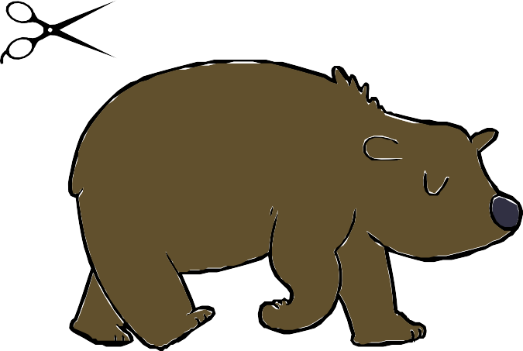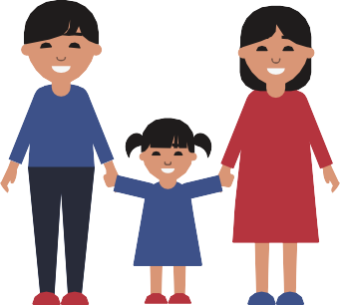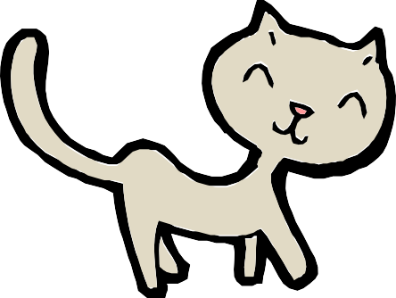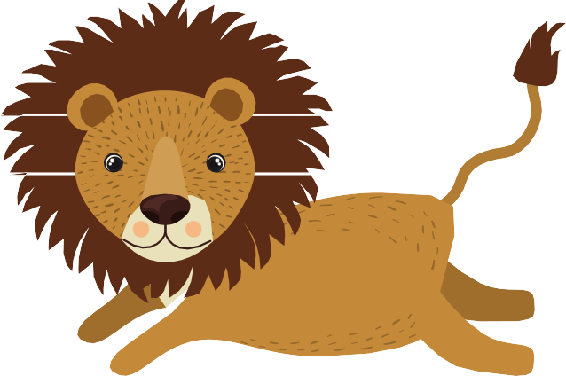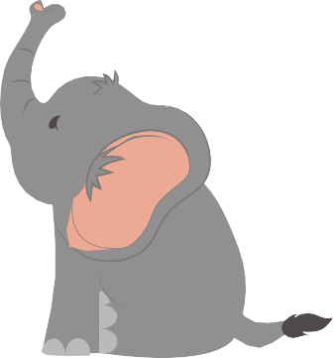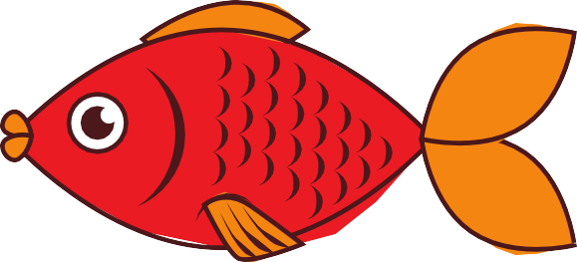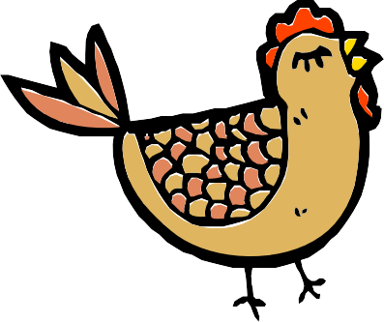

**family dog**

**cat elephant**

**bear lion**

**fish chicken**

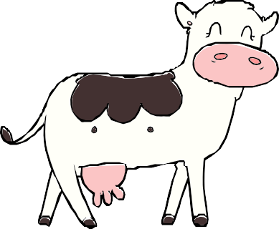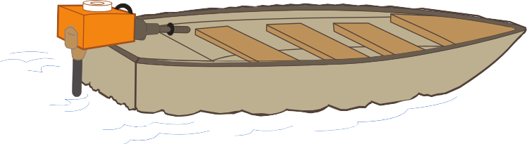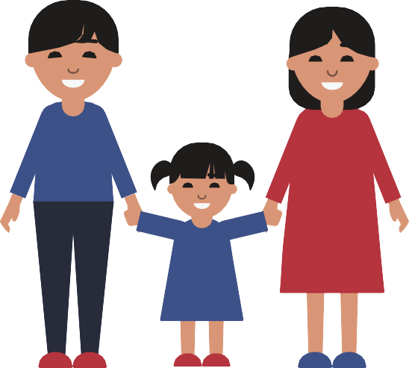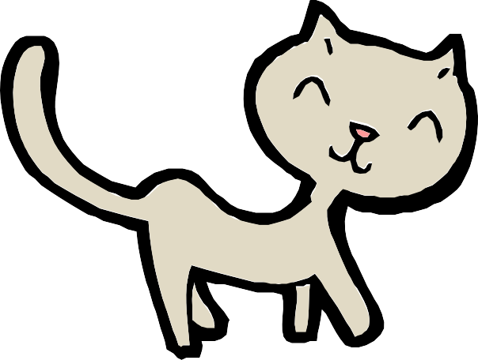

**cow boat**

**family**

**dog**

**elephant**

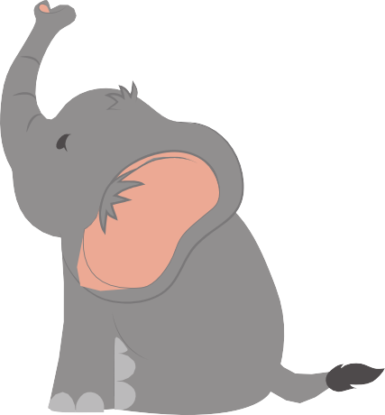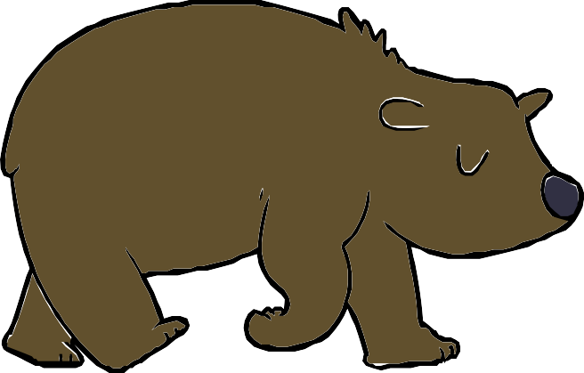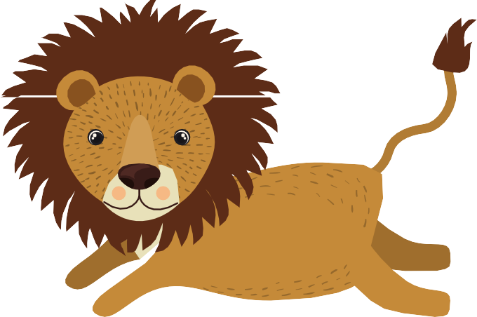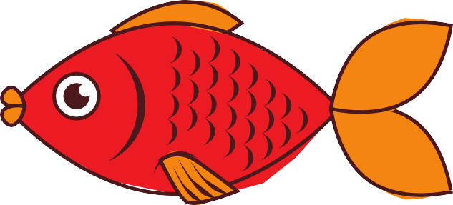

# bear

## lion

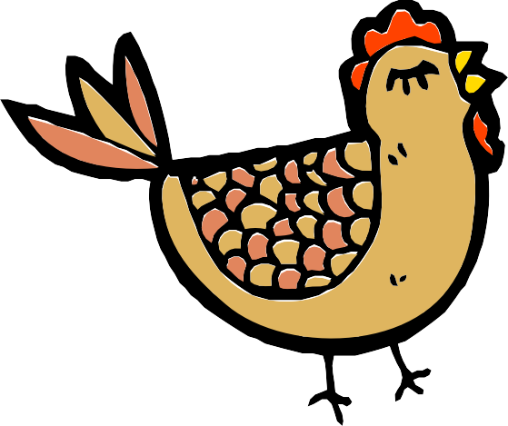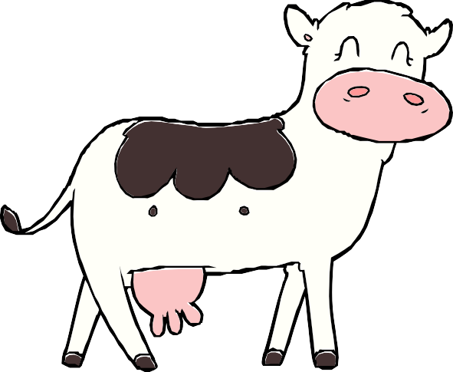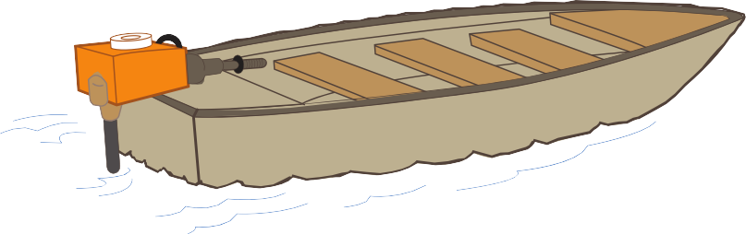

**chicken cow boat**

