# The Lord's Supper

## Lesson Fifteen

Lesson Overview

Scripture - Matthew 26:26-30 Main Point - Jesus had a supper with His twelve disciples before dying on the cross and Jesus wanted them to remember HIs sacrifice by having what we now call communion.

Craft - Communion Craft

Song - "A Gift to You"

Craft

Note to the Teacher

Before presenting this lesson, we encourage you to read the scripture passages and understand the story for yourself. This lesson plan is meant to give you direction as you teach, but it is important to share the story from your heart and allow God to lead you as you go.

Vocabulary

Materials

pre-made coloring sheet crayons, markers, pastels

eat fork spoon bowl plate

cup pot cook stove bread

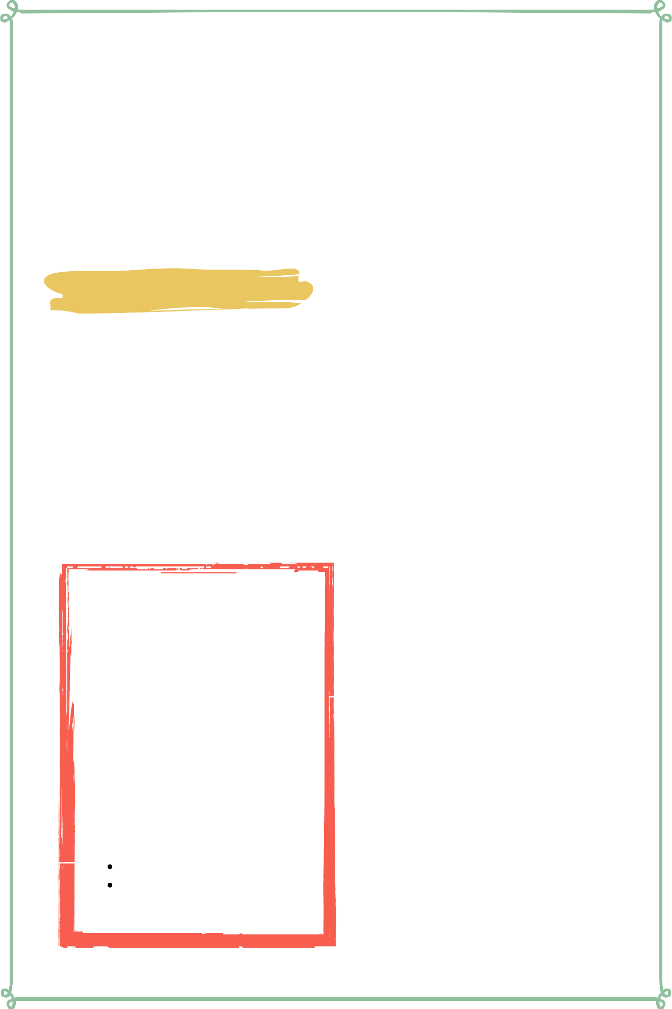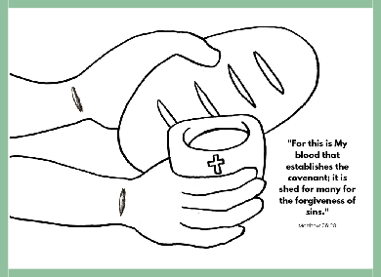

Lesson Fifteen | Page 1

Lesson Outline



**Read the Scripture** Matthew 26:26-30

**Help the children retell the story in their own words.**

What happened first? What happened next? What happened last?

**Discuss the story with the students.**

What does the bread represent? What does the cup/drink represent?

Who did Jesus share this bread and cup with?

**Discuss the story with the students.**

What does this story say about God? What does this story say about us?

What do we need to obey from this passage?

**Do the craft with the students.**

Lesson Fifteen | Page 2

Craft Instructions

**Today's craft reminds us of Jesus' sacrifice for us and how we can remember it through Communion. You can complete this craft with the pre-made coloring sheet attached to the lesson and just a few supplies!**

Materials

pre-made coloring sheet

crayons, markers, pastels

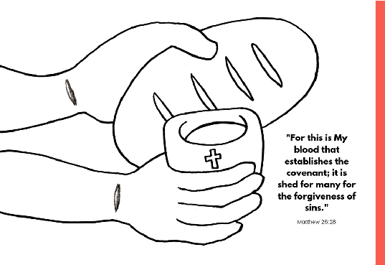

Instructions

Step 1 - Hand out the coloring sheet and the coloring materials.

Step 2 - Remind the students of the importance of Communion and what it signifies.

Step 3 - Allow the students to color their coloring sheet.

Step 4 - Have the students bring their finished coloring sheet home to remind them of today's lesson.

Lesson Fifteen | Page 3

Vocabulary Practice

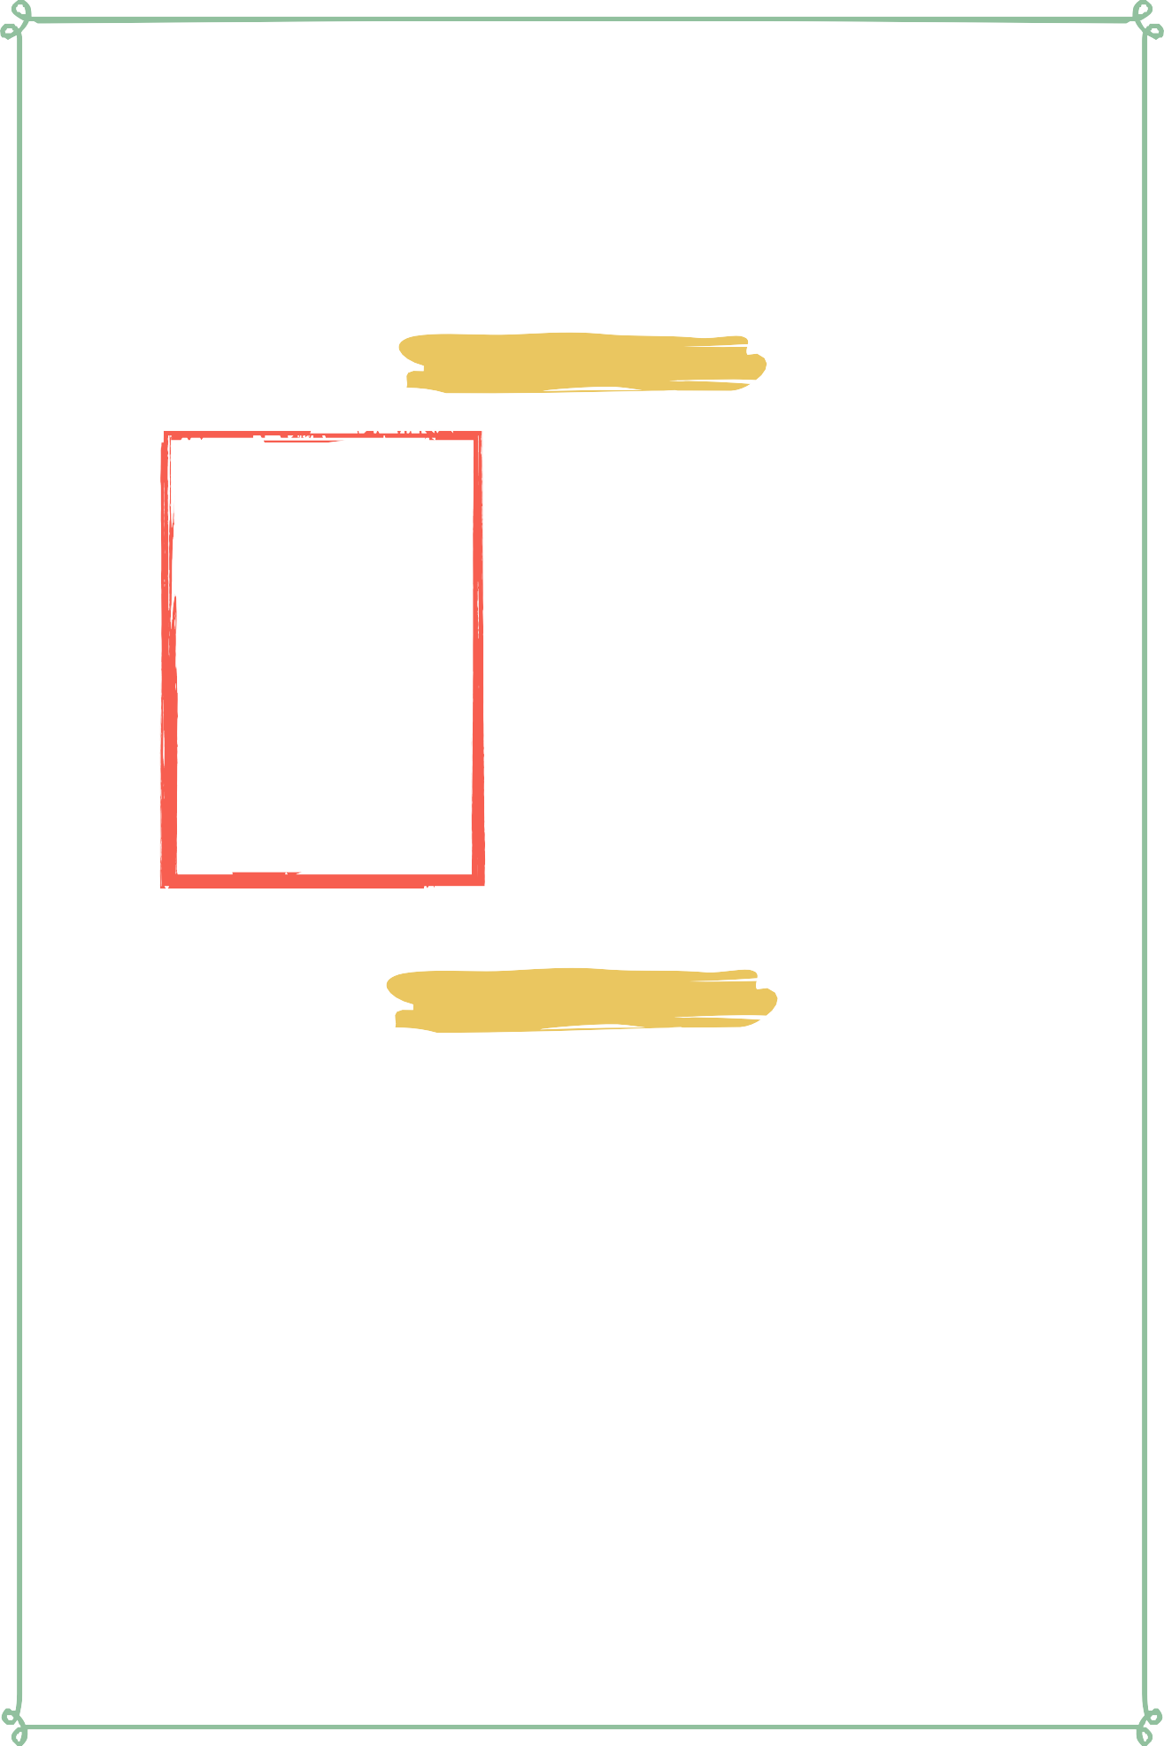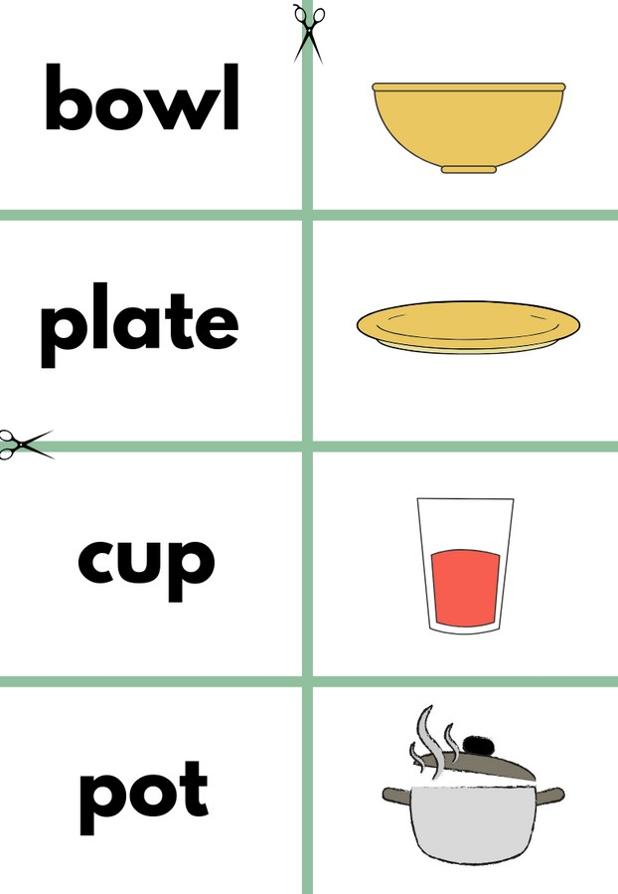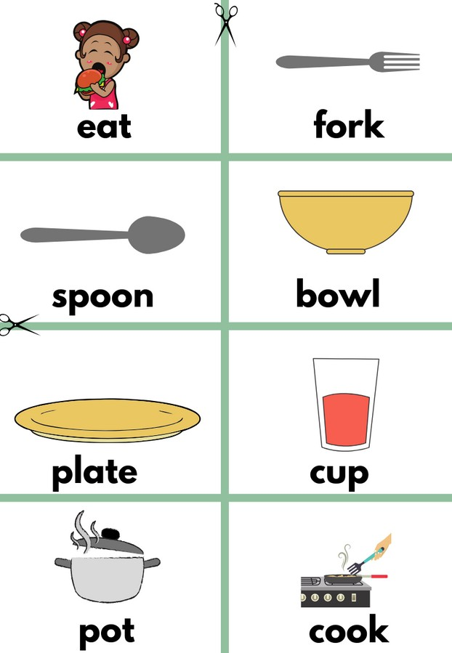

Flash Cards

Step 1- Cut out each card along the green lines.

Step 2- Use the flash cards to teach the students the English word for each picture.

Step 3- Optional: Punch a hole in the top left corner of each card. Put them on a ring and have the students practice flipping through the cards while reading each word.

Matching Game

Step 1- Cut out each card along the green lines.

Step 2- Teach the children the English words by connecting them with the corresponding picture. If you need help matching them, look at the flash cards. Step 3- Matching Game: Spread out the cards face-up on a flat surface. Make sure that they are mixed up. Have the children pick up a word or picture card and match it with the corresponding word or picture.

**Look at the following page for more ideas to use the flashcards.**

Lesson Fifteen | Page 4

Vocabulary Games

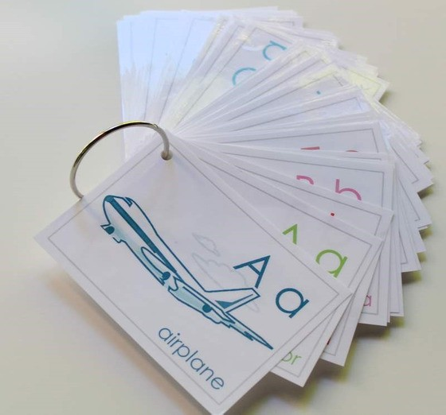

**Flashcard Game Ideas:**

The flashcards are the cards with the picture and word on the same side of the card. These flashcards are meant to help the student learn the English word for each picture. These cards can be used by putting them on a metal ring and having the student flip through the cards as they practice saying the word that goes with each picture.

**Flashcard Ring Example**

**Matching Game Ideas:**

For these four games, you can use the matching cards. The matching cards have a picture card and a word card that go together.

For this first game, start by laying the picture cards face down. (Do not use the word cards.) Have the students, one-by-one, pick up a card and flip it over and say the English word for that picture card.

For this game, lay the picture cards face-up on a flat surface. (Do not use the word cards.) Next, ask the students, one-by-one, where each picture card is. Do this by saying the English word for the picture on the card. Example: Where is the dog? Where is the door?

For this game, give each student a picture card. Then, call out one of the English words. Example: "Door". If a student has that picture card, have them hold it up, say the word, and show their friends.

For this game, lay out all of the cards (word cards and picture cards) face-up on a flat surface. One-by-one, allow the students to pick up an English word card and match it with the picture card. Try the other way by having the students pick up the picture card and match it with the English word card.

For a harder version of this game, lay all of the cards (word cards and picture cards) face-down. Have the children pick up a card and then pick up a second card. If they match, they can keep them. If they don't match they must put them back face-down and let the next student have a turn.

Lesson Fifteen | Page 5

Song Lyrics

**A Gift To You**

Everything I am, Everything I'll be

I give it to you Lord, and do it thankfully Every song I sing, Every praise I bring Everything I do, Is a gift to you Everything I have, All you've given me

I give it to You Lord, And do it thankfully Every song I sing, Every praise I bring Everything I do, Is a gift to you Everything I am, Everything I'll be

I give it to you Lord, and do it thankfully Every song I sing, Every praise I bring Everything I do, Is a gift to you

https://[www.youtube.com/watch?](http://www.youtube.com/watch) v=n3iG1gkW9R0



Lesson Fifteen | Page 6

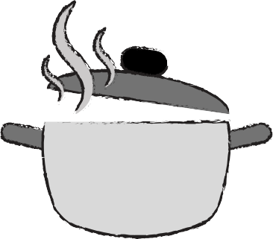

**eat fork**

**spoon bowl**

**plate cup**

**pot cook**

**stove**



**eat**

**fork spoon**

**bread**

**bowl plate cup**



**pot**

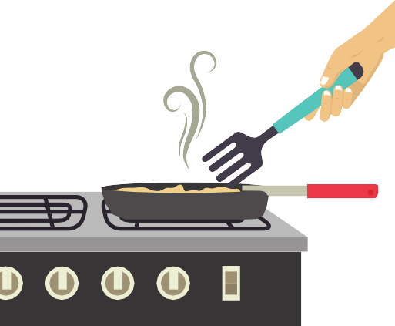

**cook stove**

**bread**

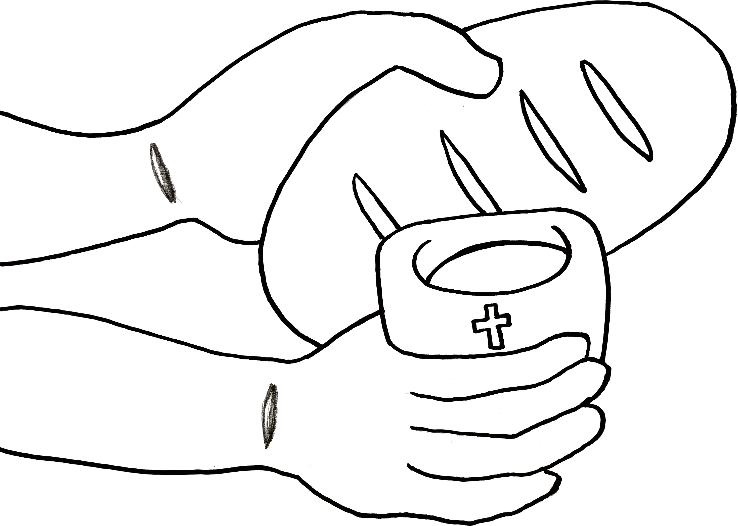

**"For this is My blood that establishes the covenant; it is shed for many for the forgiveness of sins."**

Matthew 26:28