# "I Am Optimistic"

### Lesson Six

Lesson Overview

Moral - Optimism Craft - Mindset Matters Coloring Sheet

Song - What I Am

Note to the Teacher

Before presenting this lesson, we encourage you to read through the lesson plan first so that you know the story well. This will help you present the story to the students in a way that they will understand.

Craft

Vocabulary

Materials

pre-made coloring sheet crayons, markers, pastels

eat fork spoon bowl plate

cup pot cook stove sink

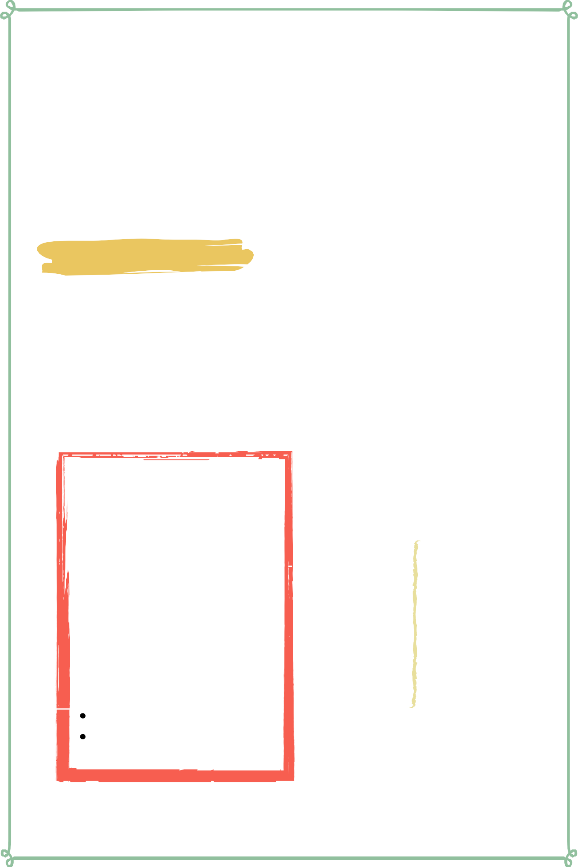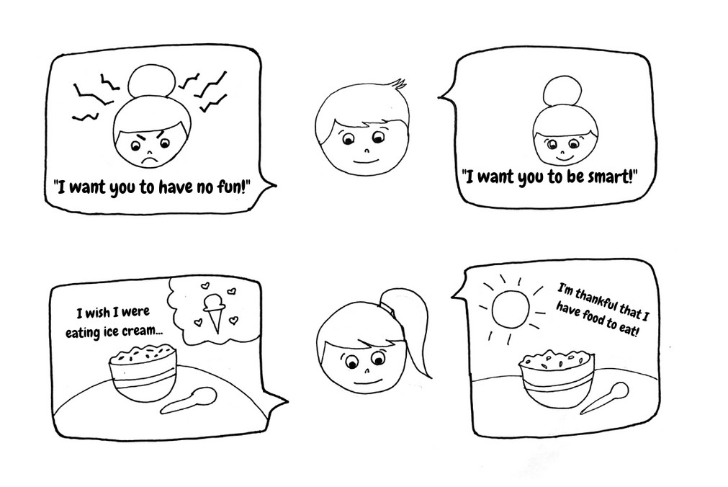

Lesson Six | Page 1

# Lesson Outline

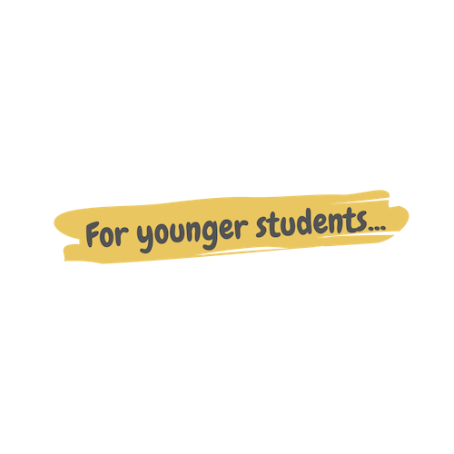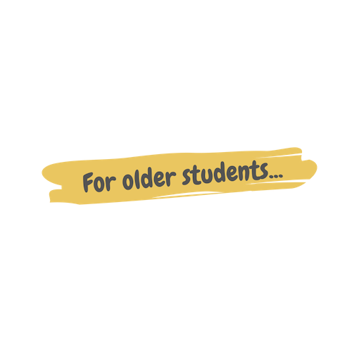

**Read the Story**

#### Help the children retell the story in their own words.

What happened first? What happened next?

What did God do on the last day?

**Discuss the story with the students.**

Why were Nabil and Nabila having a bad day? Did Nabil and Nabila like having homework?

Did Miss Meva want Nabil and Nabila to be happy?

**Discuss the story with the students.**

Why were Nabil and Nabila having a bad day?

Do you have something in your life that is negative or frustrating?

How can you change your perspective to be optimistic about this?

**Do the craft with the students.**

LessonSix | Page 2

# Story



One day, Nabil and Nabila were having a bad day. It seemed like everything was going wrong. Their plans weren't succeeding, and the food they were eating was gross, and their teacher gave them a lot of homework. They did not like what was happening to them and this upset them. And so, they sat under a tree and pouted because life felt unfair.

"All I ever do is homework," whined Nabil. "I never have any time to have fun."

"Yea!" Nabila chimed in. "We're kids! Why do they make us work so hard?"

"I don't know, Nabila, but I don't like it."

Then an older kid walked by them and noticed that Nabil and Nabila looked upset so he stopped to talk to them. "Hey guys! How's it going?"

"Bad!" Nabila grumbled, crossing her arms.

"Oh. Why?" The older kid asked, "What's wrong?"

"It's been a bad day. My lunch was really gross and Miss Meva gave us so much homework! It's like they don't want us to be kids!"

The older kid chuckled and then asked Nabil, "And why are you upset, Nabil?"

"Well," he began, "I wanted to go play futsal this afternoon with my brother and his friends, but now I can't because I have a lot of homework to do."

"Hmmm." The older kid thought carefully about what he would say next because he wanted to encourage them. "Those things are really tough, but have you thought about looking at them from a different perspective?"

Lesson Six | Page 3

# Story



(continued)

"What does that mean?" Nabila questioned skeptically.

"Well... right now you're looking at your circumstances and you see them as negative."

"But, they are negative." "But they don't have to be."

"I don't understand." Nabil said.

"Do you think Miss Meva gave you homework because she wanted to make you both unhappy?"

"No." Nabil responded, surprised that he would suggest something like that. "Miss Meva wants us to be happy!"

"Well of course she wants you to be happy and she more likely gave you homework because she also wants you to be smart, but not to make you sad. That's what it means to look at things from a different perspective. Looking at your circumstances with a positive perspective is called optimism."

"You're right. I don't have to be so upset because I know that Miss Meva wants me to be smart and that is why she gave me homework."

"I think I get this positive perspective idea," Nabila said. "My lunch may have been gross, but I had food to eat and that is a good thing!"

"Exactly!" The older kid exclaimed. "You guys are awesome and so optimistic!"

Lesson Six | Page 4

# Craft Instructions

##### Today we learned that having a positive mindset is called optimism. The coloring sheet is called Mindset Matters and shows two different ways that Nabil and Nabila can look at their circumstances. Can you guess which one is optimistic?

Materials

pre-made coloring sheet

crayons, markers, pastels

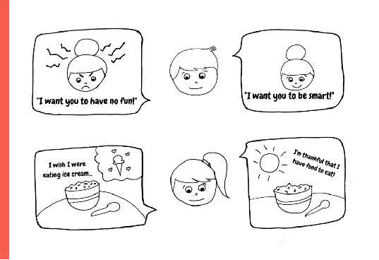

Instructions

Step 1 - Hand each student one coloring sheet and supplies.

Step 2 - Explain to them that each of us have the opportunity to look at our lives with a positive perspective or a negative one.

Step 3 - Have the kids color the optimistic perspective in warm colors (red, orange, yellow, pink) and the negative perspective in cool colors (blue, green, purple).

Step 4 - Allow the kids to take their craft home as a reminder that they too can be optimistic!

Lesson Six| Page 5

# Vocabulary Practice

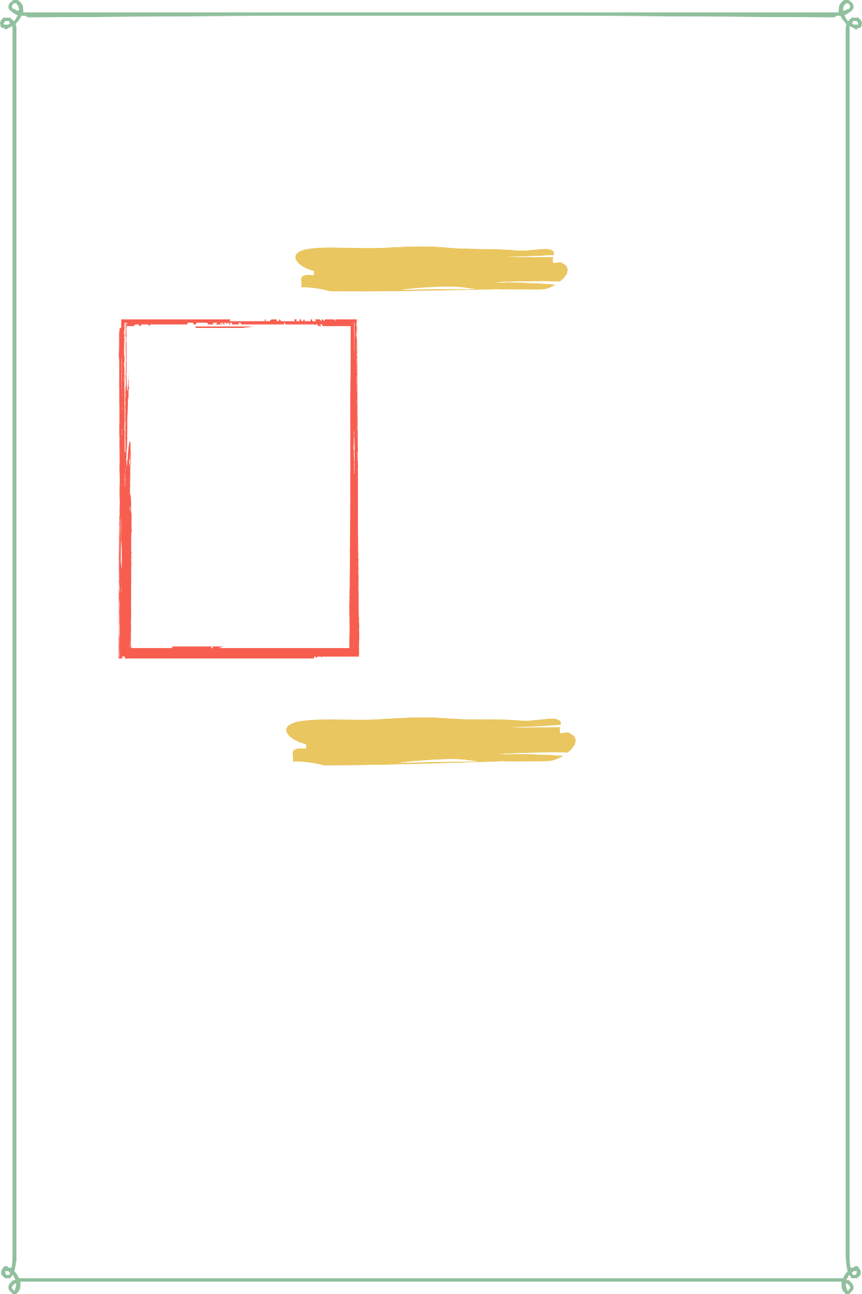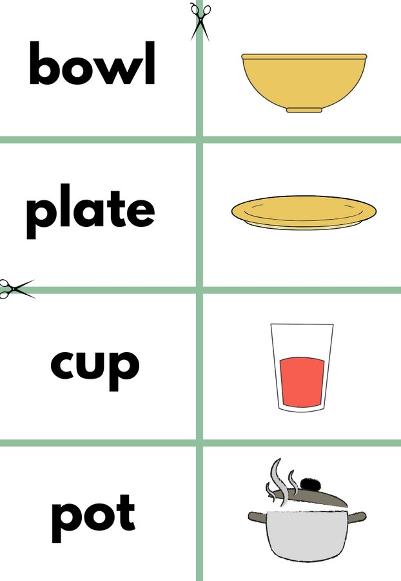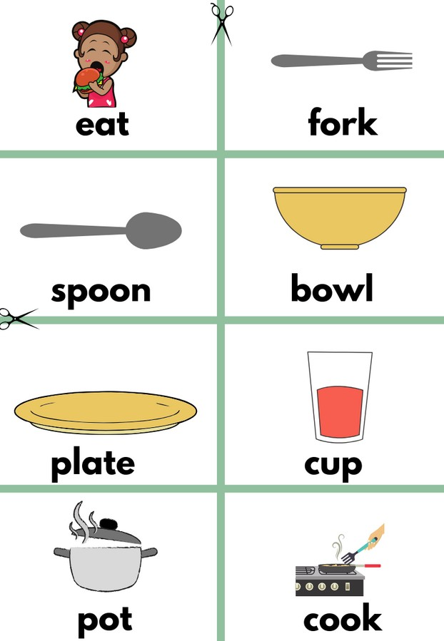

## Flash Cards

Step 1- Cut out each card along the green lines.

Step 2- Use the flash cards to teach the students the English word for each picture.

Step 3- Optional: Punch a hole in the top left corner of each card. Put them on a ring and have the students practice flipping through the cards while reading each word.

Matching Game

Step 1- Cut out each card along the green lines.

Step 2- Teach the children the English words by connecting them with the corresponding picture. (If you need help matching them, look at the flash cards.) Step 3- Matching Game: Spread out the cards face-up on a flat surface. Make sure that they are mixed up. Have the children pick up a word or picture card and match it with the corresponding word or picture.

##### Look at the following page for more ideas to use the flashcards.

Lesson Six | Page 6

# Song Lyrics

### What I Am

If what I am is what's in me, Then I'll stay strong - that's who I'll be And I will always be the best, "me" that I can be.

There's only one me, I am it, Have a dream I'll follow it It's up to me to try. Oh! I'm a keep my head up high Keep on reaching high, Never gonna quit

I'll be getting stronger. And nothing's gonna bring me down (no!) Never gonna stop, gotta go. Because I know

I'll keep getting stronger. And what I am is thoughtful What I am is musical

What I am is smart And what I am is brave What I am is helpful What I am is special

There's nothing I can't achieve. Because in myself I believe in oh...

Gonna keep our heads up high Keep on reaching high Never gonna quit Just keep getting stronger.

And nothing's gonna bring us down (no!) Never give it up, gotta go. Because I know I'll keep getting stronger.

What I am is super What I am is proud What I am is friendly What I am is grouchy What you are is magical What you are is special

There's nothing I can't achieve. Because in myself I believe in oh...

Gonna hold my head up high Keep on reaching high

Never gonna stop I'll be getting stronger. Nothing's gonna bring me down (no!) Never give it up gotta go, oh... yeah... I'll keep getting strong-er.



link

Lesson Six | Page 7

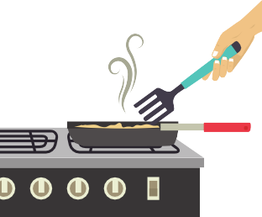

**eat fork**

**spoon bowl**

**plate cup**

**pot cook**

**stove**

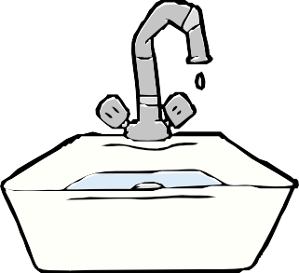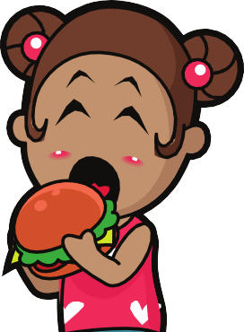

**eat**

**fork spoon**

**sink**

**bowl plate cup**



**pot**

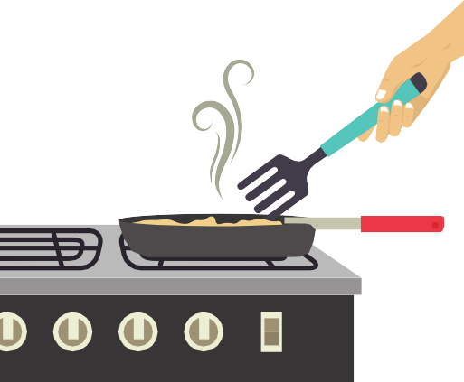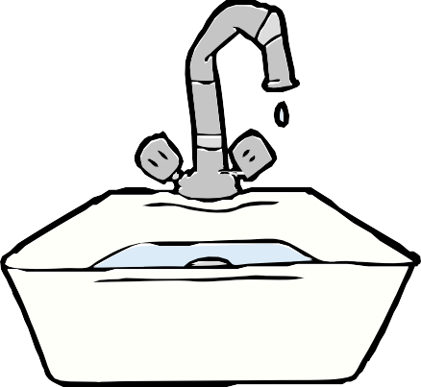

**cook stove**

**sink**

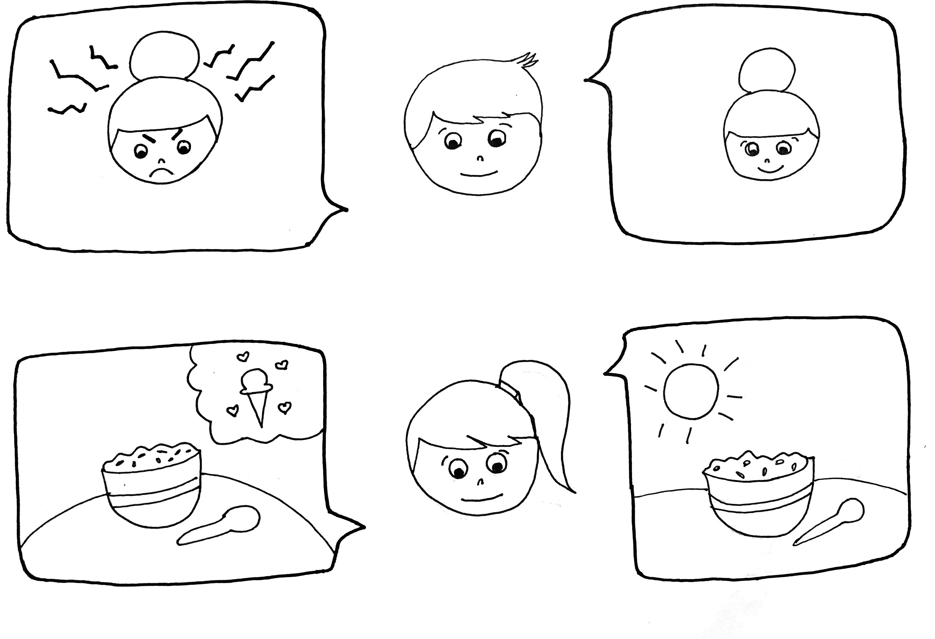

"I want you to have no fun!" "I want you to be smart!"