## Jesus Conquered Death

### Lesson Eighteen

Lesson Overview

Scripture - Luke 24:1-35 Main Point - He is Risen! We serve a God who is living!

Jesus was victorious over death and now we can trust Him with our lives too.

Craft - He is Risen craft

Song - "Victory in Jesus"

Note to the Teacher

Before presenting this lesson, we encourage you to read the scripture passages and understand the story for yourself. This lesson plan is meant to give you direction as you teach, but it is important to share the story from your heart and allow God to lead you as you go.

Craft

Vocabulary

Materials

pre-made coloring sheet crayons, markers, pastels

morning afternoon night alive dead

full empty table scripture road

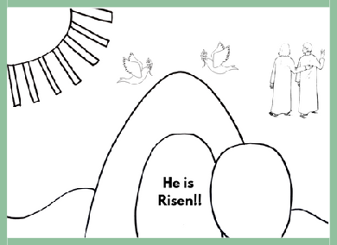

Lesson Eighteen | Page 1

Lesson Outline



**Read the Scripture** Luke 24:1-35

**Help the children retell the story in their own words.**

What happened first? What happened next? What happened last?

**Discuss the story with the students.**

How many days was Jesus in the tomb before He rose from the dead?

Who found the tomb empty?

Where did Jesus go when He rose from the dead?

**Discuss the story with the students.**

What does this story say about God? What does this story say about us?

What do we need to obey from this passage?

**Do the craft with the students.**

Lesson Eighteen | Page 2

Craft Instructions

Materials

**Today we learned that Jeus is Risen!! You can complete this craft with the pre-made coloring sheet attached to the lesson and just a few supplies!**

pre-made coloring sheet

crayons, markers, pastels

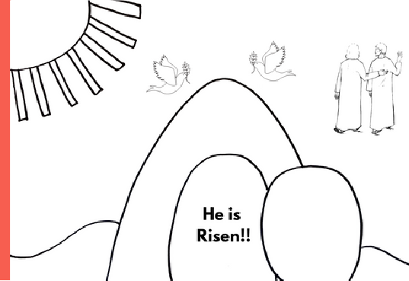

Instructions

Step 1 - Hand out the coloring sheet and coloring materials.

Step 2 - Remind the students of today's lesson about the Resurrection of Jesus!

Step 3 - Allow the students to color their coloring sheet.

Step 4 - Allow the students to bring home their finished coloring sheet to remind them of today's lesson.

Lesson Eighteen | Page 3

Vocabulary Practice

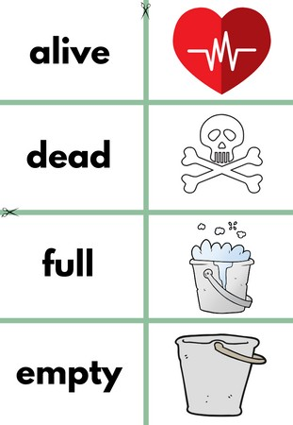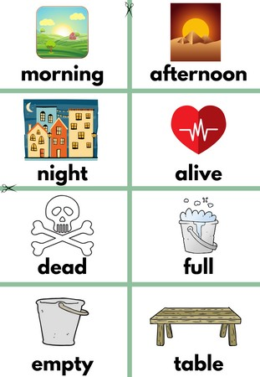

Flash Cards

Step 1- Cut out each card along the green lines.

Step 2- Use the flash cards to teach the students the English word for each picture.

Step 3- Optional: Punch a hole in the top left corner of each card. Put them on a ring and have the students practice flipping through the cards while reading each word.

Matching Game

Step 1- Cut out each card along the green lines.

Step 2- Teach the children the English words by connecting them with the corresponding picture. If you need help matching them, look at the flash cards. Step 3- Matching Game: Spread out the cards face-up on a flat surface. Make sure that they are mixed up. Have the children pick up a word or picture card and match it with the corresponding word or picture.

**Look at the following page for more ideas to use the flashcards.**

Lesson Eighteen | Page 4

Vocabulary Games

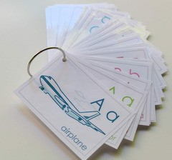

**Flashcard Game Ideas:**

The flashcards are the cards with the picture and word on the same side of the card. These flashcards are meant to help the student learn the English word for each picture. These cards can be used by putting them on a metal ring and having the student flip through the cards as they practice saying the word that goes with each picture.

**Flashcard Ring Example**

**Matching Game Ideas:**

For these four games, you can use the matching cards. The matching cards have a picture card and a word card that go together.

For this first game, start by laying the picture cards face down. (Do not use the word cards.) Have the students, one-by-one, pick up a card and flip it over and say the English word for that picture card.

For this game, lay the picture cards face-up on a flat surface. (Do not use the word cards.) Next, ask the students, one-by-one, where each picture card is. Do this by saying the English word for the picture on the card. Example: Where is the dog? Where is the door?

For this game, give each student a picture card. Then, call out one of the English words. Example: "Door". If a student has that picture card, have them hold it up, say the word, and show their friends.

For this game, lay out all of the cards (word cards and picture cards) face-up on a flat surface. One-by-one, allow the students to pick up an English word card and match it with the picture card. Try the other way by having the students pick up the picture card and match it with the English word card.

For a harder version of this game, lay all of the cards (word cards and picture cards) face-down. Have the children pick up a card and then pick up a second card. If they match, they can keep them. If they don't match they must put them back face-down and let the next student have a turn.

Lesson Eighteen | Page 5

Song Lyrics

**Victory in Jesus**

I heard an old, old story How a Savior came from glory How He gave His life on Calvary

To save a wretch like me I heard about His groaning

Of His precious blood’s atoning Then I repented of my sins And won the victory.

O victory in Jesus, My Savior, forever.

He sought me and bought me With His redeeming blood; He loved me ere I knew Him, And all my love is due Him,

He plunged me to victory, Beneath the cleansing flood

I heard about His healing,

Of His cleansing power revealing. How He made the lame to walk again

And caused the blind to see; And then I cried, “Dear Jesus, Come and heal my broken spirit,” And somehow Jesus came and brought

To me the victory.

O victory in Jesus, My Savior, forever.

He sought me and bought me With His redeeming blood; He loved me ere I knew Him, And all my love is due Him,

He plunged me to victory, Beneath the cleansing flood

I heard about a mansion He has built for me in glory.

And I heard about the streets of gold

Beyond the crystal sea; About the angels singing, And the old redemption story,

And some sweet day I’ll sing up there

The song of victory.

O victory in Jesus, My Savior, forever.

He sought me and bought me With His redeeming blood; He loved me ere I knew Him, And all my love is due Him,

He plunged me to victory, Beneath the cleansing flood



https://[www.youtube.com/watch?v=Ts3iW54ICGo](http://www.youtube.com/watch?v=Ts3iW54ICGo) Lesson Eighteen | Page 6

**morning**



**night**

**dead**

**empty**

**afternoon**

**alive**

**full**

**table**

**scripture**



**morning**

**afternoon**

# night

**road**

**alive dead full**



**empty**



**table**

**scripture**

**road**

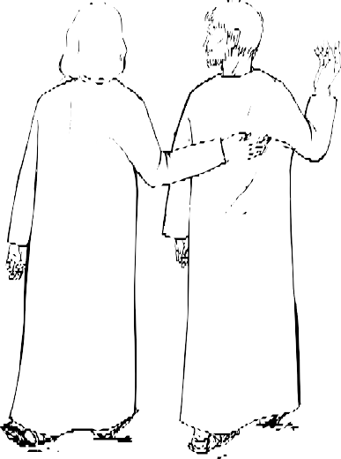

**He is Risen!!**