### The Creation of Man

##### Lesson Two

Lesson Overview

Scripture - Genesis 2:15-24 Craft - Adam and Eve in the Garden

Main Point - God made each of us unique and in His own image.

Song - "Adam and Eve"

Note to the Teacher

Before presenting this lesson, we encourage you to read the scripture passages and understand the story for yourself. This lesson plan is meant to give you direction as you teach, but it is important to share the story from your heart and allow God to lead you as you go.

Craft

Vocabulary

Materials

pre-made coloring sheet Crayons, Markers, Pastels

unique woman man dirt tree

sleep river helper heaven earth

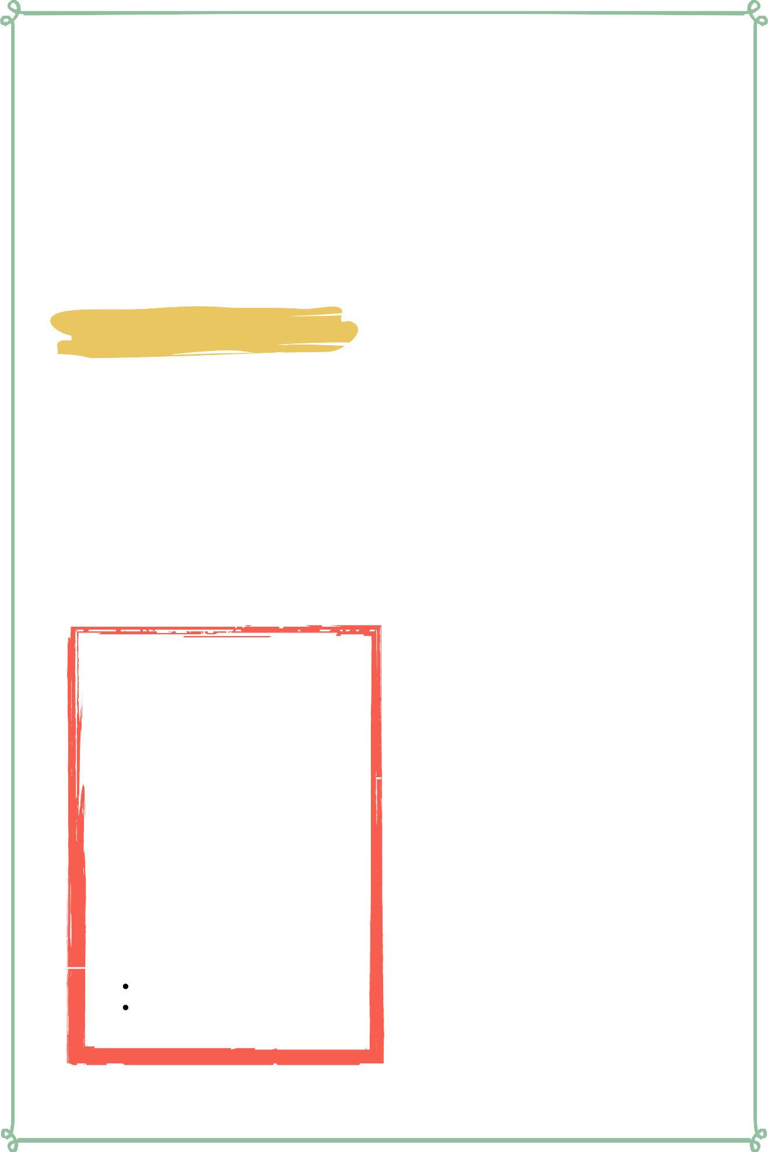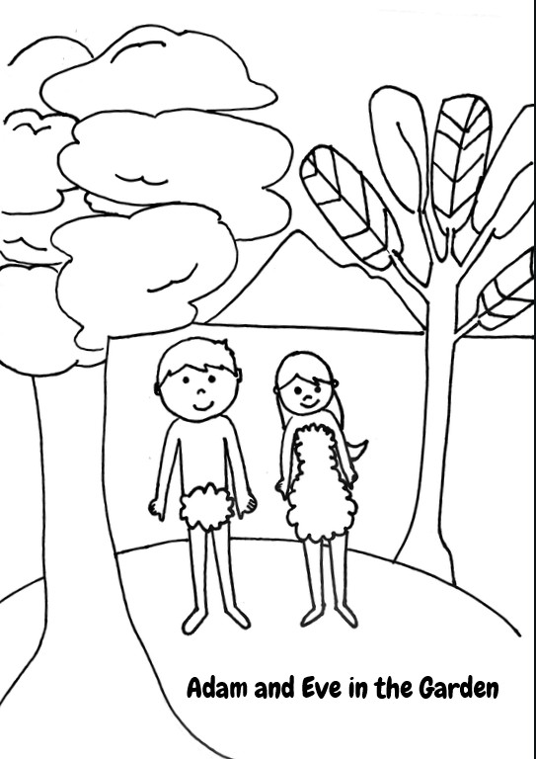

Lesson Two | Page 1

### Lesson Outline



**Read the Scripture** Genesis 2:15-24

###### Help the children retell the story in their own words.

What happened first? What happened next? What happened last?

###### Discuss the story with the students.

What was Adam doing in the Garden? Who did God make to be Adam's helper?

God is creative and He made each and every one of us unique. What is unique about you?

###### Discuss the story with the students.

What does this story say about God? What does this story say about us?

What do we need to obey from this passage?

**Do the craft with the students.**

Lesson One | Page 2

### Craft Instructions

**God made each of us unique and in His own image, starting with Adam and Eve. Today we will color a picture of Adam and Eve in the Garden! You can complete this craft with the pre-made coloring sheet attached to the lesson and just a few supplies!**

#### Materials

Pre-made coloring sheet

Crayons, Markers, Pastel

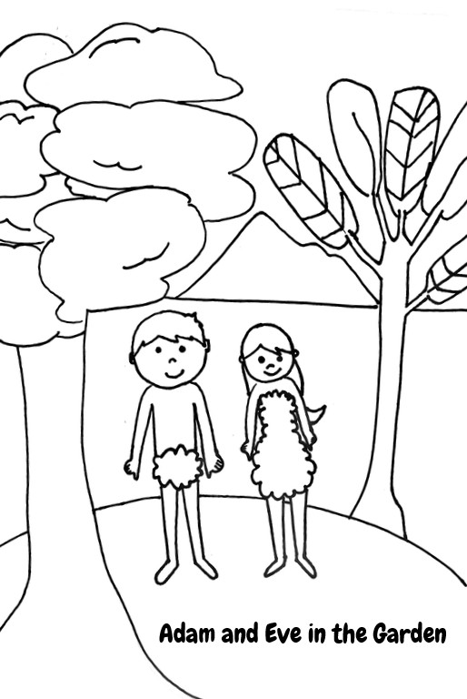

Instructions

Step 1 - Hand out the pre-made coloring sheet.

Step 2 - Have the students color the picture.

Step 3 - Remind them that God made Adam and Eve unique and His own image. Then remind them that they are also unique and made in God's own image.

Step 4 - Allow the children to bring their finished coloring sheet home with them to remember the story they learned.

Lesson Two | Page 3

### Vocabulary Practice

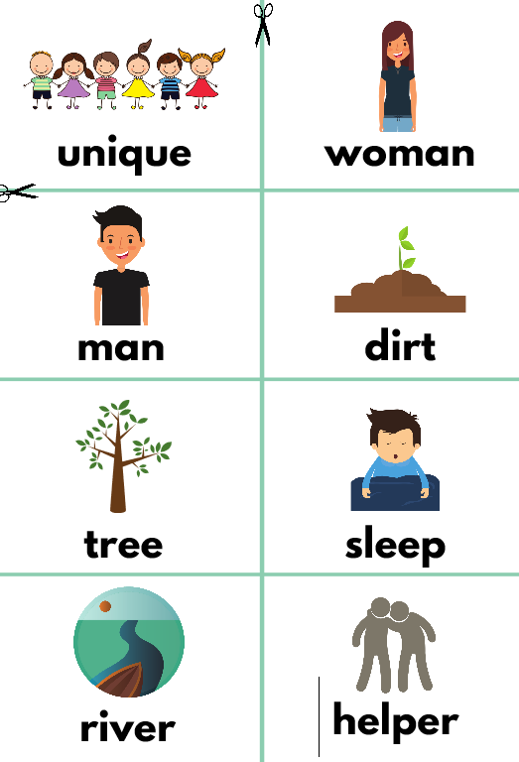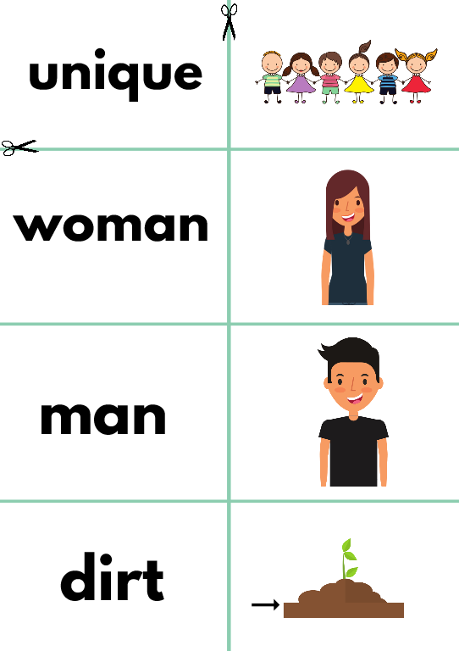

#### Flash Cards

Step 1- Cut out each card along the blue lines.

Step 2- Use the flash cards to teach the students the English word for each picture.

Step 3- Optional: Punch a whole in the top left corner of each card. Put them on a ring and have the students practice flipping through the cards while reading each word.

Matching Game

Step 1- Cut out each card along the blue lines. Step 2- Teach the children the English words by connecting them with the corresponding picture. (If you need help matching them, look at the flash cards.)

Step 3- Matching Game: Spread out the cards face-up on a flat surface. Make sure that they are mixed up. Have the children pick up a word or picture card and match it with the corresponding word or picture.

Lesson Two | Page 4

### Song Lyrics



##### Adam and Eve

Adam and Eve, Adam and eve,

the very first people that the world's ever seen, Adam and Eve, Adam and Eve,

were made in the image of God, Now Adam he was the first one around,

God made him from the dust of the ground,

He gave him a job and He gave him his life, but he didn't yet have a wife,

now it wasn't good for Adam to be all alone in the garden you see,

so God put Adam in a real deep sleep, he didn't even need to count sheep, God took a rib from Adam's side,

He formed it real nice and He made him a bride, when Adam awoke he was real pleased,

that's how the Lord made Eve, Adam and Eve, Adam and Eve,

the very first people that the worlds ever seen, Adam and Eve, Adam and Eve,

were made int he image of God.

https://[www.youtube.com/watch?v=RlyI08coJfw](http://www.youtube.com/watch?v=RlyI08coJfw)

Lesson Two | Page 5



**unique woman**

**man dirt**



**tree sleep**



**river helper**



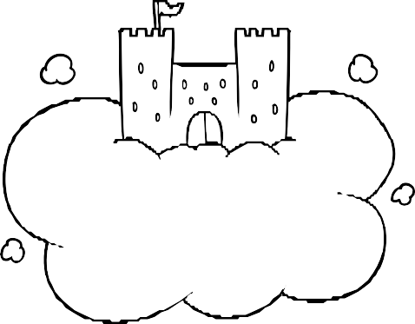**heaven earth**

**unique **

**woman **

**man**



**dirt**



**tree**

# sleep river



**helper**

## heaven

**earth**

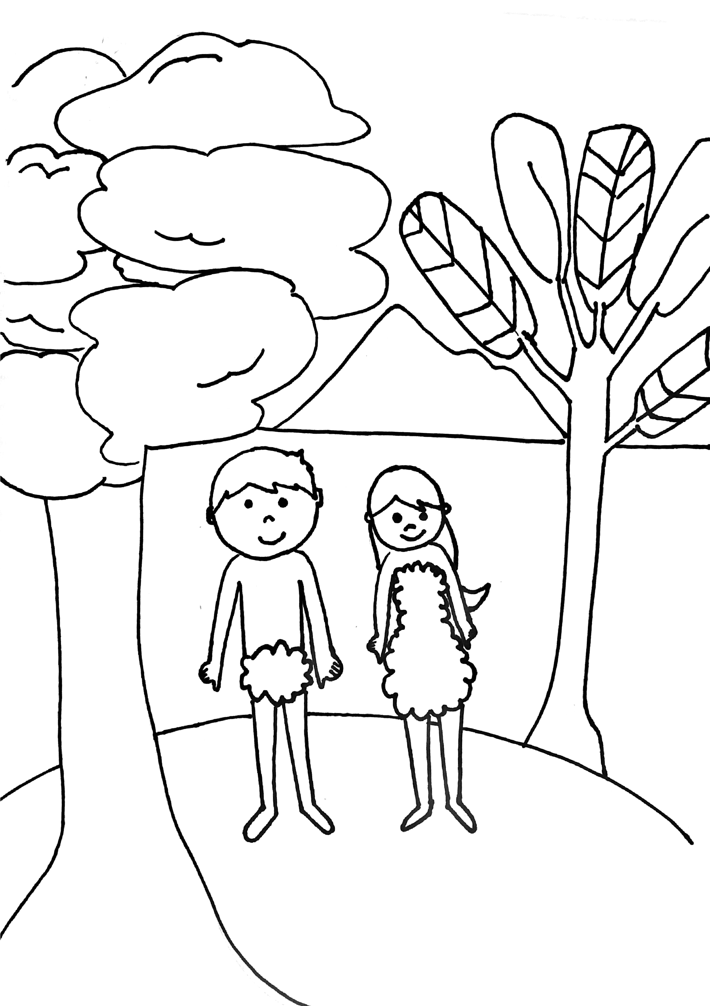

Adam and Eve in the Garden