# "I Am Loving"

## Lesson Nine

Lesson Overview

Moral - Love

Craft - I Love Baby Coloring Sheet

Song - That's What Love Is

Note to the Teacher

Before presenting this lesson, we encourage you to read through the lesson plan first so that you know the story well. This will help you present the story to the students in a way that they will understand.

Craft

Vocabulary

Materials

pre-made coloring sheet crayons, markers, pastels

under above baby tree smile

big sister baby sister crib

bottle diaper

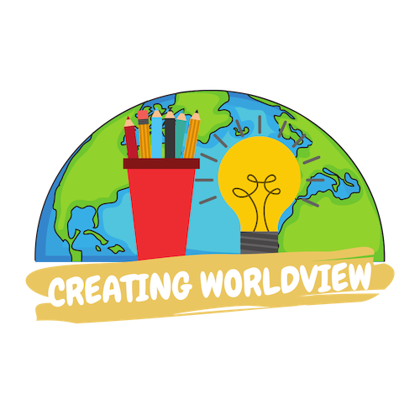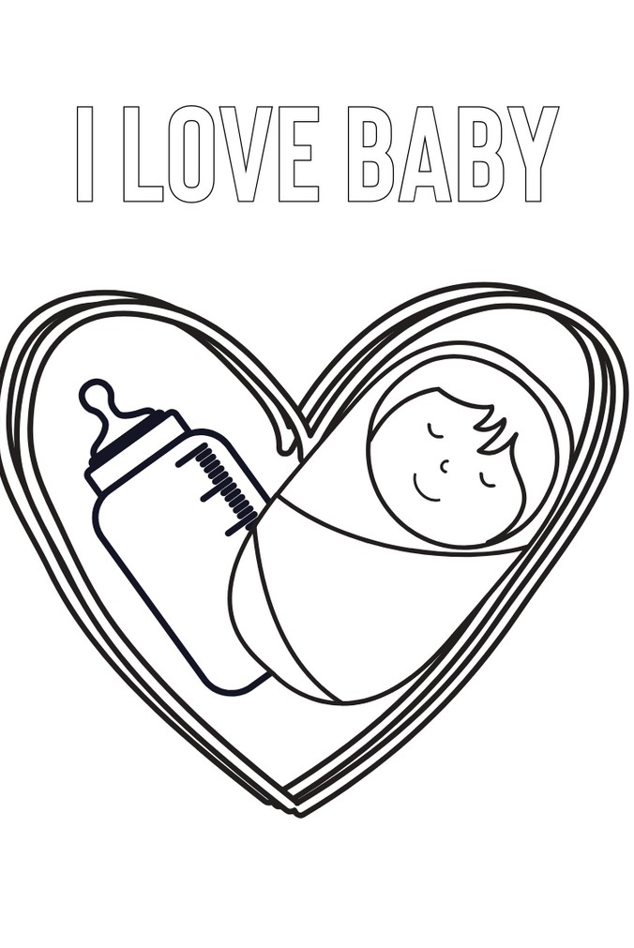

Lesson Nine | Page 1

Lesson Outline

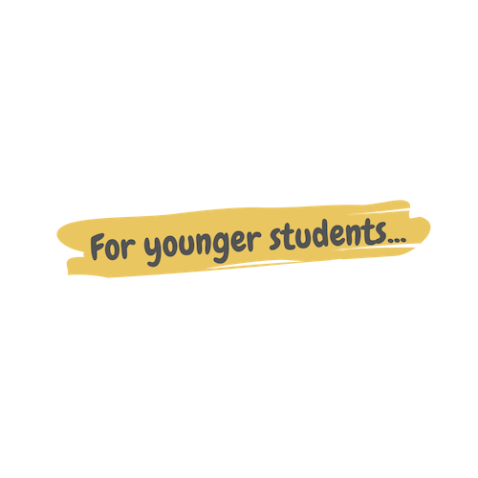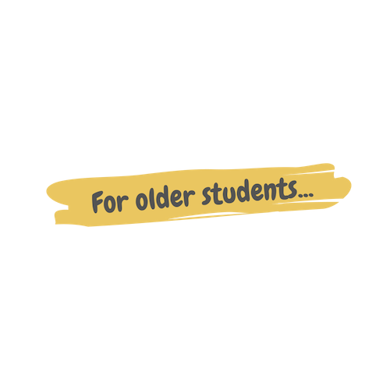

**Read the Story**

**Help the children retell the story in their own words.**

What happened first? What happened next?

What did God do on the last day?

**Discuss the story with the students.**

Did Nabila have a baby sister or a baby brother? Was Nabila excited to have a baby sister?

How can you show that you love your baby sister or baby brother?

**Discuss the story with the students.**

What did Nabila want to tell Nabil? Why was she excited? How did Nabila show that she loves her baby sister?

How can you show that you love your baby sister or brother?

**Do the craft with the students.**

Lesson Nine | Page 2

Story



"Nabil! Nabil, guess what!" Nabila shouted with excitement as she approached her friend who was sitting under a tree. She plopped down next to him with a big smile on her face.

"Whoa, whoa, whoa! What?" Nabil said. He was very curious to know why his friend was so excited.

"I'm a big sister!" Nabila squealed. "My mommy and daddy just brought home a brand new baby and her name is Selvy!"

"That is amazing Nabila! You are going to love being a big sister!"

Nabila's smile faded a little bit. "I hope I love it, but I'm nervous that I won't be a good big sister. What if I mess up? What if she doesn't like me?"

"Oh, Nabila, don't worry! All you have to do is love her."

"Love her? How do I do that?" Nabila crossed her arms and look quizzically at Nabil.

"You can do many things to show your love. You can help your mom do things like feed her, change her diaper, and play with her. And when she gets older you can protect her and be her friend."

Nabila thought for a second, and then relaxed. "You're right. I just need to love her, and I can do that by helping my mommy! I have to go. My mommy will be feeding Selvy soon and maybe I can help! Bye!!" Nabila got up and sprinted towards her home.

"Bye!" Nabil shouted into the distance as his friend ran away.

At home, Nabila helped her mom feed her new little sister and then put her in her bed for a nap. Nabila's heart was so happy and full of love for Selvy.

Lesson Nine | Page 3

Craft Instructions

**In today's story, Nabil reminded Nabila of ways she can be a loving big sister.**

**Color this page to remember the story!**

Materials

pre-made coloring sheet

crayons, markers, pastels

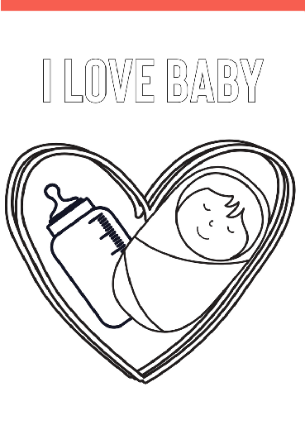

Instructions

Step 1 - Pass out one coloring sheet to each student along with markers, crayons, or pastels.

Step 2 - Instruct them to color the page.

Step 3 - Allow them to take their creations home.

Lesson Nine | Page 4

Vocabulary Practice

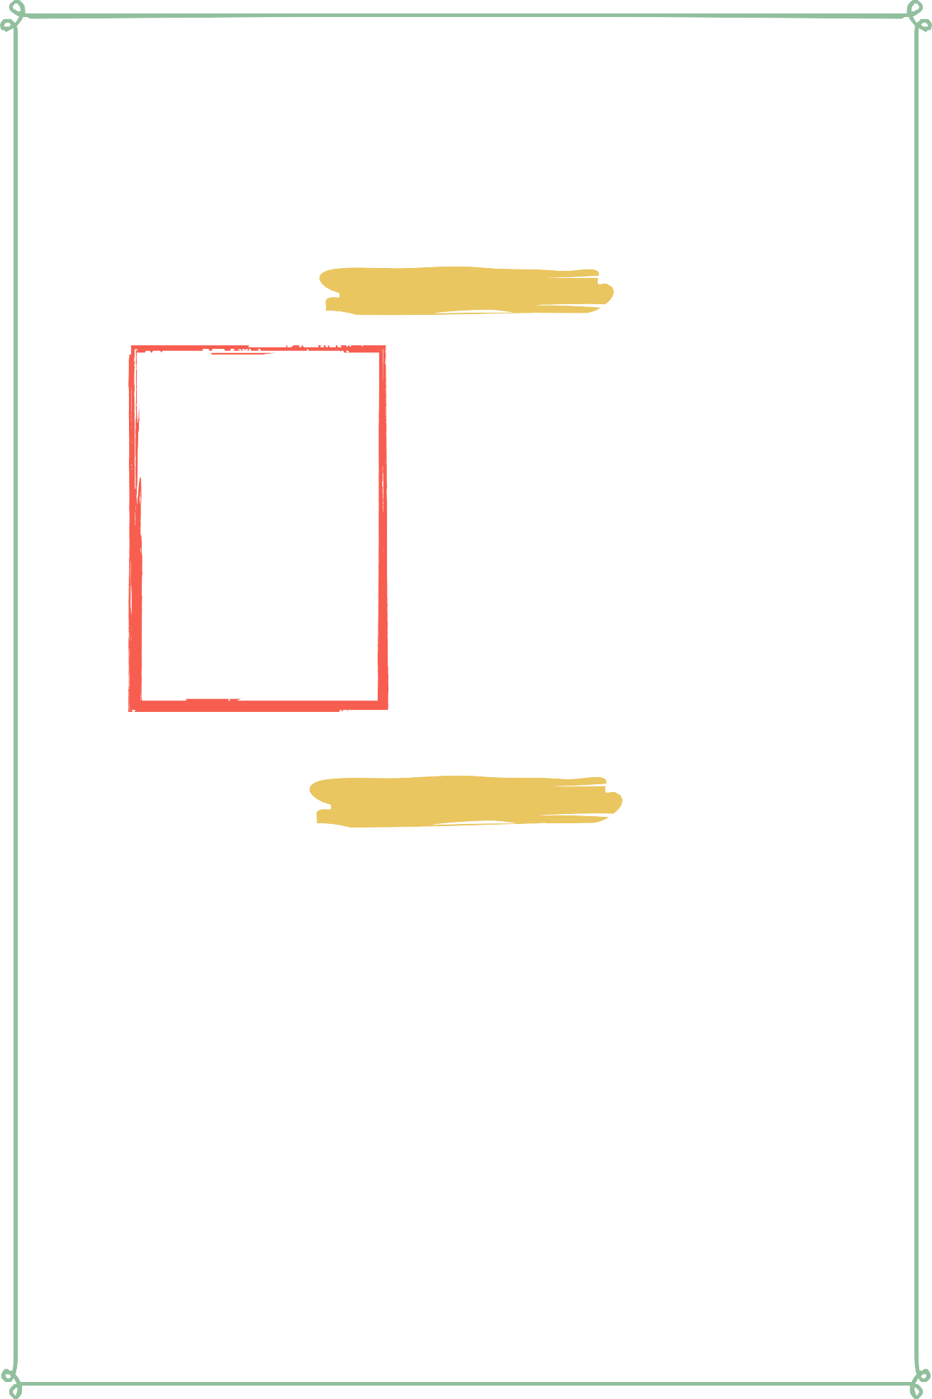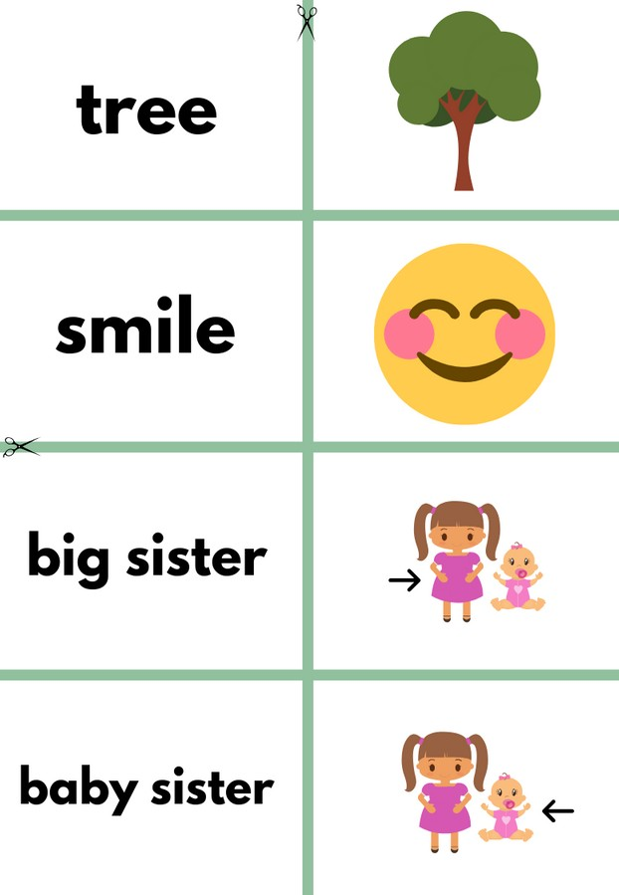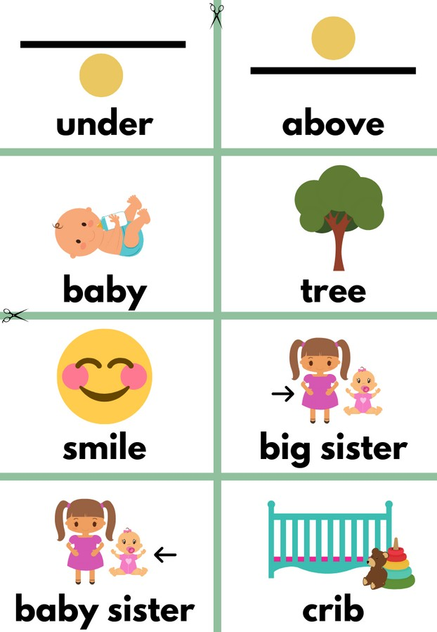

Flash Cards

Step 1- Cut out each card along the green lines.

Step 2- Use the flash cards to teach the students the English word for each picture.

Step 3- Optional: Punch a hole in the top left corner of each card. Put them on a ring and have the students practice flipping through the cards while reading each word.

Matching Game

Step 1- Cut out each card along the green lines.

Step 2- Teach the children the English words by connecting them with the corresponding picture. If you need help matching them, look at the flash cards. Step 3- Matching Game: Spread out the cards face-up on a flat surface. Make sure that they are mixed up. Have the children pick up a word or picture card and match it with the corresponding word or picture.

**Look at the following page for more ideas to use the flashcards.**

Lesson Nine | Page 5

Vocabulary Games

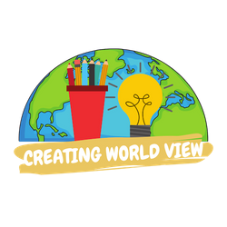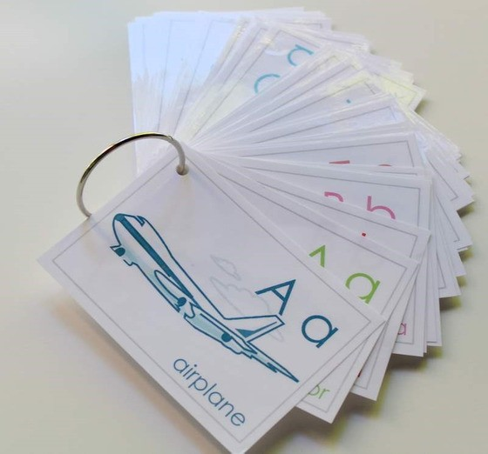

**Flashcard Game Ideas:**

The flashcards are the cards with the picture and word on the same side of the card. These flashcards are meant to help the student learn the English word for each picture. These cards can be used by putting them on a metal ring and having the student flip through the cards as they practice saying the word that goes with each picture.

**Flashcard Ring Example**

**Matching Game Ideas:**

For these four games, you can use the matching cards. The matching cards have a picture card and a word card that go together.

For this first game, start by laying the picture cards face down. (Do not use the word cards.) Have the students, one-by-one, pick up a card and flip it over and say the English word for that picture card.

For this game, lay the picture cards face-up on a flat surface. (Do not use the word cards.) Next, ask the students, one-by-one, where each picture card is. Do this by saying the English word for the picture on the card. Example: Where is the dog? Where is the door?

For this game, give each student a picture card. Then, call out one of the English words. Example: "Door". If a student has that picture card, have them hold it up, say the word, and show their friends.

For this game, lay out all of the cards (word cards and picture cards) face-up on a flat surface. One-by-one, allow the students to pick up an English word card and match it with the picture card. Try the other way by having the students pick up the picture card and match it with the English word card.

For a harder version of this game, lay all of the cards (word cards and picture cards) face-down. Have the children pick up a card and then pick up a second card. If they match, they can keep them. If they don't match they must put them back face-down and let the next student have a turn.

Lesson Nine | Page 6

Song Lyrics

**That's What Love Is**

Love is mom. Love is dad. Love is the best friend you've ever had. Love is cool. Love is fun. Love is so wishful everyone. Love is good. Love is free. I'll love you if you'll love me. That's what love is, that's what love is. That's what love is, that's what love is. Let's sing it together this time. Love is mom. Love is dad. Love is the best friend you've ever had. Love is cool. Love is fun. Love is so wishful everyone. Love is good. Love is free. I'll love you if you'll love me. That's what love is, that's what love is. That's what love is, that's what love is.



https://[www.youtube.com/watch?](http://www.youtube.com/watch) v=2F-x06QSs78

Lesson Nine | Page 7

**under**

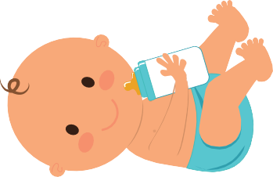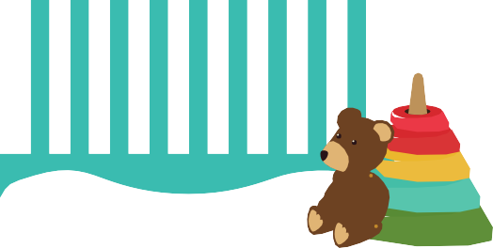

**baby**

**smile**

**baby sister**

**above**

**tree**

**big sister**

**crib**

**bottle**

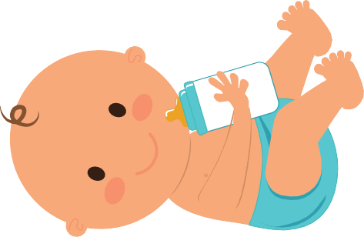

**under**

**above baby**

**diaper**

**tree smile**



**big sister**

**baby sister**

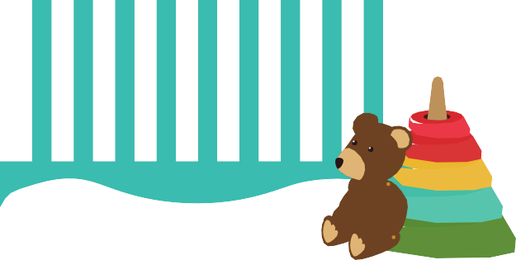

**crib bottle diaper**

i LOVE BABY

